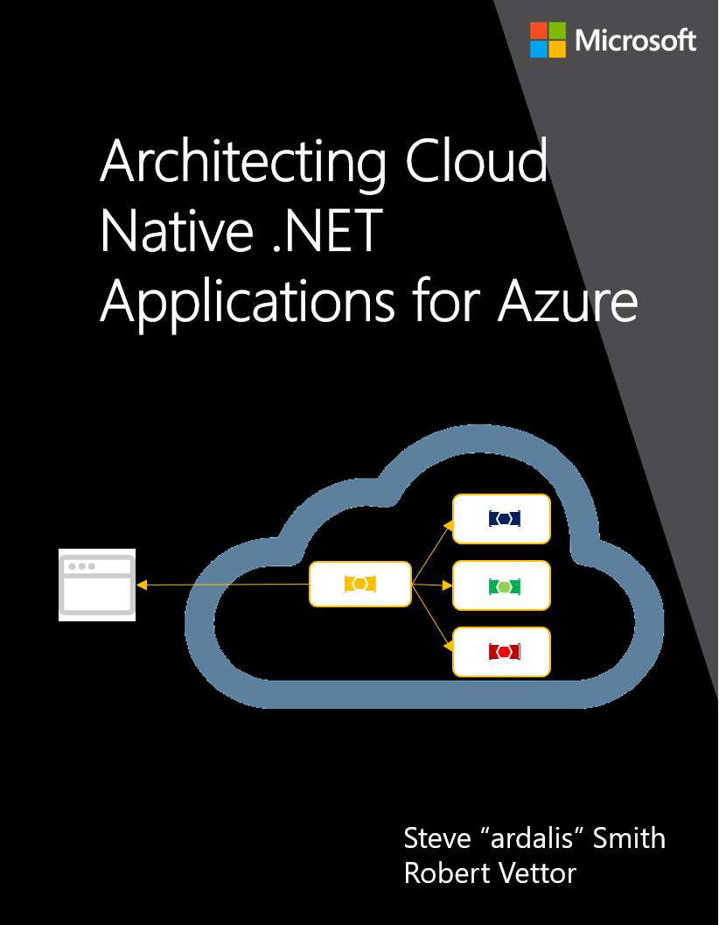

**EDITION v2.1.02**

DOWNLOAD available at: [https://aka.ms/cloudnative*](https://aka.ms/cloudnative*)

PUBLISHED BY

Microsoft Developer Division, .NET and Visual Studio product teams

A division of Microsoft Corporation

One Microsoft Way

Redmond, Washington 98052-6399

Copyright © 2019 by Microsoft Corporation

All rights reserved. No part of the contents of this book may be reproduced or transmitted in any form or by any means without the written permission of the publisher.

This book is provided “as-is” and expresses the author’s views and opinions. The views, opinions and information expressed in this book, including URL and other Internet website references, may change without notice.

Some examples depicted herein are provided for illustration only and are fictitious. No real association or connection is intended or should be inferred.

Microsoft and the trademarks listed at http://www.microsoft.com on the “Trademarks” webpage are trademarks of the Microsoft group of companies.

Mac and macOS are trademarks of Apple Inc.

The Docker whale logo is a registered trademark of Docker, Inc. Used by permission.

All other marks and logos are property of their respective owners.

Co-Authors: Editors:

|  |  |
| --- | --- |
| **Steve Smith**, Software Craftsman & Trainer at Ardalis Services  **Robert Vettor**, Principal Cloud System Architect, Microsoft Corp. | **Someone** |

Participants and reviewers:

|  |  |
| --- | --- |
| **Nish Anil**, Sr. Program Manager, .NET team, Microsoft | **Miguel Veloso**, Sr. Consultant at Turing Challenge |

Contents

Introduction to Cloud Native .NET Applications 1

Defining Cloud Native 1

Thinking in terms of the cloud… 3

Thinking in terms of microservices… 5

Thinking in terms of containers… 6

Thinking in terms of cloud-hosted backing services… 8

Thinking in terms of modern system design… 10

Thinking in terms of automation 12

Candidate Apps for Cloud Native 14

The Azure Cloud-Native Development Stack 16

Choosing an OS 16

.NET Core Platform 17

Tooling: IDE vs. Editor 17

Source control in GitHub 18

CI/CD in Azure DevOps 19

Summary 20

Scaling cloud native applications 22

The simple solution: scaling up 22

Scaling out App Services 23

References 25

Leveraging containers and orchestrators 25

Local Kubernetes Development 27

Visual Studio Docker Tooling 28

References 32

Leveraging serverless functions 32

References 33

Combining containers and serverless approaches 33

Azure functions with Kubernetes Event Driven Autoscaling (KEDA) 33

References 33

Deploying containers in Azure 34

Azure Container Registry 34

Azure Kubernetes Service 36

Azure Dev Spaces 38

References 40

Other Deployment Options 40

App Service for Containers 40

Azure Container Instances 40

References 43

Implementing a Cloud Native app 44

References 44

Introducing eShopOnContainers reference app 44

Features and requirements 45

Overview of the code 47

Mapping eShopOnContainers to Azure Services 49

Hosting the eShopOnContainers application 49

Azure Kubernetes Service 49

Helm Deployment 49

DevSpaces for Kubernetes 49

Azure Functions and Logic Apps (Serverless) 49

Centralized configuration 49

Cloud native communication patterns 50

Cross-service communication 51

Queries 51

Commands 55

Events 57

Summary 62

Additional resources 62

Distributed data for cloud native apps 63

Cloud native data patterns 65

Cross-service queries 65

Transactional support 68

CQRS pattern 70

Relational vs NoSQL 71

Data storage in Azure 73

Azure SQL Database 73

Azure Database for MySQL 75

Azure Database for MariaDB 76

Azure Database for PostgreSQL 76

Cosmos DB 77

Azure Redis Cache 81

Summary 82

Additional resources 82

Cloud native resiliency 83

Application resiliency patterns 84

Circuit breaker pattern 86

Azure platform resiliency 87

Design with redundancy 88

Design for scalability 90

Built-in retry in services 91

Resilient communications 92

Service mesh 92

Istio and Envoy 93

Integration with Azure Kubernetes Services 94

Summary 94

Additional resources 94

Monitoring and health 95

Observability patterns 95

Logging 95

Monitoring 97

Alerts 97

Elastic Stack 98

Monitoring in Azure Kubernetes Services 99

Elastic Stack 99

Azure Container Monitoring 100

Log.Finalize() 101

Identity 102

References 102

Authentication and authorization in cloud native apps 102

References 103

Azure Active Directory 103

References 103

IdentityServer for cloud native applications 104

Common web app scenarios 104

Getting started 105

Configuration 105

JavaScript clients 106

References 106

Security 107

Azure security for cloud native apps 107

Threat modeling 108

Principle of least privilege 108

Penetration testing 109

Monitoring 109

Securing the build 109

Building secure code 110

Built-in security 110

Azure network infrastructure 110

Role-based access control for restricting access to Azure resources 112

Security Principals 112

Roles 113

Scopes 113

Deny 113

Checking access 114

Securing secrets 114

Azure Key Vault 114

Kubernetes 115

Encryption in transit and at rest 115

Keeping secure 119

Cloud Native DevOps 120

Azure DevOps 121

Source control 122

Task management 126

CI/CD pipelines 128

Infrastructure as code 131

Azure Resource Manager templates 132

Terraform 133

Cloud Native Application Bundles 133

DevOps Decisions 135

Introduction to Cloud Native .NET Applications

Welcome to the world of Cloud Native computing!

You first thought might be, “What exactly does that mean?” Another industry buzzword concocted by cloud providers and software vendors to sell us more stuff?”

On the contrary, it’s far different than that and hopefully this book will help convince you.

Within a short time, cloud native has become a driving trend in the software industry. It’s a new way to think about building large, complex systems - an approach that takes full advantage of modern software development practices, technologies, and cloud infrastructure. It changes how you design, implement, deploy, and operate systems.

Unlike the constant hype that drives our industry, cloud native is “*for-real.”* Consider the [Cloud Native Computing Foundation](https://www.cncf.io/) (CNCF), a consortium of well over 300 major corporations, founded in 2015, with a charter to make cloud native computing ubiquitous across technology and cloud stacks.

The organization serves as home for many of the fastest-growing projects in GitHub, including [Kubernetes](https://kubernetes.io/), [Prometheus](https://prometheus.io/), [Helm](https://helm.sh/), [Envoy](https://www.envoyproxy.io/), and [gRPC](https://grpc.io/).

The CNCF fosters an ecosystem of open source and vendor-neutrality. While we wholeheartedly embrace this vision and present principles, patterns and best practices that are technology agnostic, this book strives to raise your awareness of the services and infrastructure available in the Microsoft Azure cloud for constructing cloud native systems.

So, what exactly *is* Cloud Native? Sit back, relax, and let us help you explore this new world and how it ties to the Azure cloud.

# Defining Cloud Native

Stop what you’re doing, and ping 10 of your colleagues. Ask them to define the term “Cloud Native.” Good chance you’ll get about 8 different answers. What’s even more interesting is that 6 months from now, as technology and cloud native technologies evolve, so will their definition.

Cloud native is about thinking differently on how we construct and evolve critical business systems.

Consider the [definition](https://github.com/cncf/foundation/blob/master/charter.md) from the Cloud Native Computing Foundation:

* Cloud native technologies empower organizations to build and run scalable applications in modern, dynamic environments such as public, private, and hybrid clouds. Containers, service meshes, microservices, immutable infrastructure, and declarative APIs exemplify this approach.
* These techniques enable loosely coupled systems that are resilient, manageable, and observable. Combined with robust automation, they allow engineers to make high-impact changes frequently and predictably with minimal toil.

Applications and their underlying systems have become increasingly complex with users demanding more and more. The new expectation is up-to-the-minute functionality, instant scalability and absolutely no downtime. Performance problems, long-standing errors and the inability to move fast are no longer acceptable to your business and customers.

Among many things, cloud native is about *speed* and *agility*. Business critical systems are evolving from an enabler of business capability to a weapon of strategic transformation, accelerating business velocity and growth. Now, it’s imperative to get ideas to market immediately. In Figure 1-1, shown below, consider three pioneers who have implemented these techniques and ponder the speed, agility and scalability they have achieved.

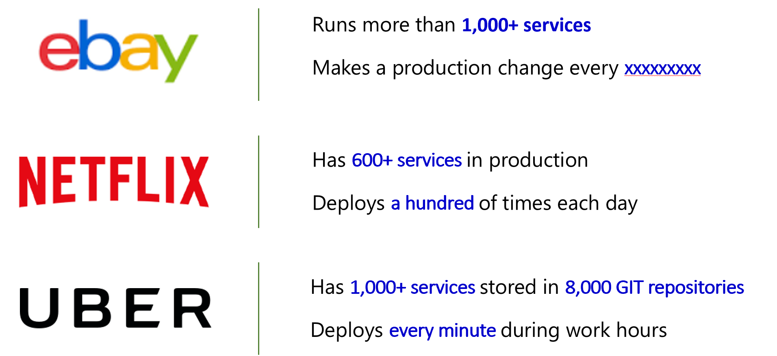

**Figure 1-1**. Companies embracing cloud native agility

As you can see, eBay, Netflix and Uber expose systems that consist of hundreds of self-contained isolated microservices. Impressively, they can rapidly respond to market conditions by instantaneously updating specific functionality without having to fully deploy the entire system.

At its core, this agility derives from the architecture and infrastructure upon which the system is constructed, which include the following six capabilities, as shown below in Figure 1-2.

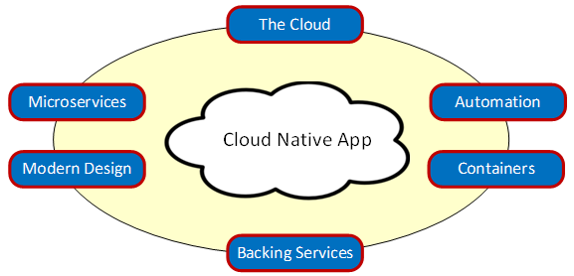

**Figure 1-2**. Capabilities of cloud native apps

As each of these capabilities are key to a cloud native system, let’s take some time to visit each.

## Thinking in terms of the cloud…

Cloud native systems are *all about the cloud*: Born, developed and deployed in the cloud – specifically designed to thrive in a cloud environment. Development teams design these systems from the ground-up in a highly-dynamic, virtualized environment. They are built to exploit the platform and infrastructure capabilities of the cloud delivery model: Elasticity, resilience, redundancy, orchestration and on-demand features.

The focus moves to “*how”* the application is created and deployed, not so much “*where*.” Cloud native apps make extensive use of PaaS (Platform as a Service) infrastructure and managed services.

Figure 1-3, shown below depicts the range of the full-featured compute services available in Azure. As you move from the top of the hierarchy to the bottom, your focus shifts away infrastructure plumbing to business functionality. Cloud native systems typically reside at the lower levels of the stack leveraging containers, PaaS and Serverless environments.

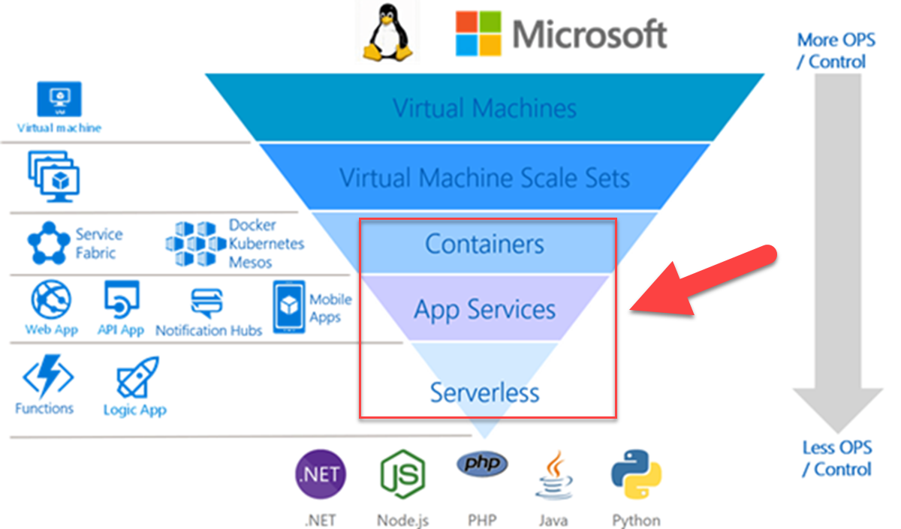

**Figure 1-3**. Azure compute stack

Cloud native systems typically view the underlying infrastructure as “*disposable*” - provisioned in minutes and resized, scaled, moved or destroyed whenever necessary – all done through automation.

Consider the agreement of *Cattle vs. Pets.* In a traditional data center, servers are treated as *Pets*. They are typically a physical machine, given a meaningful name and cared for. You scale by adding more resources to the same machine (scaling up). If one becomes sick, it is nursed back to health. When one becomes unavailable, everyone notices.

On the other hand, the *Cattle* service model is quite different. Provisioned as a virtual machine or container, each virtual instance is identical and assigned an identifier such as Service-01, Service-02, etc. When one has a problem, you automatically replace it with another, i.e., Service-03. When scaling, you “scale out” by creating more of them. When one become unavailable, nobody notices.

The cattle model moves toward *immutable infrastructure* in which servers are not repaired or modified. If a server fails or requires updating it is destroyed and a new one provisioned – all done via automation.

Cloud native systems assume the infrastructure is dynamic, i.e., the Cattle model, and continue to run as the infrastructure moves, resizes and upgrades. They are able to scale up, down, in or out and move across servers regardless of the machines upon which they are running.

As stated earlier, many companies view the cloud and associated cloud native systems as a competitive advantage – move fast, pivot quickly, expand immediately and fail fast - while reducing operational and hardware costs.

The Azure cloud platform provides a highly elastic infrastructure with a rich set of services, including automatic scaling, self-healing and monitoring capabilities.

## Thinking in terms of microservices…

Much has been written about microservices, an increasingly popular architectural style for building modern services. An excellent and comprehensive guide is [.NET Microservices: Architecture for Containerized .NET Applications](https://docs.microsoft.com/dotnet/standard/microservices-architecture/), free from Microsoft.

Cloud native systems embrace microservices. Moving beyond the popular monolithic design, in which an entire application executes in a single-tiered environment, a microservices architecture is an approach to building a system as a distributed set of small, independent services – that interact through a shared fabric.

* Each microservice runs in its own process and communicates with others using standard communication protocols such as HTTP/HTTPS, WebSockets, or [AMQP](https://en.wikipedia.org/wiki/Advanced_Message_Queuing_Protocol)
* Each microservice implements a specific business capability within a larger domain context boundary
* Each service is developed autonomously and can be deployed independently
* Each service is self-contained: Owns its related domain data model and logic, enabling it to embrace the data storage technology (SQL, NoSQL) and programming platform of choice

### Why microservices?

Why a microservices architecture? In short, it provides agility. You construct a system of consisting of independently deployable services each of which having a granular and autonomous lifecycle. Each can evolve independently and deploy frequently - whenever required. You don’t wait for a quarterly release of the entire system. Releasing individual services enables agile changes and rapid iteration. You change small areas of a large complex application with less risk of disrupting the entire system.

An additional benefit is that a microservice can scale in and out independently. Instead of scaling the entire application as a single unit, you scale out specific microservices that require more processing power or network bandwidth at some specific moment. Such fine-grained scalability provides control and equates to cost savings because you need less hardware.

Figure 1-4, shown below, contrasts a monolithic and microservices approach.

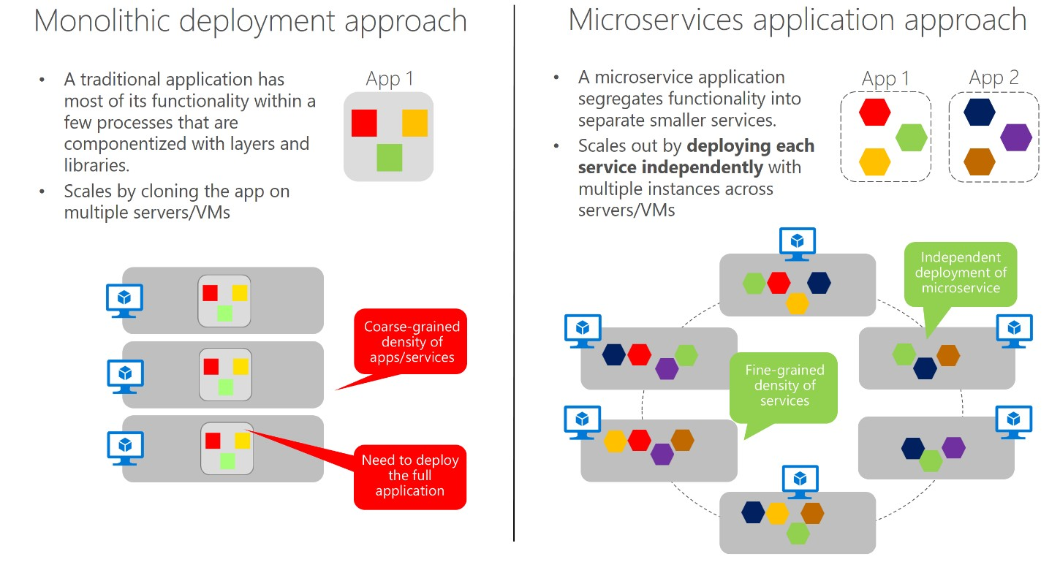

**Figure 1-4.** Monolithic deployment versus microservices

Cloud native systems are built as a set of independent microservices and microservices significantly increase agility and the overall maintainability of applications.

## Thinking in terms of containers…

The use of microservices go hand-in-hand with containerization, as approach to software deployment in which a service, its dependencies, configuration ([typically, a key-value pair file](https://docs.docker.com/compose/compose-file/)) and runtime are packaged together as a single unit, called an [image](https://docs.docker.com/glossary/?term=image). Images are stored in a container registry, which can reside on your laptop, your data center or the public cloud. When needed, you can instantly transform the image into a running instance (i.e., container) and deploy it on any computer (development laptop, QA, Staging, Production, etc.) that has the Docker software engine.

### Benefits of containers

Containers provide portability and guarantee consistency across environments. By encapsulating everything into a single package, you *isolate* the application and its dependencies from the underlying environment. If the container runs on a development laptop, it will run in test and in production as well. In this manner, containerized workloads dramatically reduce the expense (and risk) of pre-configuring an environment and troubleshooting environment-specific issues.

Each [container](https://docs.docker.com/glossary/?term=container) runs on top of a container host (typically, [Docker](https://opensource.com/resources/what-docker)) that in turn runs on top of an OS (either Linux or Windows). As containers share a single operating system instance, they have a significantly smaller footprint than virtual machine (VM) images. This increases the number of services that can run on a given VM, helping reduce overall cost.

Each microservice typically runs in its own container, as shown below in Figure 1-5. In this example, we are running a Docker host on a single virtual machine, with four microservices running upon it.

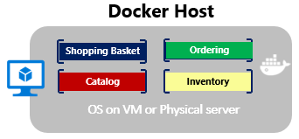

**Figure 1-5**. Multiple containers running on a container host

Even though each container shares the OS on the underlying VM, each is isolated from one another. Both Linux and Windows container provide a high-degree of process isolation across running containers. However, Windows containers offer an even higher degree of isolation using its [Hype-V Container](https://docs.microsoft.com/virtualization/windowscontainers/manage-containers/hyperv-container) offering.

Another direct benefit of containers is scalability. You can rapidly scale-out with additional containers for short-term tasks and quickly scale-in when no longer needed. From an application point of view, running an image (creating a container) is like instantiating a process such as a service or web app. For availability, however, when running multiple container instances of the same image, you typically strive for running each container on a different host VM inside of a cluster. This way, if one VM were to be unavailable, you could route requests to another VM that was operational. We’ll cover availability later in this book.

### They’re not just for deployment

Many organizations already deploy their releases inside of containers. When code is complete, developers package it and its environment into an image which is stored and *pushed* into next environment. But what about integrating containers into the *overall development process*?

Some development teams are exploring writing and running code locally (on their development machines) all inside Docker containers. Each service is defined with a dockerfile specifying the base OS along and configuration steps. They can then “pull” images to fulfill various service dependencies without having to manage the entire set of source code on their machines. Building a docker compose deployment manifest, they define how each service inter-operates. As they complete their local development, they “push” their application code plus the Docker configuration files to the code repository of their choice (i.e. Git repos) for others to consume.

Looking forward, the Azure cloud platform is previewing a service entitled [Azure Dev Spaces](https://docs.microsoft.com/azure/dev-spaces/), shown below, in Figure 1-6.

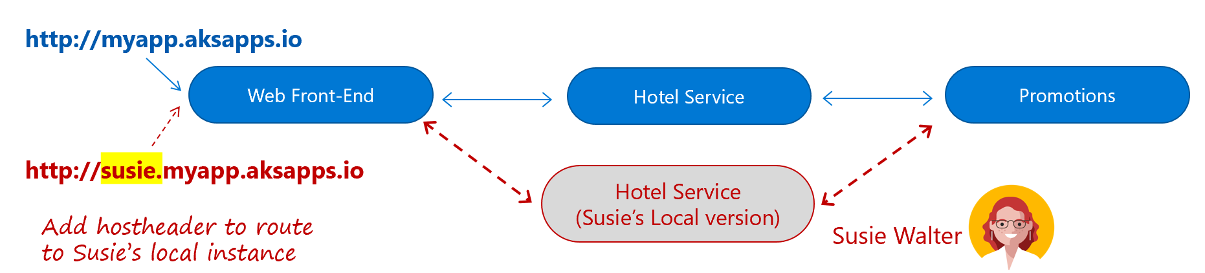

**Figure 1-6**. Azure Dev Spaces

Here Developer Susie Walker and her team share a development instance of their entire system in an [Azure Kubernetes Service](https://azure.microsoft.com/services/kubernetes-service/) cluster (shown above in blue). Leveraging Azure Dev Spaces, Susie creates a personal space on her development machine with a local copy of her Hotel Service. With that, she can work locally with the hotel service and seamlessly run against the entire system residing on the cluster without having to mock or replicate dependencies. Until Susie deploys the Hotel Service to the cluster, other team members will run against the older version in the cluster. We discuss this upcoming product, Azure Dev Spaces, in the container chapter.

Containers offer immense benefits in terms of packaging, deploying and managing cloud native applications.

## Thinking in terms of cloud-hosted backing services…

Beyond cloud compute infrastructure, cloud native systems depend upon many different ancillary resources to operate: Data stores, message brokers, monitoring and identity services - to name just a few.

A backing service is any external resource on which an application relies for functionality. While they can be local or cloud-based, cloud native apps by definition always favor cloud-based services.

Figure 1-7, shown below, depicts common backing services found in cloud native systems.

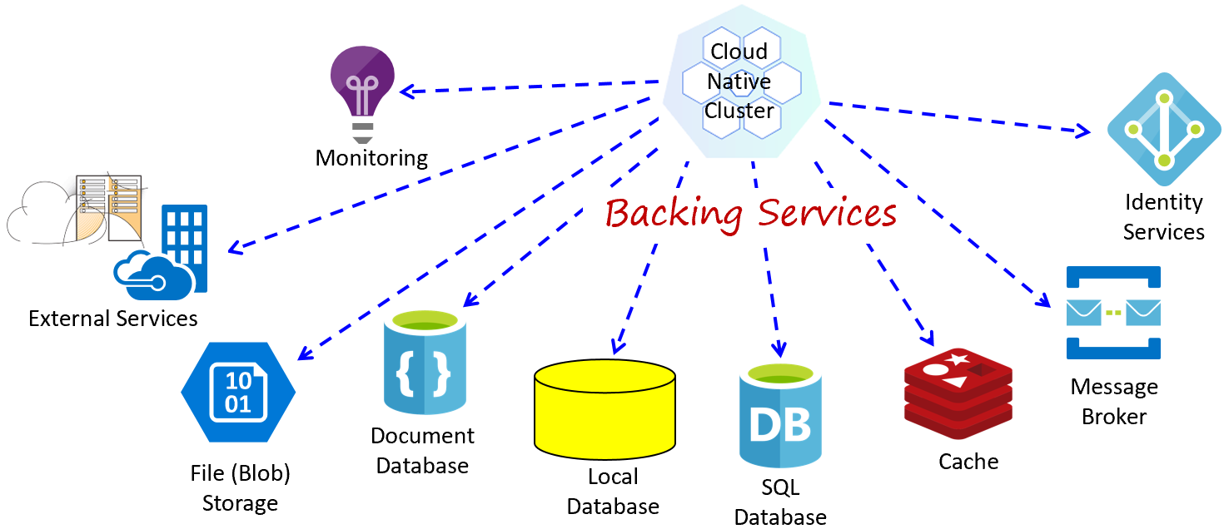

**Figure 1-7**. Cloud native backing services

Your operations team could accept the responsibility for owning these ancillary services. It wouldn’t be hard to provision a VM and install, say, an instance of the open source RabbitMQ message broker. While certainly feasible, does that make sense - especially from a business perspective?

Chances are you’re not in the message broker, database or identity server business. So, then, why incur the cost and complexity of owning these items when someone else can do it better and for less? No matter how skilled you may be, it is unlikely that you will be able to match the reliability and performance, say, of the fully-managed [Azure SQL Database](https://azure.microsoft.com/services/sql-database/) service in Azure. That Microsoft team that owns it lives and breathes databases, 24/7 - that’s their business. While you, on the other hand, sell consumer items, medical devices, etc. Do what you’re good at and let others help you with the rest. Focus your effort on building outstanding customer functionality, not becoming experts in 3rd party/open-source backing services.

All that said, cloud native systems are best built leveraging managed backing services from a cloud provider. Cloud providers manage these resources at scale and bear the responsibility for security, scalability and maintenance. You can also count on comprehensive monitoring, configurable redundancy and availability – built into the service. They are battle-tested, performant and ready to go!

As they are built on top of existing cloud technologies, these services are infinitely more agile and flexible than traditional offerings. The inherent benefits of scalability and resiliency make them an attractive proposition for developers. And like everything in the cloud, they are constantly tuned and optimized for speed, security and performance.

Not only do cloud-hosted backing services reduce cost, complexity and risk, but these services are fully-supported by the cloud provider. If you have an issue, open a support ticket and the provider fixes it. It makes little sense for you distract your focus scouring the web for a blog post that mentions error code that you’re seeing from your open-source service.

Figure 1-8, show below, depicts many of the managed services available on the Azure platform.

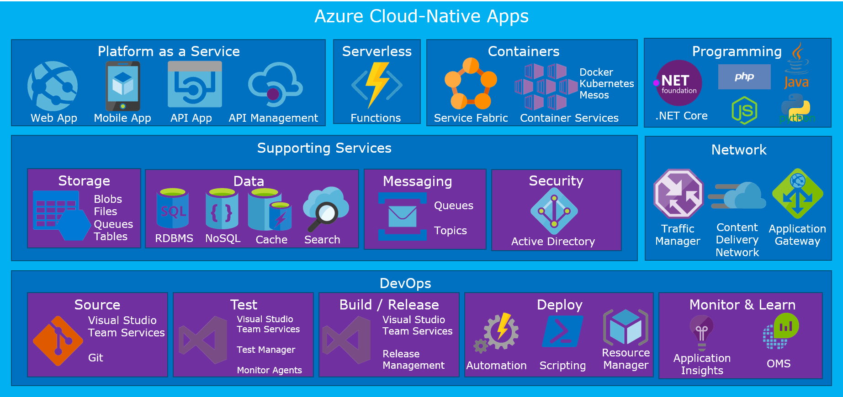

**Figure 1-8**. Managed services in Azure

You may understandably have a concern with vendor lock-in. However, you must weigh this concern against that of bearing the full responsibility for hosting your own backing services. A smart approach might be to wrap proven cloud-managed services inside of an abstraction shim, using a strategy pattern and externalized configuration, giving you the ability to register and unregister the backing service dynamically without a full redeployment of the system.

Throughout this book, we will explore many of cloud-managed backing services by mapping the eShop for Containers reference architecture application.

## Thinking in terms of modern system design…

How would you design a cloud native app? What would your architecture look like? To what principles, patterns and (so-called) best practices would you adhere? We’ve talked about several key design patterns prevalent in cloud native systems, including cloud infrastructure, microservices, containers and cloud-managed backing services. But, what about the application design process itself?

We’ll start with a widely accepted foundation for service design and then highlight some topics of critical importance.

### The 12-Factor Foundation

A widely-accepted methodology often cited for constructing cloud native systems is the [Twelve-Factor Application](https://12factor.net/) Design Principles. Presented as a manifesto, it describes rules, guidelines and best practices for building applications that are decoupled from their underlying platform, embrace continuous deployment and leverage managed backing services. Although created in 2011, many practitioners consider these principles (or, some proximity to them) to be a solid foundation for building modern cloud native apps.

In Figure 1-9, shown below, we fly you over the 12-Factor methodology at 5,000 feet – low enough to appreciate the principles, but high enough as to not get caught in the weeds.

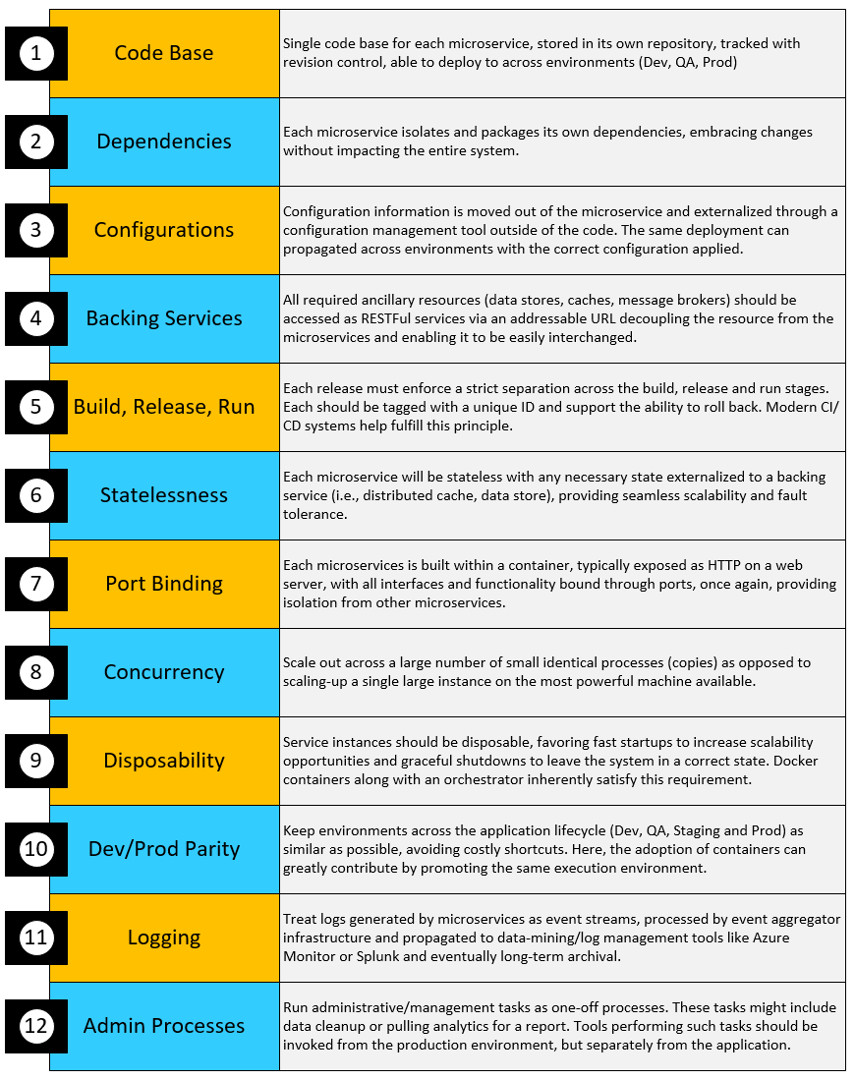

**Figure 1-9.** The 12-Factor app

### Critical Design Considerations

Beyond the guidance provided in the 12-factor manifesto, there are several critical design principles you must consider.

*Communication*

How will front-end client applications communicate with your backed-end core services? Will you allow direct communication? Or, might you abstract the backend services with a façade which provides more flexibility, control and security?

Moreover, how will backend core services communicate with each other? Will you allow direct HTTP calls which lead to coupling and can decrease performance and agility? Or, might you consider decoupled message using message brokers with queues and topics?

*Resiliency*

As a microservices architectural approach move you from in-process to network communication, what exactly will you do when Service B is not responding to a call from Service A? Or, how will you handle a scenario when a service is temporary down but calls from other services trying to reach it back-up and degrade overall network performance?

*Distributed Data*

By design, each microservice owns and encapsulates its own data, exposing operations via its public interface. In that model, how do you query data across multiple services? Even more importantly, how would affect a transaction across multiple services?

*Identity*

How will your service identify who is accessing it and what permissions they should have?

We introduce these critical considerations topics here in detail throughout the chapters in this book.

## Thinking in terms of automation

“Cloud native thinking” goes beyond microservices, containers and modern system design. DevOps engagement is crucial. Large distributed systems require rapid provisioning, decentralized deployment and close adherence to widely-accepted DevOps processes. A mandatory requirement for cloud native is *automation* – automation of the underlying infrastructure, the code and the environment.

Fortunately, the Azure platform, along with wide variety of tooling from Microsoft, is rich with automation as we will describe throughout this book.

### Automating Infrastructure

Cloud native apps play well to the practice of [Infrastructure as Code (IaC)](https://docs.microsoft.com/azure/devops/learn/what-is-infrastructure-as-code).

With IaC, you use tooling, such as [Azure Resource Manager](https://azure.microsoft.com/documentation/articles/resource-group-overview/) or [Terraform](https://www.terraform.io/), to declaratively specify the exact infrastructure that you desire. The script itself is flexible as it parameterizes the resource names, locations, capacities and secrets. That script becomes an artifact of your project and is versioned and checked into source control. At any time, you can run the IaC script to provision your desired infrastructure. Moving forward, you can modify and rerun the script to update your environment. As the script is parameterized, you can run the same script across your different system environments (i.e., Dev, Test, Staging, Production) providing an identical blueprint of resources.

We cover infrastructure automation in detail in the Cloud Native DevOps chapter of this book.

### Automating Code

Cloud native systems typically consist of numerous stand-alone, independent microservices, that can interact with each other when needed. Being self-contained, each of these services has its own independent life cycle. It would certainly be an antipattern to attempt to *manually manage* each of these services - expensive, inefficient, and error prone.

Instead, each service is best managed with its own continuous integration/continuous delivery (CI/CD) pipeline, which together can work in tandem to deploy and manage a cloud-native application.

Please hold on to your thoughts here as we cover DevOps and CI/CD later in this chapter and in a dedicated chapter of this book.

### Automating the Environment

A third critical aspect of automation is that of the environment in which the cloud native system runs.

To take full advantage of the underlying cloud infrastructure and it’s built features and services, we need a way to monitor and invoke the special features.

*Cloud-based Monitoring*

Blah

*Cloud-based Scaling*

Blah

*Cloud-based Resiliency*

Blah

*Self-Healing*

Blah

### Orchestration

If you have a handful of microservices, your DevOps might be able to manually manage the workload. They would need to pay close attention to the performance and traffic patterns, so they could manually scale accordingly. If, on the other hand, you have 10, 100 or even 1,000 services, all bets are off.

When you’re operating at scale, [container orchestration](https://blog.newrelic.com/engineering/container-orchestration-explained/), i.e., automating the deployment, management, scaling, networking, and availability of your containers – is mandatory.

Container orchestration is done with a special software program called (you guessed it) a container orchestrator. While many are available, [Kubernetes](https://kubernetes.io/) has become the de facto standard in the cloud native world. The Azure cloud features Kubernetes as a managed service, [Azure Kubernetes Service](https://azure.microsoft.com/services/kubernetes-service/), which means that you are not responsible for provisioning or maintaining the Kubernetes infrastructure – a career path in and of itself.

What exactly do containers orchestrators do? Figure 1-10, shown below, provides some insight.

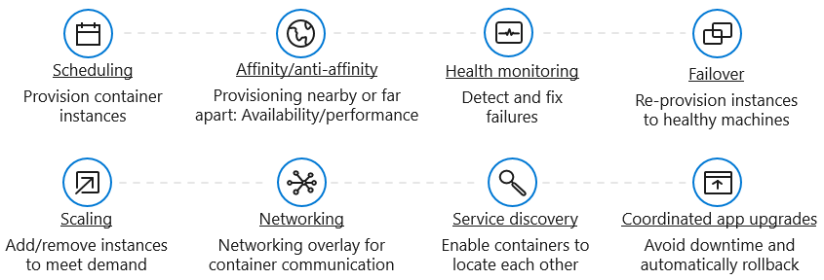

**Figure 1-10**. What container orchestrators do

We will dig deep into containers orchestrators and Azure Kubernetes Services throughout this book.

# Candidate Apps for Cloud Native

Take a close look at the apps in your portfolio. How many of them justify a cloud native architecture? All of them? Perhaps some?

Applying a cost/benefit trade-off, many wouldn’t warrant the hefty price tag required to be cloud native. A cloud native-based approach would greatly exceed the business value of the application - like driving a large 18-wheeler semi-truck to the local 7-11 store to buy milk - when your simple Honda sedan would work just fine.

What types of applications might be candidates for a cloud native approach?

* Large, strategic enterprise systems that need to align to business capabilities/features
* Systems that require a high release velocity - frequent releases with high confidence
* The ability to immediately release features without redeploying the entire system
* Applications developed by heterogenous teams with expertise in different technology stacks
* Applications with components that must scale independently

While we’d all like to maximize our developer excitement level building brand new (that is, green field) systems, often we’re charged with modernizing legacy (that is, brownfield) workloads that are critical to the business.

The free Microsoft e-book [Modernize existing .NET applications with Azure cloud and Windows Containers](https://dotnet.microsoft.com/download/thank-you/modernizing-existing-net-apps-ebook) provides a wealth of guidance for migrating on-premises workloads into cloud. Figure 1-11 shows that there isn’t a single, one-size-fits-all strategy for migrating legacy applications to the cloud.

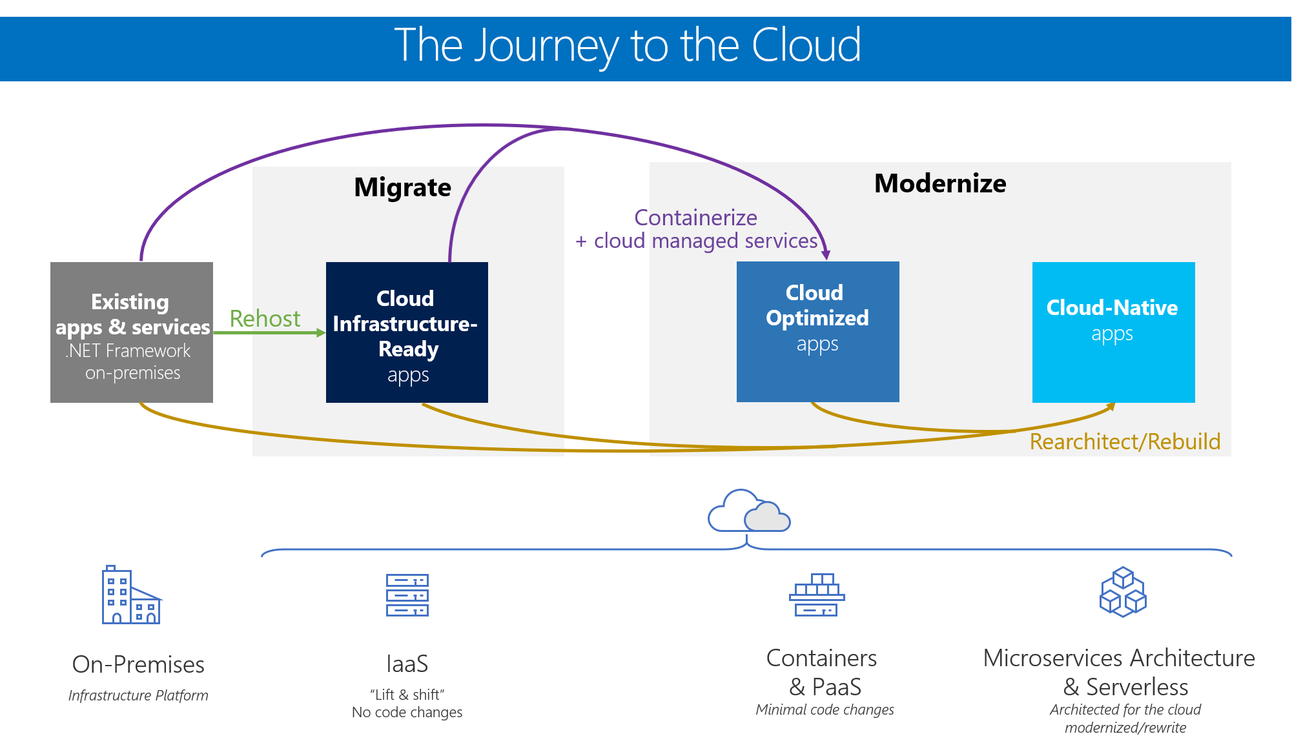

**Figure 1-11**. Strategies for migrating legacy workloads

Non-critical monolithic apps might benefit from a quick lift-and-shift ([Cloud Infrastructure-Ready](https://docs.microsoft.com/dotnet/standard/modernize-with-azure-and-containers/lift-and-shift-existing-apps-azure-iaas)) effort where an on-premises workload is re-hosted in the cloud, as-is, typically to a cloud-based VM leveraging the IaaS (Infrastructure as a Service) model. Azure includes several tools such as ([AzureMigrate](https://aka.ms/azuremigrate), [Azure SiteRecovery](https://azure.microsoft.com/services/site-recovery/), and [Azure Database Migration Service](https://azure.microsoft.com/campaigns/database-migration/)) to make such a move easier.

Business critical systems may warrant an enhanced lift-and-shift (*Cloud Optimized*) that include deployment optimizations to leverage key cloud services - without changing the core architecture of the application. You might [containerize](https://docs.microsoft.com/virtualization/windowscontainers/about/) the application to capture the code, runtime, and dependencies - without changing code - to increase deployment agility and embrace many cloud-based features.

Finally, strategic enterprise-critical applications might best benefit from a *Cloud-Native* approach, the subject of this book. This approach provides for increased long-term agility and more efficient application maintenance but comes at a cost of rearchitecting and rewriting code.

If you and your team believe that a cloud native approach might be justified, it behooves you to rationalize the decision with the business needs of your organization. What exactly is the business problem that a cloud native approach will solve? How would it align with business needs?

* Rapid releases of features?
* Release with confidence
* Improve system resiliency?
* Provide more visibility into operations?
* Blend platforms and data stores to arrive at the best tool for the job?

The right strategy for you depends on your organization’s needs and priorities, and the system that you’re targeting. In many cases, you may find it more cost effective to create a simpler monolithic application, or add coarse-grained services to an N-Tier app. In these cases, you can still make full use of cloud PaaS capabilities like the ones offered by Azure App Service.

# The Azure Cloud-Native Development Stack

Microsoft offers organizations seeking to build cloud native systems a compelling value proposition: A tightly integrated, but open, end-to-end stack for constructing and managing cloud native workloads.

Moreover, Microsoft is [making tremendous investments in open source](https://www.zdnet.com/article/why-microsoft-is-turning-into-an-open-source-company/) and cross-platform development tools to reach a wider range of developers - these tools are easy to acquire and free in many cases. It behooves CIOs to think differently about Microsoft development tools and investments in the Azure cloud as both provide comprehensive support for Linux and open-source initiatives.

We’ll examine key considerations of the stack.

## Choosing an OS

For years, Microsoft and Linux vendors fought tooth-and-nail for control of the enterprise *server* market. Sides were formed, battle lines drawn. In many ways, it resembled a religious battle. Linux symbolizing freedom and Microsoft with a well understood, comprehensive platform.

### The operating system becomes transparent

Interestingly, with the growth of modern development platforms and container orchestrators, the operating system has become more transparent.

Why is that?

To start, most modern development platforms natively support cross-platform portability. Developers write an application in a preferred language, deploy it to the operating system of choice and the platform runtime engine automatically handles the environment-specific dependencies. Later, that same application package can be redeployed to a different operating system and ran just the same with the appropriate runtime engine and configuration changes.

Even further clouding operating system concerns is the explosive growth of containers. Containers allow applications to run independently of the operating system. “If you take a look at the way that containers have evolved, it’s basically an evolution of the OS model we’ve had to this point,” says Microsoft Azure CTO [Mark Russinovich](https://www.google.com/search?q=If+you+take+a+look+at+the+way+that+containers+have+evolved%2C+it%E2%80%99s+basically+an+evolution+of+the+OS+model+we%E2%80%99ve+had+to+this+point&rlz=1C1GCEU_enFR819US820&oq=If+you+take+a+look+at+the+way+that+containers+have+evolved%2C+it%E2%80%99s+basically+an+evolution+of+the+OS+model+we%E2%80%99ve+had+to+this+point&aqs=chrome..69i57.915j0j9&sourceid=chrome&ie=UTF-8). The operating system still exists, but its role has become further abstracted. Instead, the container orchestrator, which will we cover in detail later in the book, has become the *de-facto operating system* of choice. Developers and cloud administrators are less concerned about the operating system on which the container runs provided that the services exposed by container are reliable and can be quickly deployed.

### Azure, LCOW and Windows Server 2019 Platform

Finally, cloud providers like Microsoft openly embrace both Windows and Linux workloads. For Azure, it’s Linux, not Windows Server, that has become the most popular operating system. Furthermore, many critical Azure services run on Linux. Consider, for example, Redis Cache, Sql Server on Linux, NoSql, or the variety of Linux VMs supporting at least eight Linux distributions that are available and have full support in Azure.

Even [Windows Server 2019](https://cloudblogs.microsoft.com/windowsserver/2018/03/20/introducing-windows-server-2019-now-available-in-preview/) itself features a subsystem for Linux that enables Windows and Linux environments to run simultaneously. Another new Windows feature, [Linux Containers on Windows](https://blogs.msdn.microsoft.com/premier_developer/2018/04/20/running-docker-windows-and-linux-containers-simultaneously/) ([LCOW](https://blogs.msdn.microsoft.com/premier_developer/2018/04/20/running-docker-windows-and-linux-containers-simultaneously/)) makes it possible to run Linux *and* Windows containers simultaneously - all from a single Docker engine. LCOW not only simplifies day-to-day management, but also consolidates infrastructure costs as there is no longer the need for dedicated hosts for each operating system.

As cloud native architecture and container orchestrators evolve, expect to see less and less importance placed on the choice of the operating system.

## .NET Core Platform

The Microsoft’s .NET development platform originated in 2002 and is among the most loved technologies, according to a [Stack Overflow survey](http://dontcodetired.com/blog/post/Stack-Overflow-Developer-Survey-2018-Overview-for-NET-Developers).

Fast-forward to 2019 and the [Microsoft .NET Core platform](https://dotnet.microsoft.com/learn/dotnet/what-is-dotnet), a modernized rewrite of .NET. A free, open source and cross-platform development stack for building applications. It is a feature-rich platform that can be used to build services, devices and IoT applications, among others. It is maintained by Microsoft and the .NET community on GitHub. Cross-platform, applications built with .NET Core can run on Windows, macOS, and several flavors of Linux.

.NET Core supports multiple programming languages, editors, and libraries. It fully supports the C# programming language, which is a widely used and mature language that is frequently updated and continually modernized.

.NET core is highly performant and has scored very well in comparison to Node.js and other completing platforms see the [TechEmpower](https://www.techempower.com/benchmarks/#section=data-r17&hw=ph&test=plaintext) benchmark.

.NET Core plays especially well with microservice-based applications, including built-in features, open-source initiatives that directly support microservice development and direct support for Docker containers. All that said, the .NET Core stack with C# is an excellent choice for building cloud native applications in the Azure cloud.

## Tooling: IDE vs. Editor

When building cloud native applications with the .NET Core platform, you have several development tools from which to choose.

### Visual Studio

At the top of the list is [Visual Studio](https://visualstudio.microsoft.com/), a full-featured IDE ([Integrated Development Environment](https://learn.g2crowd.com/ide)) for Windows including compilers, debuggers, source control, and profiling tools. It’s a complete solution used primarily for .NET development.

It includes built-in support of Docker container-based development and a rich set of web development tooling providing everything you need to develop, manage, and deploy complex microservice applications. In the latest version of Visual Studio, you can develop cross-platform applications without leaving the IDE.

Rated as one of the [world’s leading IDEs](https://www.g2crowd.com/categories/integrated-development-environment-ide), Visual Studio is available in a free fully functional [Community Edition](https://visualstudio.microsoft.com/vs/community/), with more feature-rich version available for Corporate use.

### Visual Studio Code

More recently, Microsoft has released [Visual Studio Code](https://code.visualstudio.com/docs/editor/whyvscode), a free, lightweight, cross-platform editor that contains built-in Git integration and can be used to view, edit, run, and debug source code for applications. Being an editor, it is primarily oriented around files, not projects and has limited scaffolding support.

It supports macOS, Linux, and Windows, featuring support for a variety of programming languages through its extensions model.

One of the key attractions of Visual Studio Code is the rich, fast-growing ecosystem of pluggable extensions. Easily installable from the [Extension Marketplace](https://marketplace.visualstudio.com/), these plug-ins let you customize your editing experience and add programming languages, debuggers, and tools to support a wide variety of development workflows.

Both Visual Studio and Visual Studio Code have tight integration with the Azure platform including productivity tooling and libraries that make it easy to discover and interact with cloud services that power your cloud native applications.

### Other Open Source Editors

But it doesn’t stop there. Not only does .NET Core embrace cross-platform support, but it can be written across cross-platform. Figure 1-12 presents open-source development tools that can be used to construct .NET Core cloud native applications across multiple environments.

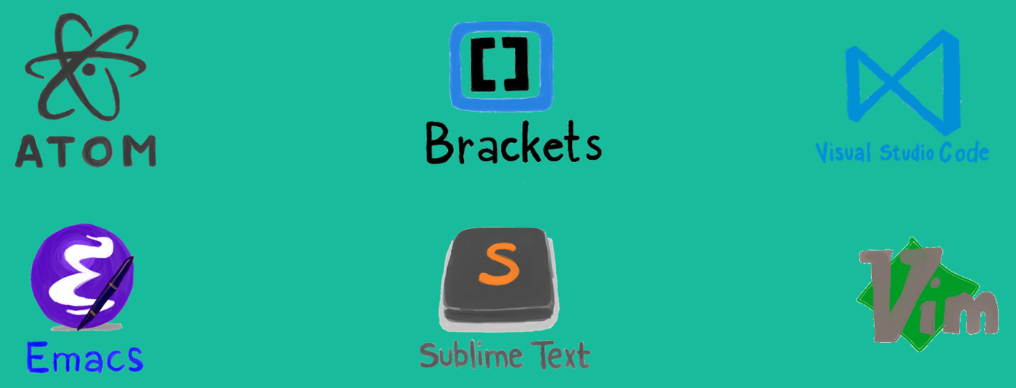

**Figure 1-12**. Cross-platform editors for .NET Core

## Source control in GitHub

*Factor #1* from the [Twelve-Factor Application](https://12factor.net/) guidelines, detailed above, calls for *storing your code in a repository tracked by revision control*. Such a repository can provide many services. To start, it can track changes to software development projects. With it, developers can simultaneously collaborate on a shared codebase and separate larger tasks into separate branches, merging changes when complete. At any time, developers can view the history of changes and revert to a previous version, if necessary.

Fortunately, development teams have many available options when selecting a repository.

One of them is [GitHub](https://github.com/). Founded in 2009, GitHub is an extremely popular web-based repository for hosting projects, documentation, and code. Apple, Amazon, Google, and many other large tech companies use GitHub. Using the open-source, distributed version control system named [Git](https://en.wikipedia.org/wiki/Git) as its foundation, GitHub adds its own features, including defect tracking, feature and pull requests, tasks management and wikis for each code base.

As of June 2018, GitHub had over 28 million users, making it the largest host of source code in the world. In October of 2018, Microsoft purchased GitHub. Microsoft has pledged that GitHub will remain an [open platform](https://techcrunch.com/2018/06/04/microsoft-promises-to-keep-github-independent-and-open/) that any developer can plug into and extend. It continues to operate as an independent company.

GitHub offers plans for enterprise, team, professional and free accounts and is an excellent location on which to store your source code.

## CI/CD in Azure DevOps

*Factor #5* from the [Twelve-Factor Application](https://12factor.net/) guidelines calls for *strict separation of the build, release, and run stages*. Modern, automated CI/CD pipelines help fulfill this principle. They help to ensure consistent and quality code that’s readily available to users.

[Continuous Integration/Continuous Delivery](https://www.infoworld.com/article/3271126/what-is-cicd-continuous-integration-and-continuous-delivery-explained.html) (CI/CD) is a set of operating principles that enable application development teams to deliver code changes frequently and reliably. Applying these practices, organizations have radically evolved how they ship software. Many have moved scheduled quarterly releases to immediate on-demand updates.

### Continuous Integration

[Continuous Integration (CI)](https://martinfowler.com/articles/continuousIntegration.html) works to establish a consistent, simplified, and automated *pipeline* approach to building, testing, and packaging applications. The process is typically invoked from a commit to your source code repository and composed of a series of steps to verify the commit, as shown in Figure 1-13.



**Figure 1-13**. Steps in the CI Pipeline

The beauty of the pipeline approach is that additional steps and checks can be inserted to map the process to the exact deployment requirements for your organization.

The goal is to catch problems early in the development cycle when they’re less expensive to fix. The longer the duration between integrations, the more expensive problems become to resolve. The CI process outputs project artifact items that are used by the CD pipeline to drive automatic deployments. With consistency in the integration process, teams can commit code changes more frequently, which leads to better collaboration and software quality.

### Continuous Deployment

[Continuous Delivery(CD)](https://martinfowler.com/bliki/ContinuousDelivery.html), closely related to CI, picks up where CI ends. It automatically picks up the package built by CI process and deploys it to a specified environment, such as QA, Staging, or Production, as shown in Figure 1-14.

It can invoke additional steps such as integration and performance tests.



**Figure 1-14**. Steps in the CD Pipeline

The goal is an automated, predictable deployment that can be performed on demand.

### Azure Pipelines

The Azure cloud includes a new CI/CD service entitled [Azure Pipelines](https://azure.microsoft.com/services/devops/pipelines/), which is part of the [Azure DevOps](https://azure.microsoft.com/services/devops/) offering, as shown in Figure 1-15.

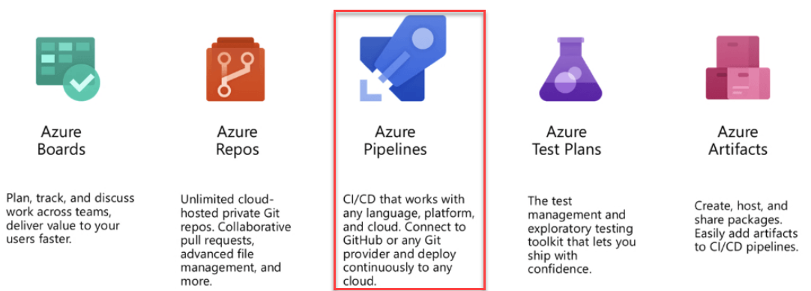

**Figure 1-15**. Azure Pipelines in DevOps

Azure DevOps works with most Git providers, including GitHub, and can generate deployment pipelines for Linux, macOS, and Windows. It works with just about any language or project type, including .NET Languages, such as C#, F#, Visual Basic, along with Java, JavaScript, Python, .NET, PHP, Go, XCode, and C++.

To use Azure Pipelines, an organization creates an account (called an Organization) in [Azure DevOps](https://azure.microsoft.com/services/devops/pipelines/) service and stores its source code in a version control system. Interestingly, if your project is stored in a public repository, such as GitHub, Azure Pipelines is free to use. For private projects, there is a charge.

Azure Pipelines combines continuous integration (CI) and continuous delivery (CD) to consistently test and build your code and ship it to any target.

## Summary

In this chapter, we flew over cloud native computing at 5,000 feet, providing a definition along with the key characteristics of a cloud native application. We looked at the type of applications that might justify this type of investment and effort. Lastly, we looked cloud native development stack available in the Azure Cloud <https://deloitte.wsj.com/cio/2018/08/27/3-reasons-to-go-cloud-native/> working toward a [cloud-native](https://deloitte.wsj.com/cio/2016/12/12/making-the-leap-to-a-cloud-native-world/) mindset reorganizing people and processes and reworking applications with the cloud in mind organizations can maximize the benefits of their cloud efforts.

### References

* [Lift and Shift with Containers Book](https://aka.ms/liftandshiftwithcontainersebook)

Scaling cloud native applications

One of the most-often touted advantages of moving to a cloud hosting environment is scalability. Scalability, or the ability for an application to accept additional user load without unduly degrading performance for each user, is most often achieved by breaking up applications into small pieces that can each be given whatever resources they require. Another approach is to simply add more resources to the servers hosting the application. While simple and effective, this last approach usually hits its limits very quickly and is more difficult to apply dynamically in response to changing demands.

## The simple solution: scaling up

The process of upgrading existing servers to give them more resources (CPU, memory, disk I/O speed, network I/O speed) is known as *scaling up*. In cloud native applications, scaling up doesn’t typically refer to purchasing and installing actual hardware on physical machines so much as choosing a more capable plan from a list of options available. Figure 2-1 shows several options available for Azure App Service Plans.

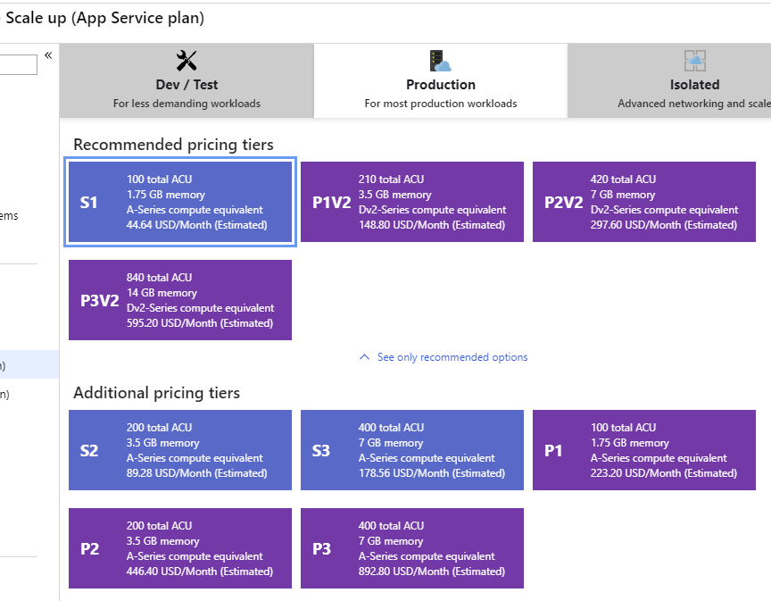

**Figure 2-1**. App Service Plans

Note that even among these plans, the actual hardware involved is abstracted. Each plan specifies a number of Azure Compute Units (ACU) that are dedicated to the plan, not specific hardware CPUs or cores that will be made available. Scaling up can quickly improve performance of an application, and can often be sufficient to respond to a small surge in traffic, but once the maximum plan is in place, scaling up is no longer an option. From there, you must look to scaling *out*.

## Scaling out App Services

Azure App Service plans can be configured to *scale out*, either manually when specified by an administrator or automatically using a feature called *autoscale*. Scaling out refers to increasing the number of (identical) instances used to support an application, such that incoming traffic is spread among the instances. Theoretically, there is no limit to the number of instances that can be added in support of a particular application. Figure 2-2 shows how to manually specify the number of instances that will support a given App Service plan.

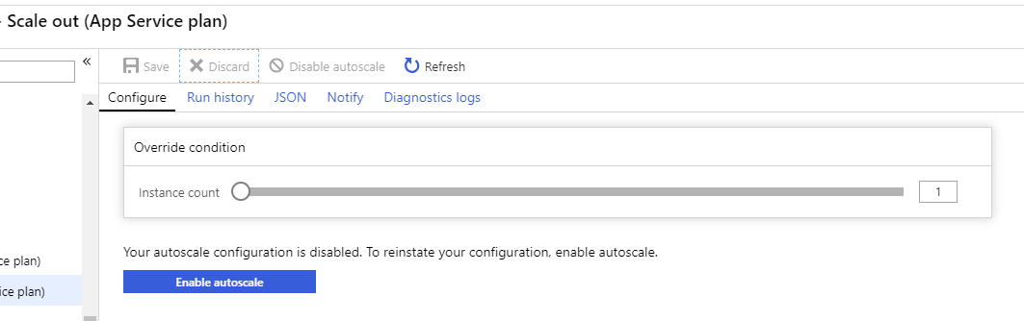

**Figure 2-2**. Scaling out an App Service plan.

Autoscale is an Azure feature that can be enabled for App Services and other plans. It allows plan administrators to configure rules that dictate when additional instances should be added to or removed from the plan. Figure 2-3 shows an example set of rules that add an additional instance whenever the average CPU of all current instances exceeds 70%. A separate rule removes an instance whenever the average CPU of all current instances drops below 40%. The plan also supports upper and lower limits to prevent the pool from climbing out of control or dropping to zero, and by default there’s a 5-minute delay between alterations so the plan isn’t constantly adding and then immediately removing instances. Essentially, you can use these rules to act as a kind of thermostat for your application, where instead of regulating temperature with heating or cooling, you try to maintain a constant level of load across your app nodes. Autoscale adds and removes nodes as necessary to maintain this level.

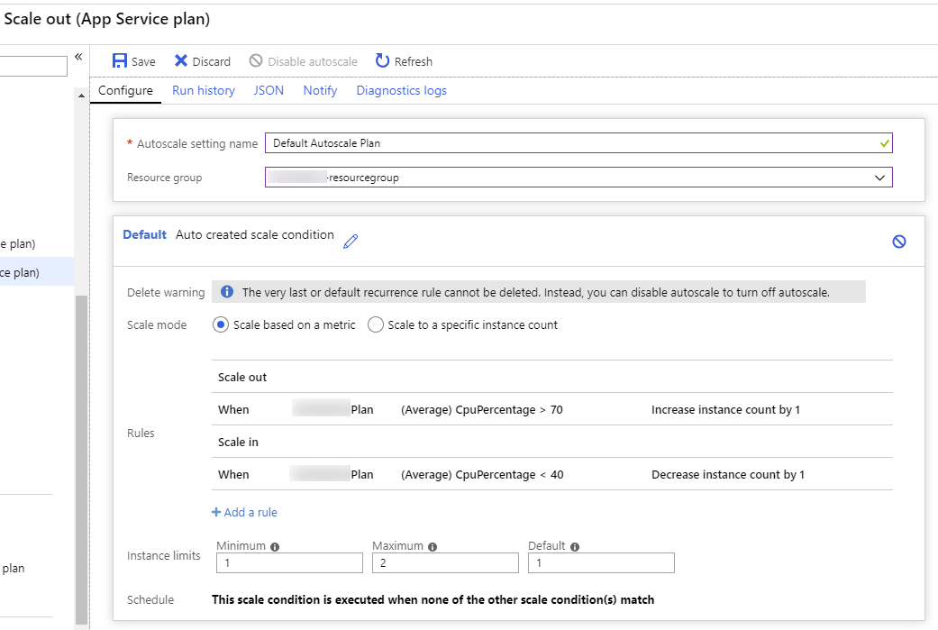

**Figure 2-3**. Configuring autoscale for an App Service plan.

Although Azure App Service plans work for a wide variety of apps, many complex business apps benefit from leveraging containers that can be built and tested locally and then deployed to the cloud. Simple container-based apps can still leverage App Service plans using Web App for Containers, but once multiple containers are needed to work in concert with one another, it’s likely time to look to more powerful deployment options.

## References

* [Web App for Containers](https://azure.microsoft.com/services/app-service/containers/)

# Leveraging containers and orchestrators

Docker is the most popular container management and imaging platform and allows you to quickly work with containers on Linux and Windows. Containers provide separate but reproducible application environments that run the same way on any system. This makes them perfect for hosting and scaling applications and app components in cloud native applications. Containers are isolated from one another, so two containers on the same host hardware can have completely different versions of software and even operating system installed, without the dependencies causing conflicts.

What’s more, containers are completely defined by simple files that can be checked into source control. Unlike full servers, even virtual machines, which frequently require manual work to apply updates or install additional services, container infrastructure can easily be version-controlled. Thus, apps built to run in containers can be developed, tested, and deployed using automated tools as part of a build pipeline.

Containers are immutable. Once you have the definition of a container, you can recreate that container and it will run exactly the same way. This immutability lends itself to component-based design. If some parts of an application don’t change as often as others, why redeploy the entire app when you can just deploy the parts that change most frequently? A typical monolithic application is deployed as a single unit, despite typically being composed of several modules or assemblies, as shown in Figure 2-4.

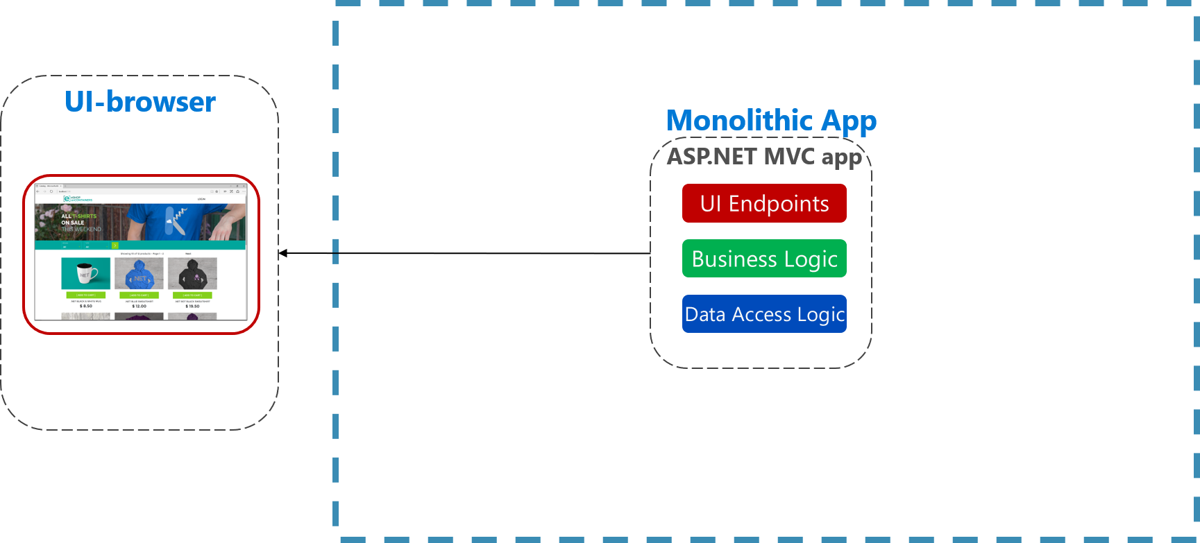

**Figure 2-4**. Monolithic architecture.

Multi-tier architectures are nothing new, but with container-based applications it may make sense at a minimum to separate different tiers into separate containers, or to split an app into different containers based on features or cross-cutting concerns. Figure 2-5 shows how a monolithic app can take advantage of containers and microservices by delegating certain features or functionality. The remaining functionality in the app itself has also been containerized.

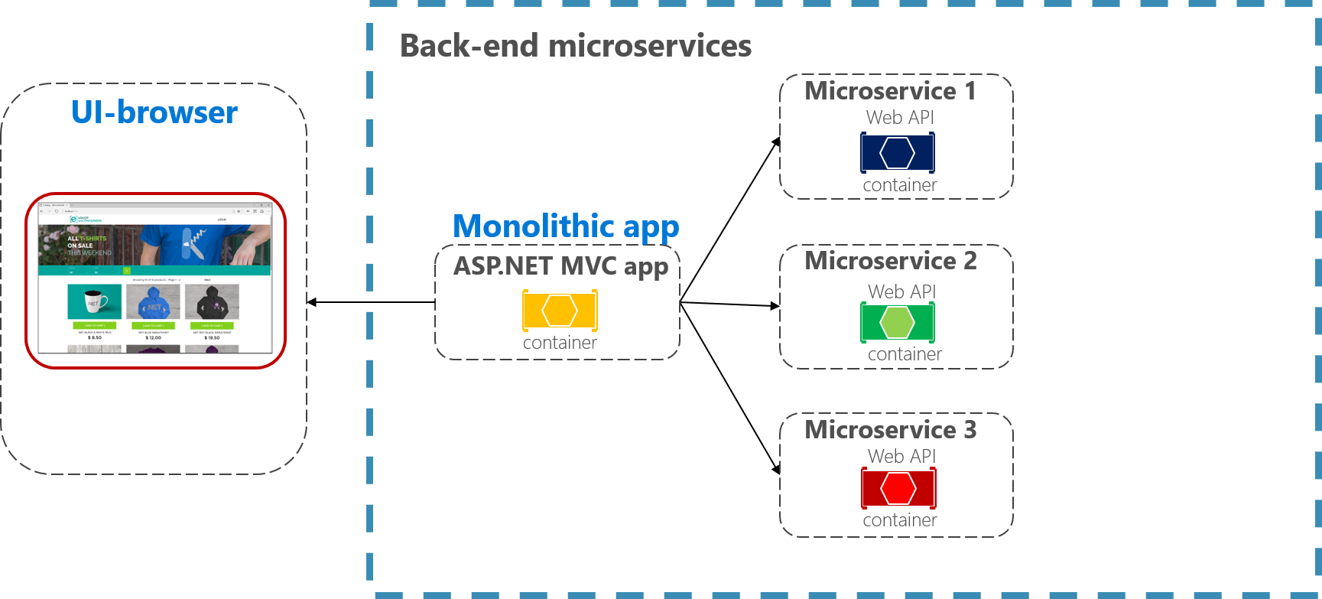

**Figure 2-5**. Breaking up a monolithic app to use microservices in the backend.

Once you start to have multiple containers that need to work together, it can be worthwhile to organize them at a higher level. By design containers only know about themselves. Organizing large numbers of containers and their shared dependencies, such as network configuration, is where orchestration tools come in to save the day! Kubernetes is a container orchestration platform designed to automate deployment, scaling, and management of containerized applications. It creates an abstraction layer on top of groups of containers, which it organized into what it calls *pods*. Pods run on worker machines referred to as *nodes*. The whole organized group is referred to as a *cluster*. Figure 2-6 shows the different components of a Kubernetes cluster.

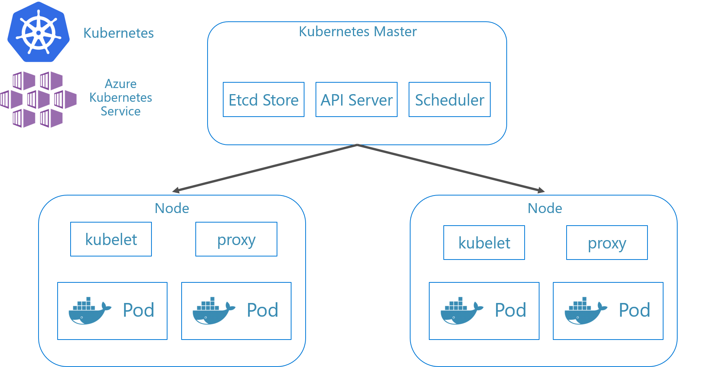

**Figure 2-6**. Kubernetes cluster components.

## Local Kubernetes Development

Kubernetes deployments provide great value in production environments, but you can also run them locally. Although much of the time it’s good to be able to work on individual apps or microservices independently, sometimes it’s good to be able to run the whole system locally just as it will run when deployed to production. There are several ways to achieve this, two of which are Minikube and Docker Desktop. Visual Studio also provides tooling for Docker development.

### Minikube

What is Minikube? The Minikube project says “Minikube implements a local Kubernetes cluster on macOS, Linux, and Windows.” Its primary goals are “to be the best tool for local Kubernetes application development and to support all Kubernetes features that fit.” Installing Minikube is separate from Docker, but Minikube supports different hypervisors than Docker Desktop supports. The following Kubernetes features are currently supported by Minikube:

* DNS
* NodePorts
* ConfigMaps and secrets
* Dashboards
* Container runtimes: Docker, rkt, CRI-O, and containerd
* Enabling Container Network Interface (CNI)
* Ingress

After installing Minikube, you can quickly start using it by running the minikube start command, which downloads an image and start the local Kubernetes cluster. Once the cluster is started, you interact with it using the standard Kubernetes kubectl commands.

### Docker Desktop

You can also work with Kubernetes directly from Docker Desktop on Windows. This is your only option if you’re using Windows Containers, and is a great choice for non-Windows containers as well. The standard Docker Desktop configuration app is used to configure Kubernetes running from Docker Desktop.

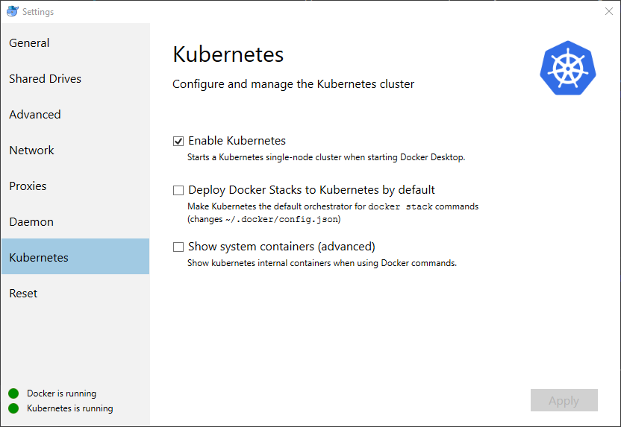

**Figure 2-7**. Configuring Kubernetes in Docker Desktop.

Docker Desktop is already the most popular tool for configuring and running containerized apps locally. When you work with Docker Desktop, you can develop locally against the exact same set of Docker container images that you’ll deploy to production. Docker Desktop is designed to “build, test, and ship” containerized apps locally. Once the images have been shipped to an image registry like Azure Container Registry or Docker Hub, then services like Azure Kubernetes Service (AKS) manage the application in production.

## Visual Studio Docker Tooling

Visual Studio supports Docker development for web applications. When you create a new ASP.NET Core application, you’re given the option to configure it with Docker support as part of the project creation process, as shown in Figure 2-8.

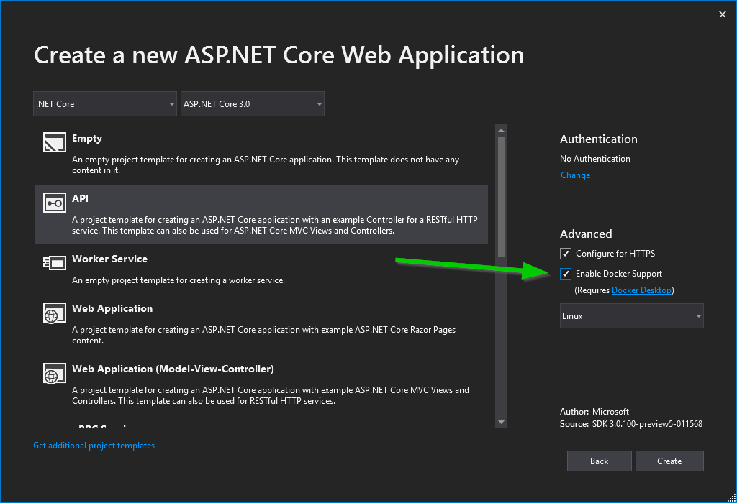

**Figure 2-8**. Visual Studio Enable Docker Support

When this option is selected, the project is created with a Dockerfile in its root, which can be used to build and host the app in a Docker container. An example `Dockerfile is shown in Figure 2-9.

FROM mcr.microsoft.com/dotnet/core/aspnet:3.0-stretch-slim AS base  
WORKDIR /app  
EXPOSE 80  
EXPOSE 443  
  
FROM mcr.microsoft.com/dotnet/core/sdk:3.0-stretch AS build  
WORKDIR /src  
COPY ["WebApplication3/WebApplication3.csproj", "WebApplication3/"]  
RUN dotnet restore "WebApplication3/WebApplication3.csproj"  
COPY . .  
WORKDIR "/src/WebApplication3"  
RUN dotnet build "WebApplication3.csproj" -c Release -o /app  
  
FROM build AS publish  
RUN dotnet publish "WebApplication3.csproj" -c Release -o /app  
  
FROM base AS final  
WORKDIR /app  
COPY --from=publish /app .  
ENTRYPOINT ["dotnet", "WebApplication3.dll"]

**Figure 2-9**. Visual Studio Generated Docker File

The default behavior when the app runs is configured to use Docker as well. Figure 2-10 shows the different run options available from a new ASP.NET Core project created with Docker support added.

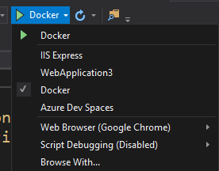

**Figure 2-10**. Visual Studio Docker Run Options

In addition to local development, [Azure Dev Spaces](https://docs.microsoft.com/azure/dev-spaces/) provides a convenient way for multiple developers to work with their own Kubernetes configurations within Azure. As you can see in Figure 2-10, you can also run the application in Azure Dev Spaces.

If you don’t add Docker support to your ASP.NET Core application when you create it, you can always add it later. From the Visual Studio Solution Explorer, right click on the project and select **Add** > **Docker Support**, as shown in Figure 2-11.

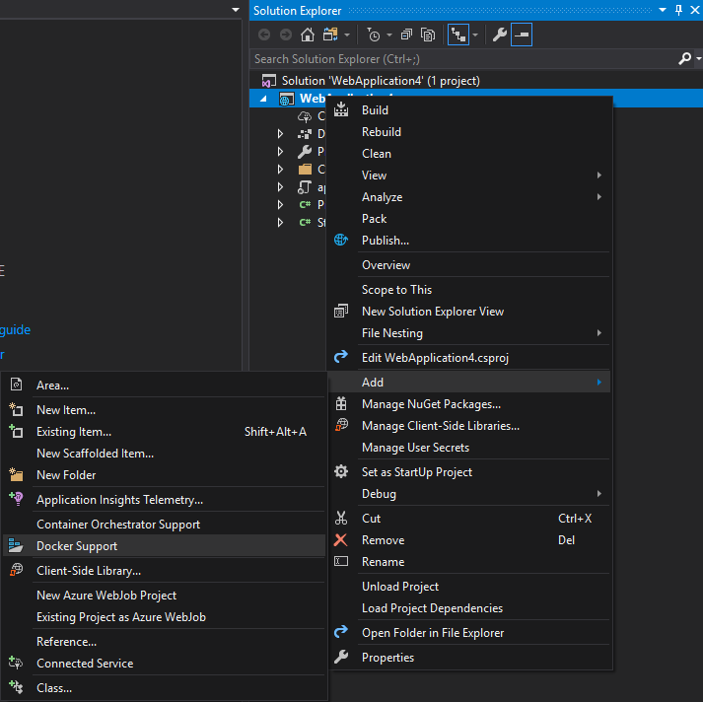

**Figure 2-11**. Visual Studio Add Docker Support

In addition to Docker support, you can also add Container Orchestration Support, also shown in Figure 2-11. By default, the orchestrator uses Kubernetes and Helm. Once you’ve chosen the orchestrator, a azds.yaml file is added to the project root and a charts folder is added containing the Helm charts used to configure and deploy the application to Kubernetes. Figure 2-12 shows the resulting files in a new project.

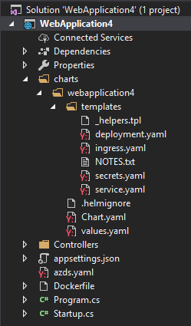

**Figure 2-12**. Visual Studio Add Orchestrator Support

## References

* [What is Kubernetes?](https://blog.newrelic.com/engineering/what-is-kubernetes/)
* [Installing Kubernetes with Minikube](https://kubernetes.io/docs/setup/learning-environment/minikube/)
* [MiniKube vs Docker Desktop](https://medium.com/containers-101/local-kubernetes-for-windows-minikube-vs-docker-desktop-25a1c6d3b766)
* [Visual Studio Tools for Docker](https://docs.microsoft.com/dotnet/standard/containerized-lifecycle-architecture/design-develop-containerized-apps/visual-studio-tools-for-docker)

# Leveraging serverless functions

In the spectrum of managing full machines and operating systems to leveraging cloud capabilities, serverless lives at the extreme end where the only thing you’re responsible for is your code, and you only pay for your code when it runs. Azure Functions provides a way to build serverless capabilities into your applications. Traditionally, Azure Functions is built on the Azure platform or on infrastructure running the Azure Stack or the Azure Functions Runtime. However, you can also run Azure Functions within a Docker container for additional portability and flexibility. Adding support for docker to an Azure Functions project is as simple as adding a switch to the command line:

func init ProjectName --docker

When creating an Azure Function, you must choose the programming language you want to use from these options:

* dotnet (C#)
* node (JavaScript)
* python

When the project is created, it will include a Dockerfile. Next, you can create and test your function locally. For detailed steps to get started building Azure Functions with Docker support, see the [Create a function on Linux using a custom image](https://docs.microsoft.com/azure/azure-functions/functions-create-function-linux-custom-image) tutorial.

## References

* [Create a function on Linux using a custom image](https://docs.microsoft.com/azure/azure-functions/functions-create-function-linux-custom-image)

# Combining containers and serverless approaches

Frequently, microservices-based applications rely heavily on containers, orchestration, and message-passing for communication between nodes. This messaging is an ideal task for Azure Functions, but with the rest of the application configured and deployed using Kubernetes and related tools, it would be nice to be able to leverage Azure Functions within this same toolset. Fortunately, you can wrap Azure Functions in Docker containers and deploy them using the same processes and tools as the rest of your Kubernetes-based app.

Note that one of the primary benefits of leveraging functions is that the consumption plan allows you to only pay for when your functions are running. If you migrate your functions to Docker containers that are deployed and managed through your Kubernetes cluster, you’ll no longer benefit from this serverless feature, or from Azure Functions’ built-in scale out feature. Instead, you’ll benefit from having a consistent development and deployment process that will allow you to host your Function apps locally or compose them within your AKS cluster in whatever way best suits your app’s needs.

To wrap an Azure Function in a Docker container, you should install the Azure Functions Core Tools and then run the func init –docker command. Choose which worker runtime you want (for example, dotnet), and the project will be generated for you, along with a Dockerfile. Now that the app is set up, you can build and run it using docker build and docker run commands, as shown in [this walkthrough](https://markheath.net/post/azure-functions-docker).

## Azure functions with Kubernetes Event Driven Autoscaling (KEDA)

Azure functions scale automatically to meet demand based on the rate of events that are targeting a given function. Additionally, you can leverage Kubernetes to host your functions in Docker containers with event-driven scaling using KEDA. When no events are occurring, KEDA can scale down to 0 instances, and then in response to events it can scale up the number of containers to meet the demand. [Learn more about scaling Azure functions with KEDA](https://docs.microsoft.com/azure/azure-functions/functions-kubernetes-keda).

## References

* [Run Azure Functions in a Docker Container](https://markheath.net/post/azure-functions-docker)
* [Azure Functions with Kubernetes Event Driven Autoscaling](https://docs.microsoft.com/azure/azure-functions/functions-kubernetes-keda)

# Deploying containers in Azure

Containers provide many benefits, one of which is portability. You can easily take the same container you’ve developed and tested locally and deploy it to Azure where it can run your app in staging and production environments. Azure provides a number of options for container-based app hosting, and likewise supports several different means of deployment. The most common and most flexible approach is to deploy your containers to Azure Container Registry (ACR), where they are accessible by whatever services you wish to use to host them. Azure Web App for Containers, Azure Kubernetes Services (AKS), and Azure Container Instance (ACI) all can access container images that have been pushed to ACR.

## Azure Container Registry

Azure Container Registry lets you build, store, and manage images for all of your container deployments. You can [create a container registry using the Azure Portal](https://docs.microsoft.com/azure/container-registry/container-registry-get-started-portal) or [using the Azure CLI](https://docs.microsoft.com/azure/container-registry/container-registry-get-started-azure-cli) or [PowerShell tools](https://docs.microsoft.com/azure/container-registry/container-registry-get-started-powershell). Creating a new container registry just requires an Azure subscription, a resource group, and a unique name. Figure 2-x shows the basic options for creating a registry, which will be hosted at *registryname*.azurecr.io.

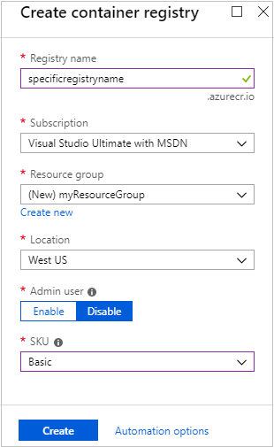

**Figure 2-x**. Create container registry

Once you’ve created a registry, you’ll need to authenticate with it before you can use it. Typically you’ll log into the registry using the Azure CLI command:

az acr login --name *registryname*

Once you’ve created a registry in Azure Container Registry, you can use docker commands to push container images to it. Before you can do so, however, you must first tag your image with the fully qualified name (URL) of your ACR login server. This will have the format *registryname*.azurecr.io.

docker tag mycontainer myregistry.azurecr.io/mycontainer:v1

After you’ve tagged the image, you use the docker push command to push the image to your ACR instance.

docker push myregistry.azurecr.io/mycontainer:v1

After you push an image to the registry, it’s a good idea to remove the image from your local Docker environment, using this command:

docker rmi myregistry.azurecr.io/mycontainer:v1

### Integrating Azure DevOps

Ideally, developer will rarely push directly from their machines to a container registry. Instead, developers should build and test locally, and then commit their code into a source control repository like GitHub or Azure DevOps. From there, a continuous integration process will run a build to ensure the code compiles and passes a suite of automated tests. Assuming these conditions are met, a release pipeline will create a new container instance, tag it, and deploy it automatically to a container registry. Figure 2-x demonstrates a development process that takes advantage of Azure DevOps for Continuous Integration (CI) and Continuous Deployment (CD) to a variety of Azure container hosting options.

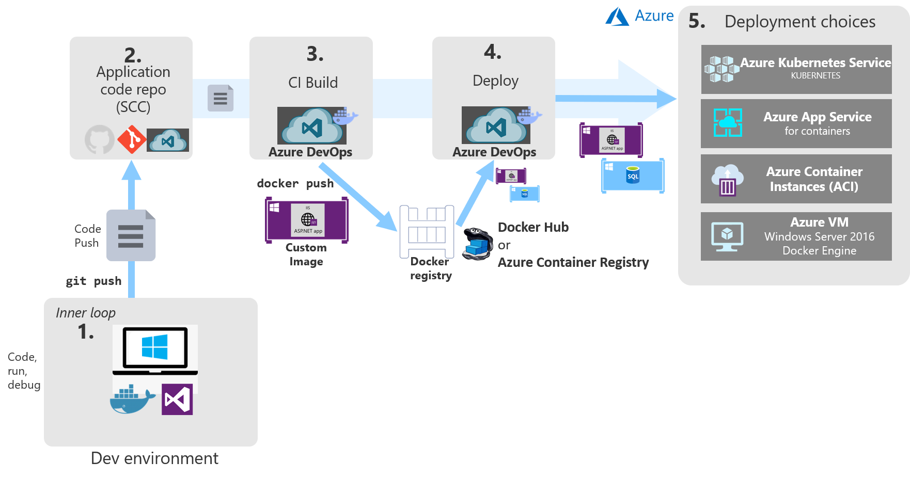

**Figure 2-x**. Azure DevOps Container Deployment

## Azure Kubernetes Service

If your container-based application involves multiple containers, you’ll most likely want to define and manage the interactions between the containers using an *orchestrator* like Kubernetes. Once you’ve deployed your container images to ACR, you can easily configure Azure Kubernetes Services to automatically deploy updated images from ACR. With a full CI/CD pipeline in place, you can configure a [canary release](https://martinfowler.com/bliki/CanaryRelease.html) strategy to minimize the risk involved when rapidly deploying updates. The new version of the app is initially configured in production with no traffic routed to it, and then a small number of users are routed to the newly-deployed version of the app. As the team gains confidence in the new version of the software, more instances of the new version are rolled out and the previous version’s instances are retired. AKS easily supports this style of deployment.

As with most resources in Azure, you can create Azure Kubernetes clusters using the portal or using command line tools or infrastructure automation tools like Helm or Terraform. To get started with a new cluster, you need to provide the following information:

* Azure subscription
* Resource group
* Kubernetes cluster name
* Region
* Kubernetes version
* DNS name prefix
* Node size
* Node count

This information is sufficient to get started. As part of the creation process in the Azure Portal, you can also configure options for the following features of your cluster:

* Scale
* Authentication
* Networking
* Monitoring
* Tags

Figure 2-x shows the basic form requirements in the Azure Portal to create a new Kubernetes cluster.

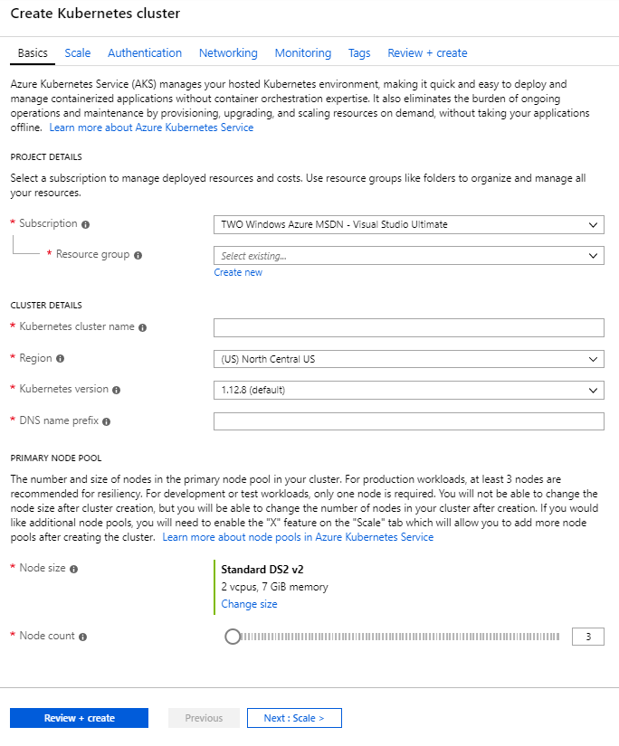

**Figure 2-x**. Create Kubernetes cluster

## Azure Dev Spaces

Complex Kubernetes clusters can require significant resources to host, which can make it difficult for developers to run the entire application on a single machine (especially a laptop). Azure Dev Spaces offers a solution to this by allowing developers to work with their own versions of Azure Kubernetes clusters hosted in Azure. Azure Dev Spaces is designed to ease development of microservice-based applications using AKS.

To understand the value of Azure Dev Spaces, let me share this quote from Gabe Monroy, PM Lead of Containers at Microsoft Azure:

"Imagine you are a new employee trying to fix a bug in a complex microservices application consisting of dozens of components, each with their own configuration and backing services. To get started, you must configure your local development environment so that it can mimic production including setting up your IDE, building tool chain, containerized service dependencies, a local Kubernetes environment, mocks for backing services, and more. With all the time involved setting up your development environment, fixing that first bug could take days.

Or you could use Dev Spaces and AKS."

The process for working with Azure Dev Spaces involves the following steps:

1. Create the dev space
2. Configure the root dev space
3. Configure a child dev space (for your own version of the system)
4. Connect to the dev space

All of these steps can be performed using the Azure CLI and new azds command line tools. For example, to create a new Azure Dev Space for a given Kubernetes cluster, you would use a command like this one:

az aks use-dev-spaces -g my-aks-resource-group -n MyAKSCluster

Next, you can use the azds prep command to generate the necessary Docker and Helm chart assets for running the application. Next, you run your code in AKS using azds up. The first time you run this command, the Helm chart will be installed, and the container(s) will be built and deployed according to your instructions. This may take a few minutes the first time it’s run. However, after you make changes, you can connect to your own child dev space using azds space select and then deploy and debug your updates in your isolated child dev space. Once you have your dev space up and running, you can send updates to it by re-issuing the azds up command or you can use built-in tooling in Visual Studio or Visual Studio Code. With VS Code, you use the command palette to connect to your dev space. Figure 2-x shows how to launch your web application using Azure Dev Spaces in Visual Studio.

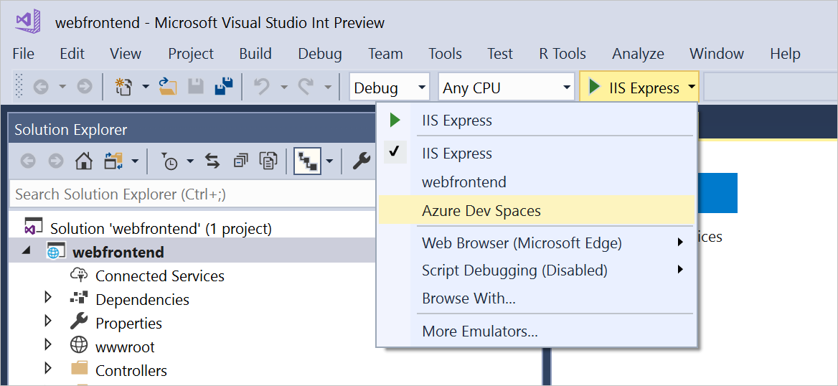

**Figure 2-x**. Connect to Azure Dev Spaces in Visual Studio

## References

* [Canary Release](https://martinfowler.com/bliki/CanaryRelease.html)
* [Azure Dev Spaces with VS Code](https://docs.microsoft.com/azure/dev-spaces/quickstart-netcore)
* [Azure Dev Spaces with Visual Studio](https://docs.microsoft.com/azure/dev-spaces/quickstart-netcore-visualstudio)

# Other Deployment Options

In addition to deploying to AKS, you can also deploy containers to Azure App Service for Containers and Azure Container Instances. Simple production applications that don’t require orchestration are well-suited to Azure App Service for Containers. Azure Container Instances are best used for testing scenarios.

## App Service for Containers

**Note**: Do we need to cover deployment to App Service for Containers here or is that covered elsewhere?

## Azure Container Instances

To deploy to [Azure Container Instances (ACI)](https://docs.microsoft.com/azure/container-instances/), you need to have configured an Azure Container Registry (ACR) and credentials for accessing it. You must also have previously pushed your container image to the registry, so it’s available to pull into ACI. You can work with ACI using the Azure CLI or through the portal. Azure Container Registries make it easy to deploy individual container instances to ACI directly from within the registry, as shown in Figure 2-x.

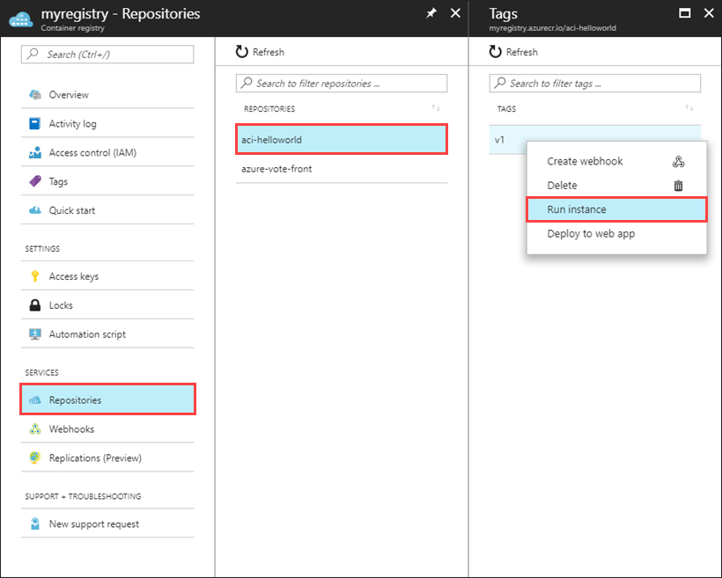

**Figure 2-X**. Azure Container Registry Run Instance

Creating a container instance from the registry just requires specifying the usual Azure settings (name, subscription, resource group, and location) as well as how much memory to allocate to the container and which port it should listen on. Figure 2-X shows the Azure Portal form used to create the new instance.

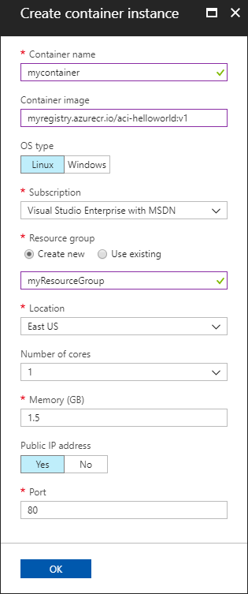

**Figure 2-X**. ACR Run Instance Create container instance

Once the deployment completes, you can find the newly-deployed container’s IP address and communicate with it over the port you specified.

Azure Container Instances offers the fastest, simplest way to run a container in Azure. There’s no need to configure an app service or an orchestrator or to deal with virtual machines. However, because of its simplicity, ACI should primarily be used for testing purposes. If your application requires automatic scalability, multiple containers configured to work together, or any additional complex features, there are other better-suited Azure services available to host your app.

## References

* [Azure Container Instances Docs](https://docs.microsoft.com/azure/container-instances/)
* [Deploy Container Instance from ACR](https://docs.microsoft.com/azure/container-instances/container-instances-using-azure-container-registry#deploy-with-azure-portal)

Implementing a Cloud Native app

Before starting this chapter, we recommend that you download the eShopOnContainers reference application. If you do so, it should be easier for you to follow along with the information presented.

## References

* [eShopOnContainers reference application](https://github.com/dotnet-architecture/eShopOnContainers)

# Introducing eShopOnContainers reference app

Microsoft, in partnership with leading community experts, has produced a full-featured cloud native microservices reference application, eShopOnContainers. This application is built to showcase using .NET Core and Docker, and optionally Azure, Kubernetes, and Visual Studio, to build an online storefront.

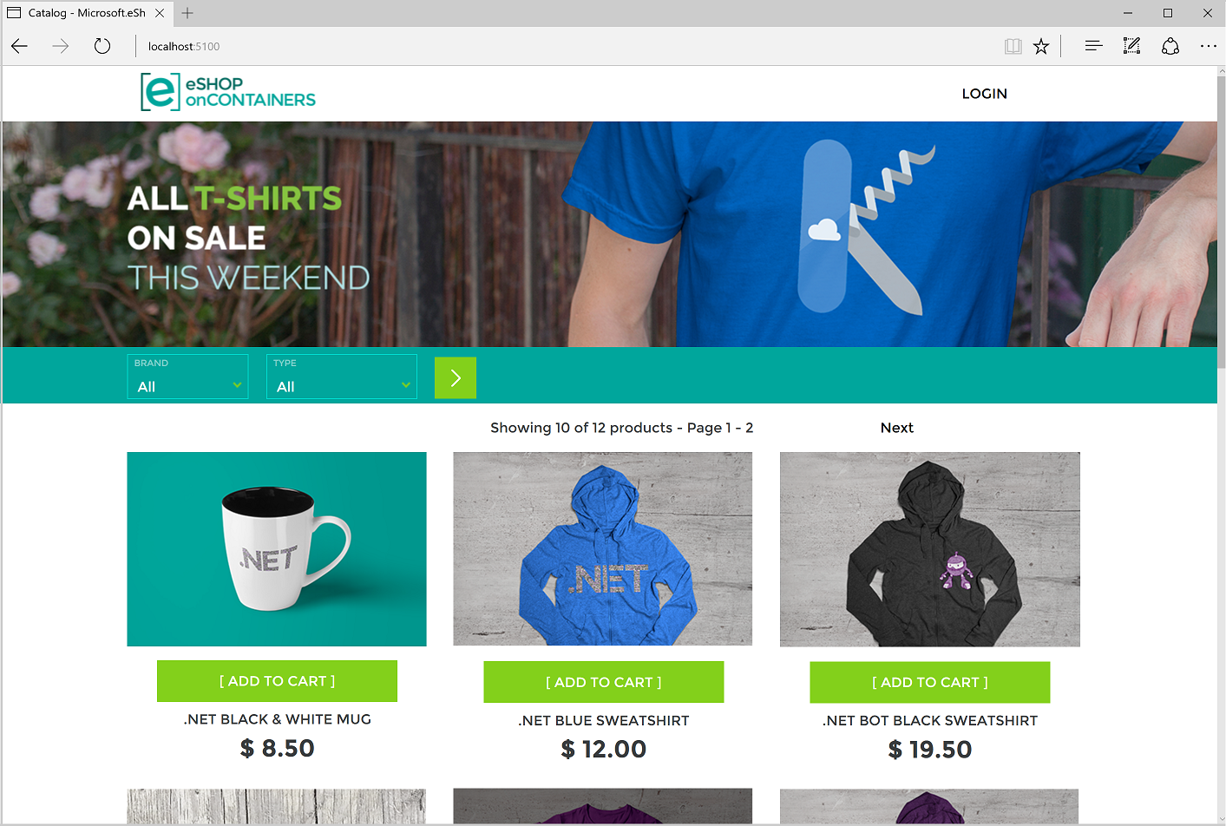

**Figure 3-1**. eShopOnContainers Sample App Screenshot.

## Features and requirements

Let’s start with a review of the application’s features and requirements. The eShopOnContainers application represents an online store that sells various physical products like t-shirts and coffee mugs. If you’ve bought anything online before, the experience of using the store should be relatively familiar. Here are some of the basic features the store implements:

* List catalog items
* Filter items by type
* Filter items by brand
* Add items to the shopping basket
* Edit or remove items from the basket
* Checkout
* Register an account
* Sign in
* Sign out
* Review orders

The application also has the following non-functional requirements:

* It needs to be highly available and it must scale automatically to meet increased traffic (and scale back down once traffic subsides).
* It should provide easy-to-use monitoring of its health and diagnostic logs to help troubleshoot any issues it encounters.
* It should support an agile development process, including support for continuous integration and deployment (CI/CD).
* In addition to the two web front ends (traditional and Single Page Application), the application must also support mobile client apps running different kinds of operating systems.
* It should support cross-platform hosting and cross-platform development.

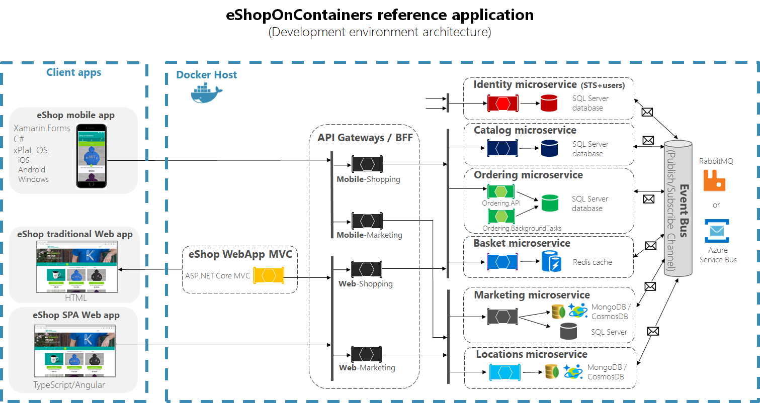

**Figure 3-2**. eShopOnContainers reference application development architecture.

The eShopOnContainers application is accessible from web or mobile clients that access the application over HTTPS targeting either the ASP.NET Core MVC server application or an appropriate API Gateway. API Gateways offer several advantages, such as decoupling backend services from individual front-end clients and providing better security. The application also makes use of a related pattern known as Backends-for-Frontends (BFF), which recommends creating separate API gateways for each front-end client. The reference architecture demonstrates breaking up the API gateways based on whether the request is coming from a web or mobile client.

The application’s functionality is broken up into a number of distinct microservices. There are services responsible for authentication and identity, listing items from the product catalog, managing users’ shopping baskets, and placing orders. Each of these separate services has its own persistent storage. Note that there is no single master data store with which all services interact. Instead, coordination and communication between the services is done on an as-needed basis and through the use of a message bus.

Each of the different microservices are designed differently, based on their individual requirements. This means their technology stack may differ, although they’re all built using .NET Core and designed for the cloud. Simpler services provide basic Create-Read-Update-Delete (CRUD) access to the underlying data stores, while more advanced services use Domain-Driven Design approaches and patterns to manage business complexity.

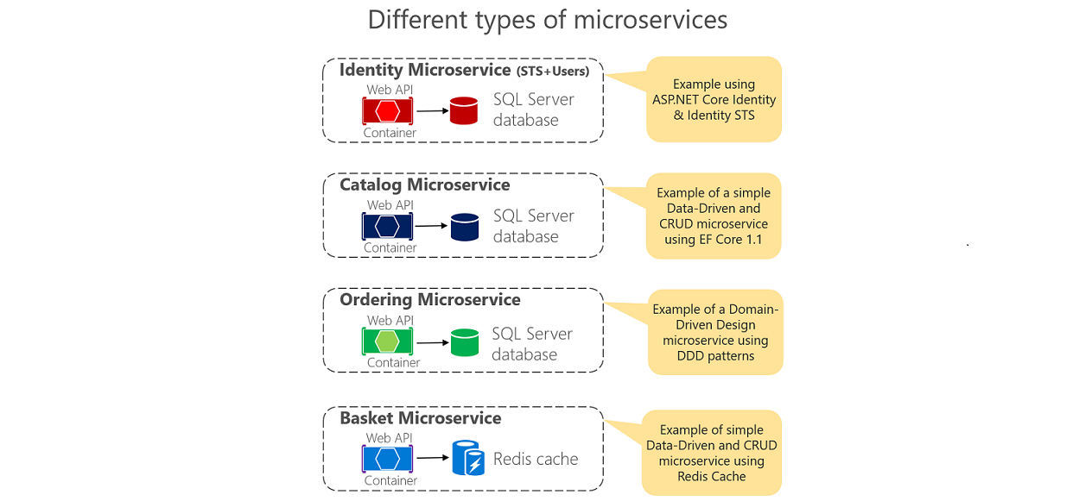

**Figure 3-3**. Different kinds of microservices.

## Overview of the code

Because it leverages microservices, the eShopOnContainers app includes quite a few separate projects and solutions in its GitHub repository. In addition to separate solutions and executable files, the various services are designed to run inside their own containers, both during local development and at runtime in production. Figure 3-4 shows the full Visual Studio solution, in which the various different projects are organized.

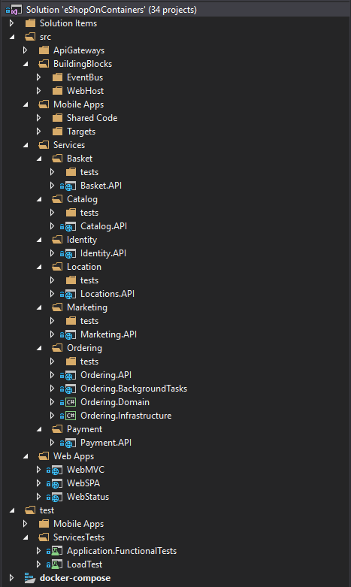

**Figure 3-4**. Projects in Visual Studio solution.

# Mapping eShopOnContainers to Azure Services

Although not required, Azure is very well-suited to supporting the eShopOnContainers because the project was built to be a cloud native application.

(expand on mapping)

# Hosting the eShopOnContainers application

The logic supporting the eShopOnContainers application can be supported by Azure using a variety of services. The recommended approach is to leverage Kubernetes using Azure Kubernetes Service. This can be combined with Helm deployment to ensure easily repeated infrastructure configuration. Optionally, developers can leverage DevSpaces for Kubernetes as part of their development process. Another option is to host the functionality of the app using Azure Serverless features like Azure Functions and Azure Logic Apps.

## Azure Kubernetes Service

asdf

## Helm Deployment

asdf

## DevSpaces for Kubernetes

asdf

## Azure Functions and Logic Apps (Serverless)

asdf

# Centralized configuration

Cloud native applications involve many more running services than traditional single-instance monolithic apps. Managing configuration settings for dozens of interdependent services can be challenging, which is why centralized configuration stores are often implemented for distributed applications.

As discussed in [Chapter 1]**INTERNAL-LINK:(introduction.md)**, the 12 Factor App recommendations require strict separation between code and configuration. This means storing configuration settings as constants or literal values in code is a violation. This recommendation exists because the same code should be used across multiple environments, including development, testing, staging, and production. However, configuration values are likely to vary between each of these environments. So, configuration values should be stored in the environment itself, or the environment should store the credentials to the centralized configuration store.

# Cloud native communication patterns

In a traditional monolithic application, functionality is implemented as modules that all run in the same process. What this means is that all application code shares the same executable space within the operating system. It can be efficient as everything runs together, but poor in terms of scalability.

When constructing cloud native systems, you implement a microservice-based architecture that consists of a large number of small, independent, self-contained services, each running in its own separate process, typically deployed inside a container to a *cluster*.

A cluster represents a pool of virtual machines that federated together form a highly available environment. Clusters are typically managed by an orchestrator, which is responsible for deploying and managing the various containerized microservices. Figure 4-1 shows a Kubernetes cluster as deployed in the Azure cloud with the fully managed [Azure Kubernetes Services](https://docs.microsoft.com/azure/aks/intro-kubernetes).

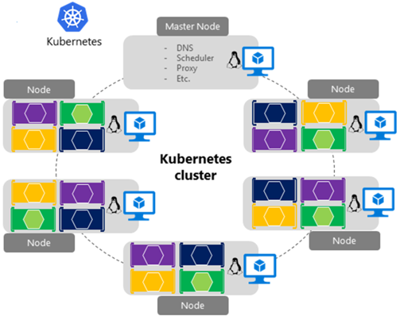

**Figure 4-1**. A Kubernetes cluster in Azure

While such an approach enables each microservice to evolve, deploy, and scale independently as needed, it adds a great deal of complexity to both your architecture and infrastructure. For example, many new considerations come about:

* Each service now communicates over a network protocol
* Network congestion, latency, and transient faults now become an issue
* Resiliency (that is, retrying failed requests) becomes required
* Some calls must be [idempotent](https://www.restapitutorial.com/lessons/idempotency.html)
* Each service must authenticate and authorize each call
* Message encryption/decryption become important
* Each message must be serialized and then deserialized - which can be expensive

In this module, we’ll first address communication between front-end applications and back-end microservices and then to microservice-to-microservice communication.

# Cross-service communication

Moving from the front-end client, we now address communication across the backend core microservices, or microservice-to-microservice communication.

When constructing a cloud native application, you’ll want to be sensitive to how backend services communicate with each other. Ideally, the less cross-service communication, the better. However, avoidance isn’t always possible as backend services often rely on one another to complete an operation.

There are several widely accepted approaches to implementing cross-service communication. The type of *communication interaction* will often determine the best approach.

Consider the following interaction types:

* *Query* – when a calling service requires a response from a called service, such as, “Hey, give me the number of customer orders for a given date range.”
* *Command* – when the calling service needs another service to execute an action but doesn’t require a response, such as, “Hey, just ship this order.”
* *Event* – when one service (the publisher) raises an event of a state change or notification that an action has occurred. Other services, called subscribers, who are interested, can react to the event appropriately. The publisher and the subscribers aren’t aware of each other.

Microservice systems typically use a combination of these interaction types when executing operations that require cross-service interaction. Let’s take a close look at each and how you might implement them.

## Queries

Often, one microservice might need to *query* another, requiring an immediate response to complete an operation. For example, a shopping basket microservice may need product information and a price to add an item to its basket. There are a number of approaches for implementing query operations.

### Request/Response Messaging

One option for implementing this scenario is direct HTTP calls from the calling microservice to those it needs to query as shown in Figure 4-9.

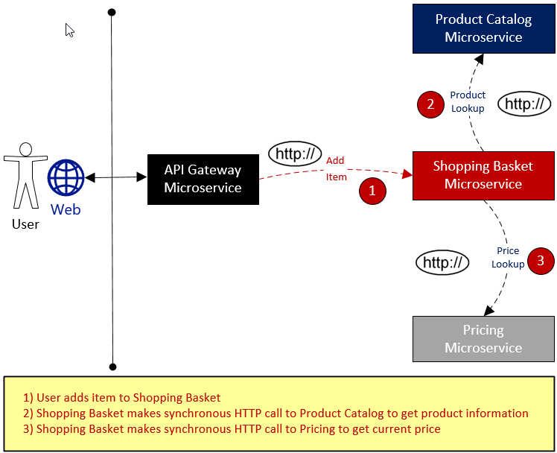

**Figure 4-9**. Direct HTTP communication

While direct HTTP calls between microservices are relatively simple to implement, care should be taken to minimize this practice. Because what were once self-contained, independent services, able to evolve independently and deploy frequently, now become coupled to each other. As coupling among microservices increase, their architectural benefits diminish.

While performing a request that executes infrequently and makes a single synchronous HTTP network call might be acceptable, high-volume calls that invoke multiple services can increase latency and negatively impact the performance, scalability, and availability of your system. Even worse, a long series of direct HTTP communication can lead to deep, complex chains of synchronous microservices calls, as shown in Figure 4-10:

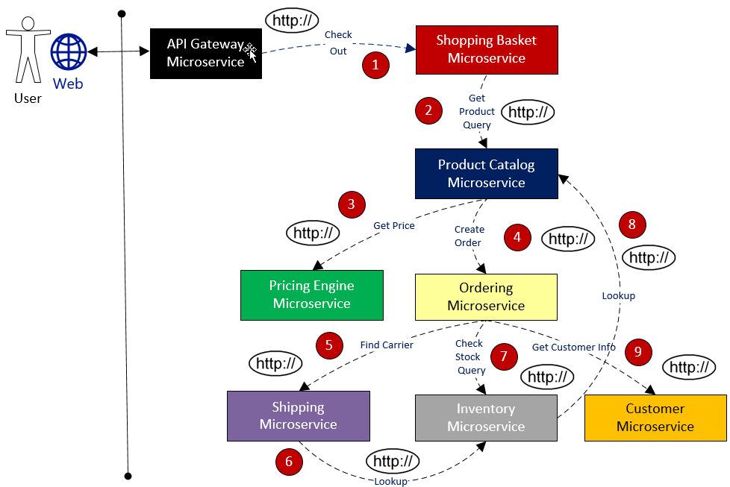

**Figure 4-10**. Chaining HTTP queries

While somewhat exaggerated, you can certainly imagine the risk in the design shown in the previous image. What happens if Step #3 fails? Or Step #8 fails? How do you recover? What if Step #6 is slow because the underlying service is busy? How do you continue? Even if all works correctly, think of the latency this call would incur, which is the sum of the latency of each step.

The high degree of coupling shown in the previous image suggests that the services weren’t modeled as optimally as they could be. It would behoove the team to invest time rationalizing the design with which the services were decomposed.

### Materialized View pattern

One option for reducing such coupling is implementing the [Materialized View pattern](https://docs.microsoft.com/azure/architecture/patterns/materialized-view), where a microservice stores a local, denormalized copy of the data it needs that’s owned by other services. Instead of the Shopping Basket calling the Product Catalog and Pricing microservices, it has its own local copy of that data. This pattern removes unnecessary coupling while improving response time and reliability. We explore this pattern and other data concerns in Chapter 5.

### Service Aggregator Pattern

Another option for such a workflow orchestration might be an [Aggregator Service](https://devblogs.microsoft.com/cesardelatorre/designing-and-implementing-api-gateways-with-ocelot-in-a-microservices-and-container-based-architecture/), as shown in purple in Figure 4-11:

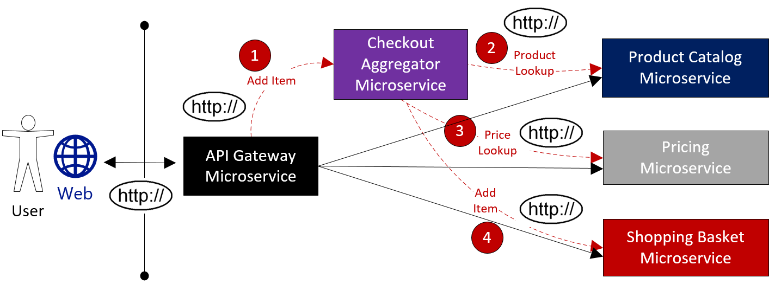

**Figure 4-11**. Aggregator service

The Aggregator service isolates an operation that makes calls to multiple backend services, centralizing its logic into an orchestration. Here, the purple Checkout Aggregator Microservice orchestrates the workflow for the Checkout operation, which includes calls to multiple services in a sequenced order.

### Request/Reply Pattern

Another approach to decouple synchronous HTTP messages is to implement a [Request-Reply Pattern](https://www.enterpriseintegrationpatterns.com/patterns/messaging/RequestReply.html) using queuing functionality from a message broker. Communication using a queue is always a one-way channel, with a producer sending the message and consumer receiving it. With this pattern, both a request queue and response queue are implemented as shown in Figure 4-12:

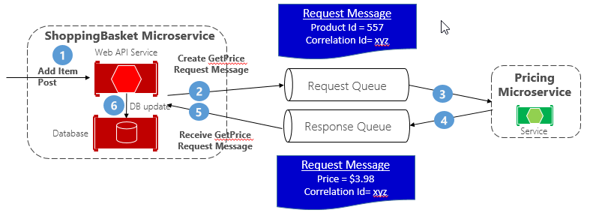

**Figure 4-12**. Request-reply pattern

Here, the message producer creates a query-based message that contains a unique correlation ID and places it into a request queue. The consuming service dequeues the messages, processes it and places the response into the response queue with the same correlation ID. The producer service dequeues the message, matches it with the correlation ID and continues processing. We cover queues in detail in the next section.

## Commands

Sometimes, a microservice may require another microservice to perform an action. For example, the Ordering microservice may need the Shipping microservice to create a shipment for an approved order. Often called a *command message*, the microservice invoking the action, called a Producer, makes a command to another service, the Consumer, by sending it a message as shown in Figure 4-13:

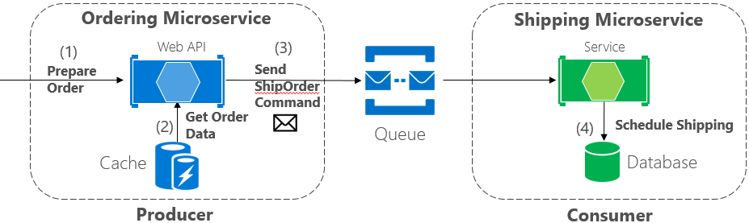

**Figure 4-13**. Command interaction with a queue

Often, the Producer doesn’t require a response and can *fire-and-forget* the message. If a reply is needed, the Consumer sends a separate message back to Producer on another channel. A command message is best sent asynchronously with the preferred infrastructure being a lightweight message broker that supports a message queue. In the previous diagram, note how a queue separates and decouples both services.

A message queue is an intermediary construct through which a producer and consumer pass a message. Queues implement an asynchronous, point-to-point messaging pattern in that the Producer knows where a command needs to be sent and routes appropriately. The queue guarantees that a message is processed by exactly one of the consumer instances that are reading from the channel. In this scenario, either the producer or consumer service can scale out without affecting the other. As well, technologies can be disparate on each side, meaning that we might have a Java Producer and Golang Consumer.

The Azure cloud supports two types of queues: Azure Storage Queues and Azure Service Bus Queues.

### Azure Storage Queues

Azure storage queues offer a simple queueing infrastructure that is fast, affordable, and backed by Azure storage accounts.

A service of the Azure storage infrastructure, storage queues feature a REST-based queuing mechanism with reliable and persistent messaging between services. They provide a minimal feature set but are inexpensive and enable the storage of millions of messages, with capacity ranging up to 500 TB. A single message can be up to 64 KB in size.

You can access messages from anywhere in the world via authenticated calls using HTTP or HTTPS. Storage queues can scale out to large numbers of concurrent clients to handle traffic spikes.

That said, there are limitations with the service:

* Message order isn’t guaranteed.
* A message can only persist for seven days before it’s automatically removed.
* Support for state management, duplicate detection, or transactions isn’t available.

Figure 4-14 shows the hierarchy of an Azure Storage Queue:

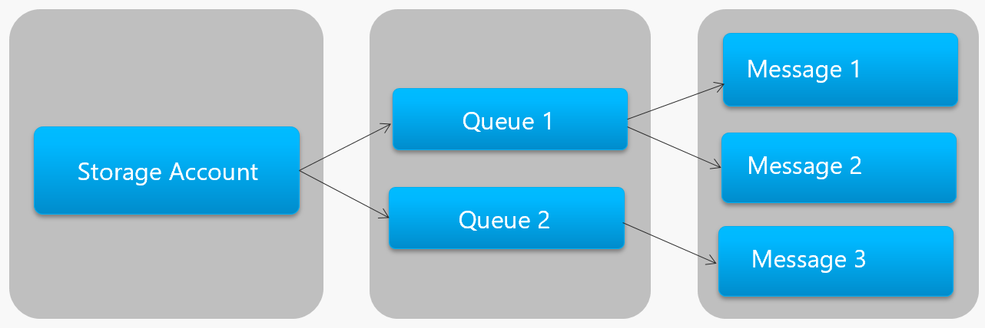

**Figure 4-14**. Storage queue hierarchy

Note in Figure 4-14 how storage queues are exposed as a service that sits on top of an Azure Storage account, which is where the messages are stored.

To make it easier for development teams, Microsoft provides a large variety of client and server-side libraries for Storage queue processing, reaching across every major platform, including .NET, Java, JavaScript, Ruby, Python, and many more.

Again, Storage queues are economical: you only pay for the actual storage of the messages. There are no fixed hourly charges as found with other cloud-based services.

Storage queues are a great solution when a queue size will exceed 80 GB, or a simple feature set is acceptable.

### Azure Service Bus Queues

For more complex messaging requirements, consider Azure Service Bus queues.

Sitting atop a robust message infrastructure, [Azure Service Bus](https://docs.microsoft.com/azure/service-bus-messaging/service-bus-messaging-overview) supports a *brokered messaging model*. Messages are reliably stored in a broker (the queue) until received by the consumer. The queue guarantees First-In/First-Out (FIFO) message delivery, respecting the order in which messages were added to the queue.

The size of a message can be much larger, up to 256 KB, and is persisted in the queue for an unlimited period of time. Service Bus supports not only HTTP-based calls, but also provides full support for the [AMPQ protocol](https://docs.microsoft.com/azure/service-bus-messaging/service-bus-amqp-overview), which is an open-standard across vendors that supports a binary protocol and higher degrees of reliability.

Service Bus provides a rich set of features, including full [transaction support](https://docs.microsoft.com/azure/service-bus-messaging/service-bus-transactions) when sending or receiving multiple messages and a [duplicate detection feature](https://docs.microsoft.com/azure/service-bus-messaging/duplicate-detection) with which the queue automatically discards a message that has already been sent. If a producer is in doubt, it can resend the same message and Service Bus guarantees that only one copy will be processed. It also guarantees “at most once delivery” per message without the need for you to build additional infrastructure components.

Another enterprise feature is sessions and partitioning. [Sessions](https://codingcanvas.com/azure-service-bus-sessions/) provide a way to group related messages together so they can be processed together. This feature might be helpful in a workflow scenario where a group of related messages are processed in their entirety with the operation completed at the end. To take advantage, sessions must be explicitly enabled for the queue and each related messaged must contain the same session ID.

However, there are some important caveats: Service Bus queues size is limited to 80 GB, which is much smaller than what’s available from store queues. Additionally, Service Bus queues are more expensive with a base cost and charge per operation.

Figure 4-15 outlines the high-level architecture of a Service Bus queue:

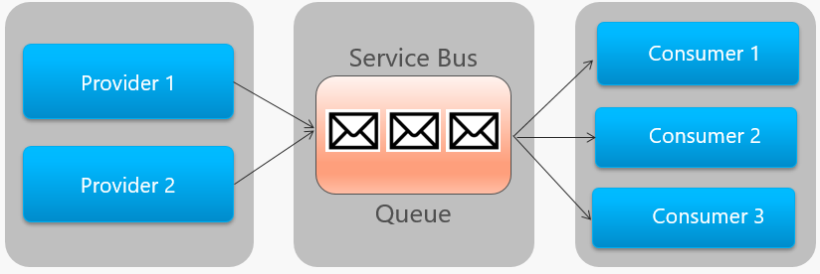

**Figure 4-15**. Service Bus queue

Note the point-to-point relationship in the Figure 4-15 above where two identical providers are enqueuing messages into a single Server Bus queue and how each message is consumed by one (and only one) of the three identical consumers on the right. Next, we discuss how to implement messaging where different consumers may all be interested the same message.

## Events

As discussed, asynchronous messaging is an effective way to decouple senders and consumers and avoid blocking while waiting for a response. However, a dedicated message queue for each consumer wouldn’t scale well when you may have many different consumers interested in the same message. A better approach for these scenarios is a [Publish/Subscribe](https://docs.microsoft.com/azure/architecture/patterns/publisher-subscriber) pattern, which enables you to implement [event-based communication](https://docs.microsoft.com/dotnet/standard/microservices-architecture/multi-container-microservice-net-applications/integration-event-based-microservice-communications).

Eventing is a two-step process. To start, a microservice can raise an event and publish it to a message broker, making it available to other services. Then, any other microservice can ask to be notified whenever the event is raised by subscribing to the event in the message broker. As a best practice, development teams should encapsulate the message broker plumbing inside a custom *EventBus* component that can expose the messaging operations. Figure 4-16 shows Microservice #1 publishing an event to an *EventBus*, with Microservices #2 and #3 subscribing to and receiving the event.

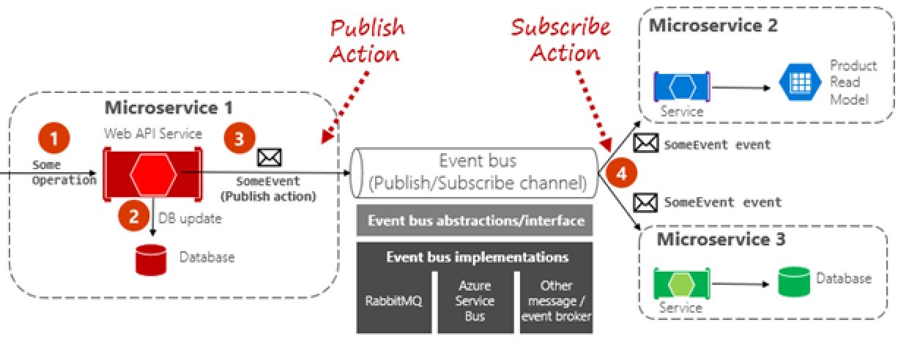

**Figure 4-16**. Event-Driven messaging

In the previous scenario, Microservices #2 and #3 independently receive and operate on an event with no knowledge of each other, nor of Microservice #1. They simply wait for a registered event to be published to the event bus and then act upon it.

Typically, with eventing, we move from queuing technology to *topics*. A [topic](https://docs.microsoft.com/azure/service-bus-messaging/service-bus-dotnet-how-to-use-topics-subscriptions) is similar to a queue but supports a one-to-many messaging pattern where multiple subscribers can choose to receive a message that is sent by a publisher. Figure 4-17 shows a topic architecture:

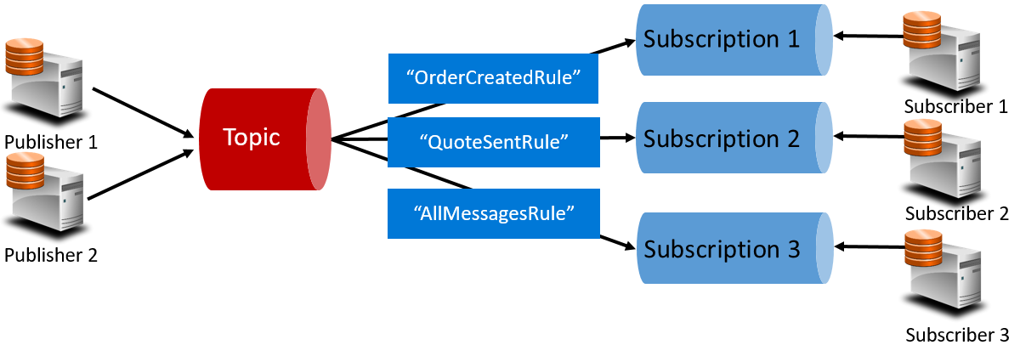

**Figure 4-17**. Topic architecture

In Figure 4-17, note how publishers send messages to the topic. But messages aren’t received directly from the topic. Instead, the topic is responsible for forwarding messages to the subscriptions for each registered subscriber. Each subscriber then can receive messages from its corresponding subscription. Think of each subscription as a standalone queue. An important component here is the *Rule (dark blue boxes)*. The rule acts as a filter determining messages that are forwarded to a specific subscription, enabling a subscription to listen only for messages that are important to it. In the previous figure, if an “OrderCreated” event is published, the topic would send it to Subscription #1 and Subscription #3, but not to Subscription #2 as the message isn’t a “QuoteSent”.

The Azure cloud supports two types of topic mechanisms: Azure Service Bus Topics and Azure EventGrid.

### Azure Service Bus Topics

Sitting on top of the same robust brokered message model of Azure Service Bus queues are [Azure Service Bus Topics](https://docs.microsoft.com/azure/service-bus-messaging/service-bus-dotnet-how-to-use-topics-subscriptions). A topic can receive messages from multiple independent publishers and can send messages to up to 2,000 subscribers. As well, subscriptions can be dynamically added or removed at runtime without stopping the system or recreating the topic.

Many of the advanced features from Azure Service Bus that we saw for queues are also available for topics, including [Duplicate Detection](https://docs.microsoft.com/azure/service-bus-messaging/duplicate-detection), [Transaction support](https://docs.microsoft.com/azure/service-bus-messaging/service-bus-transactions), and [Partitioning](https://docs.microsoft.com/azure/service-bus-messaging/service-bus-partitioning). [Scheduled Message Delivery](https://docs.microsoft.com/azure/service-bus-messaging/message-sequencing) is a feature where a message is tagged with a specific time for processing and won’t appear in the topic before then. Finally, [Message Deferral](https://docs.microsoft.com/azure/service-bus-messaging/message-deferral) is an option where you can defer retrieval of a message to a later time. Typically used in workflow processing scenarios where operations are processed in a particular order, you can postpone processing of received messages until prior work has been completed.

A conventional Service Bus topic (or queue) is handled by a single message broker and stored in a single messaging store. However, [Service Bus Partitioning](https://docs.microsoft.com/azure/service-bus-messaging/service-bus-partitioning) enables topics and queues to be partitioned across multiple message brokers and message stores. Partitioning means that the overall throughput of a partitioned entity is no longer limited by the performance of a single message broker or messaging store. In addition, a temporary outage of a messaging store doesn’t render a partitioned queue or topic unavailable. Partitioned queues and topics can contain all advanced Service Bus features, such as support for transactions and sessions.

### Azure Event Grid

While Azure Service Bus is a battle-tested messaging broker, supporting both traditional queues and topics with a full set of enterprise features, Azure Event Grid is the new kid on the block.

At first glance, Event Grid may look like just another topic-based messaging system. However, it’s different in many ways. Focused on event-driven workloads, it enables real-time event processing, deep Azure integration, and an open-platform - all on serverless infrastructure. It’s designed for contemporary cloud native and serverless applications

As a centralized *eventing backplane*, or pipe, Event Grid lets you react to events originating inside Azure resources as well as those events from your own services and applications.

Event notifications are published to an Event Grid Topic, which, in turn, routes each event to a Subscription. Subscribers map to subscriptions and consume the events. Similar to Service Bus, Event Grid supports a *filtered subscriber model* wherein a Subscription can set rules as to what events it wishes to receive. Event Grid provides fast throughput with a guarantee of 10 million events per second enabling near real-time delivery - far more than what Azure Service Bus can generate.

One of the sweet spots for Event Grid is its deep integration into the fabric of Azure infrastructure. An Azure resource, such as Cosmos DB, can directly publish built-in events to other interested Azure resources without the need for custom code. Event Grid can publish events from Azure resources at the Subscription, Resource Group, or Service levels allowing developers to gain fine-grained control over the lifecycle of cloud resources. However, Event Grid isn’t limited to Azure. It’s an open platform that can consume custom HTTP events published from applications or third-party services and route events to external subscribers.

When publishing and subscribing to native events from Azure resources, no coding is required. With simple configuration, you can integrate events from one Azure resource to another leveraging built-in Topics and Subscriptions as plumbing. Figure 4-18 shows the anatomy of Event Grid.

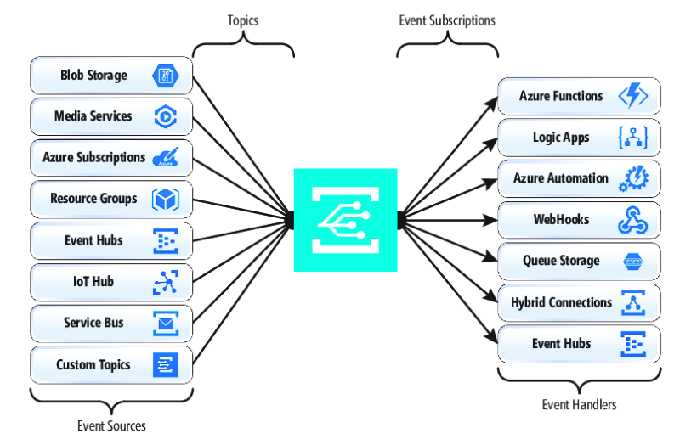

**Figure 4-18**. Event Grid anatomy

A major difference between EventGrid and Service Bus is the underlying *message exchange pattern*.

Service Bus implements an older style *pull model* in which the downstream subscriber actively polls the topic subscription for new messages. On the upside, this approach gives the subscriber full control of the pace at which it processes messages as it controls when and how many messages it wants to process at any given time. Unread messages remain in the subscription until processed. A significant shortcoming of this approach is the latency between the time the event is generated and the polling operation that pulls that message to the subscriber for processing. Also, the overhead of constant polling for the next event needlessly consumes resources and money.

EventGrid, however, is different. It implements a *push model* in which events are sent to the EventHandlers as received, giving you near real-time event delivery. It also reduces cost as code is triggered only when it’s needed to consume an event – not continually as with polling. That said, an event handler must be able to handle the incoming load and provide throttling mechanisms to protect itself from becoming overwhelmed. Many Azure services that consume these events, such as Azure Functions, Logic Apps, and so on, support automatic autoscaling capabilities that can handle the required processing capacity. Most interestingly, Event Grid is a fully managed serverless cloud service. It dynamically scales based on your traffic and charges you only for your actual usage, not pre-purchased capacity. The first 100,000 operations per month are free – operations being defined as event ingress (incoming event notifications), subscription delivery attempts, management calls, and filtering by subject. With 99.99% availability, EventGrid guarantees the delivery of an event within a 24-hour period, with built-in retry functionality for unsuccessful delivery. Undelivered messages can be moved to a “dead-letter” queue for resolution. Unlike Azure Service Bus, Event Grid is tuned for fast performance and doesn’t support features like ordered messaging, transactions, and sessions.

### Azure Event Hubs

While Azure Service Bus and Event Grid provide great support for applications that expose single, discrete events (that is, a new document has been inserted into the underlying Cosmos DB), what is the best way to process a *stream of related events*? [Event streams](https://msdn.microsoft.com/magazine/dn904671.aspx?f=255&MSPPError=-2147217396) are more complex as they’re typically time-ordered, interrelated and must be processed as a group.

Azure Event Hub is a data streaming platform and event ingestion service that collects, transforms, and stores events. Fine-tuned to capture streaming data, such as continuous event notifications emitted from a telemetry context, it’s highly scalable and can store and [process millions of events per second](https://docs.microsoft.com/azure/event-hubs/event-hubs-about). It typically plays the role of the front door for an event pipeline, decoupling the ingest of the event stream from the consumption of those events, as shown in Figure 4-19:

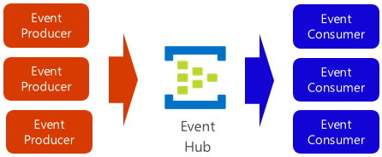

**Figure 4-19**. Azure Event Hub

Event Hub supports low latency and configurable time retention. Differing from queues and topics, Event Hubs keep event data after it’s been read by a consumer. This feature enables other data analytic services, both internal and external, to replay the data for further analysis. Events stored in event hub are only deleted upon expiration of the retention period, which is one day by default, but configurable.

Event Hub support a number of protocols for publishing events including HTTPS, AMQP, and even Kafka 1.0, which enables existing [Kafka applications to communicate with Event Hub](https://docs.microsoft.com/azure/event-hubs/event-hubs-for-kafka-ecosystem-overview) using the Kafka protocol, providing an alternative to provisioning and managing large Kafka clusters.

Event Hubs implement message streaming through a [partitioned consumer model](https://docs.microsoft.com/azure/event-hubs/event-hubs-features) in which each consumer only reads a specific subset, or partition, of the message stream. This pattern enables tremendous horizontal scale for event processing and provides other stream-focused features that are unavailable in queues and topics. A partition is an ordered sequence of events that is held in an event hub. As newer events arrive, they’re added to the end of this sequence. Figure 4-20 shows partitioning in an Event Hub.

Instead of reading from the same resource, each consumer group reads across a subset, or partition, of the message stream.

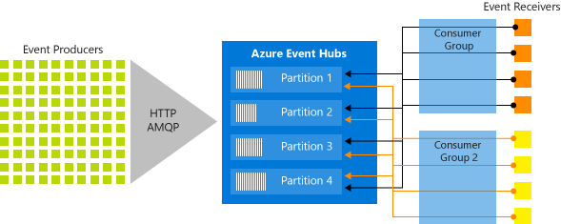

**Figure 4-20**. Event Hub partitioning

For applications that must stream numbers of events, Azure Event Hub can be a robust and affordable solution.

## Summary

Blah, blah, blah

## Additional resources

* **Blah**  
  https://aka.ms/liftandshiftwithcontainersebook

Distributed data for cloud native apps

When constructing a cloud native system that consists of many independent microservices, the way you think about data storage changes.

Traditional monolithic applications favor a centralized data store shown in Figure 5-1.

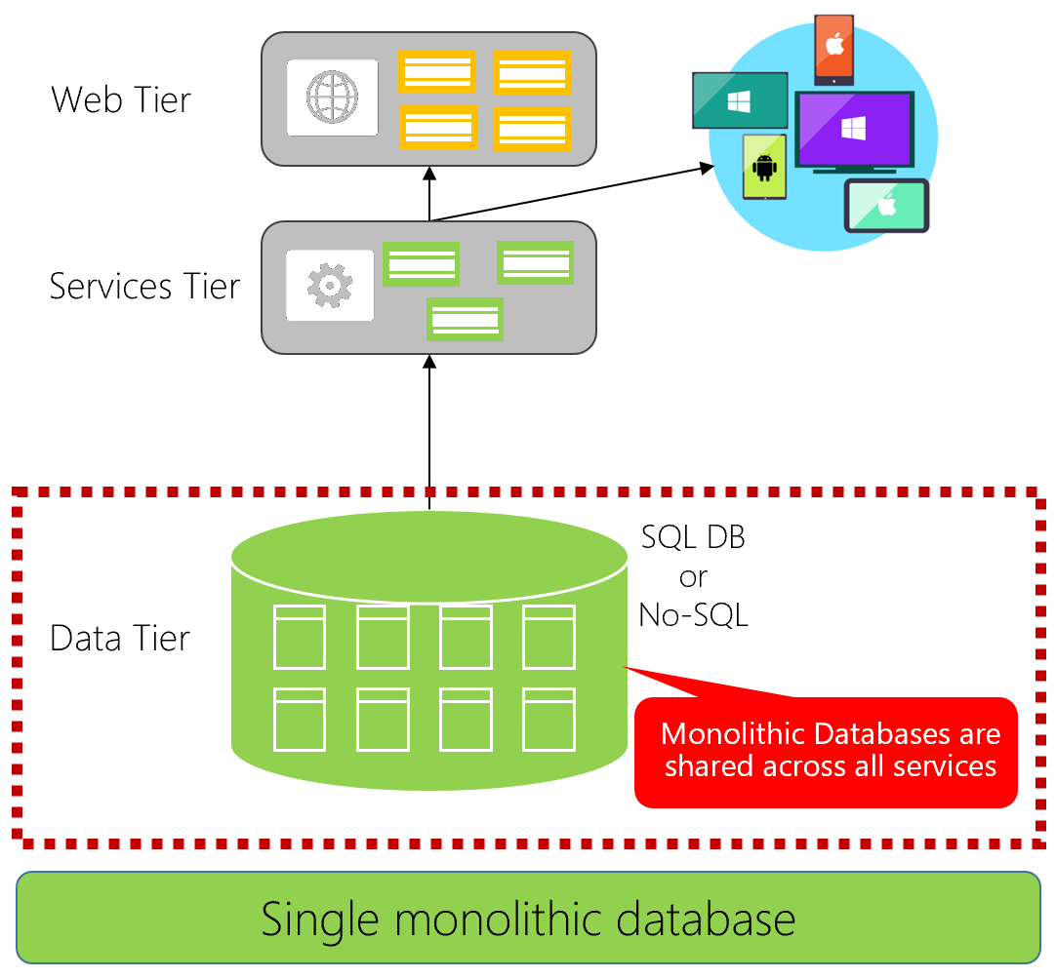

**Figure 5-1**. Single monolithic database

Note in the previous figure how all of the application components consume a single relational database.

There are many benefits to this approach. It’s straightforward to query data spread across multiple tables, and it’s straightforward to implement [ACID transactions](https://docs.microsoft.com/windows/desktop/cossdk/acid-properties) that ensure data consistency. You always end up with *immediate consistency*: Either all your data updates or none of it does.

Cloud native systems favor a data architecture shown in Figure 5-2 in which each microservice owns and encapsulates its own data.

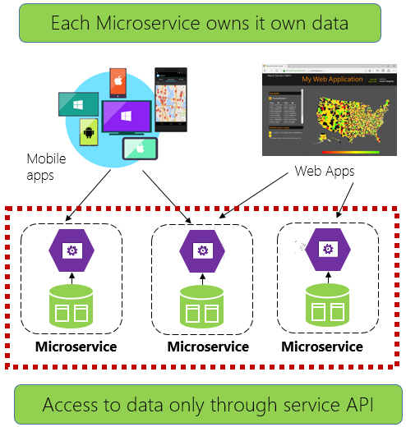

**Figure 5-2**. Multiple databases across microservices

Note how in the previous figure each microservice owns and encapsulates it data store and only exposes data to the outside world from its public API.

This model enables each microservice to evolve independently without having to coordinate data schema changes with other microservices. Each microservice is free to implement the data store (relational database, document database, key-value store) type that best matches its needs. At runtime, each microservice can scale its data accordingly. This is shown in Figure 5-3

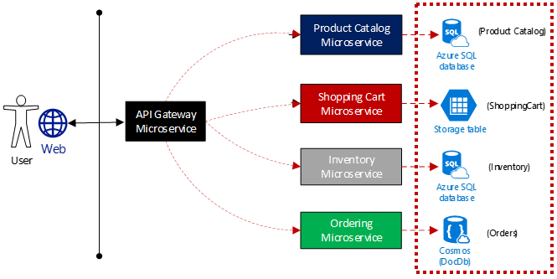

**Figure 5-3**. Polyglot data persistence

Note how in the previous figure the product catalog and inventory microservices adopt relational databases, the ordering microservice, a NoSql document database and the shopping cart microservice, an external key-value store. While relational databases remain relevant for microservices with complex data, NoSQL databases have gained considerable popularity, providing adaptability, fast lookup, and high availability. Their schemaless nature allows developers to move away from an architecture of typed data classes and ORMs that make change expensive and time-consuming.

# Cloud native data patterns

While decentralized data can lead to improved performance, scalability and cost savings, it also presents many challenges. Querying for data across microservices is complex. A transaction that spans microservices must be managed programmatically as distributed transactions are not supported in cloud-native applications. You move from a world of *immediate consistency* to *eventual consistency*.

We discuss these challenges now.

## Cross-service queries

How does an application query data that is spread across many independent microservices?

Figure 5-4 shows this scenario.

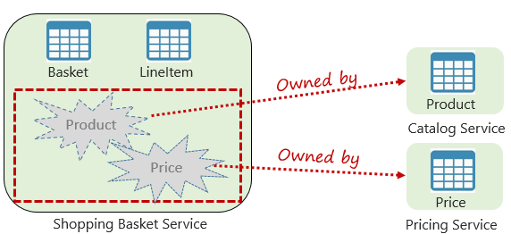

**Figure 5-4**. Querying across microservices

Note how in the previous figure we see a shopping basket microservice that adds an item to a user’s shopping cart. While the shopping basket’s data store contains a basket and lineItem table, it does not contain product or pricing data as those items are found in the product and price microservices. In order to add an item, the shopping basket microservice needs product data and pricing data. What are options to obtain the product and pricing data?

Figure 5-5 shows the shopping basket microservice making a direct HTTP call to both the product catalog and pricing microservices.



**Figure 5-5**. Direct HTTP communication

While feasible to implement, in chapter 4 we discussed how direct HTTP calls across microservices couple the system and are not considered a good practice.

We could implement an aggregator microservice shown in Figure 5-6.

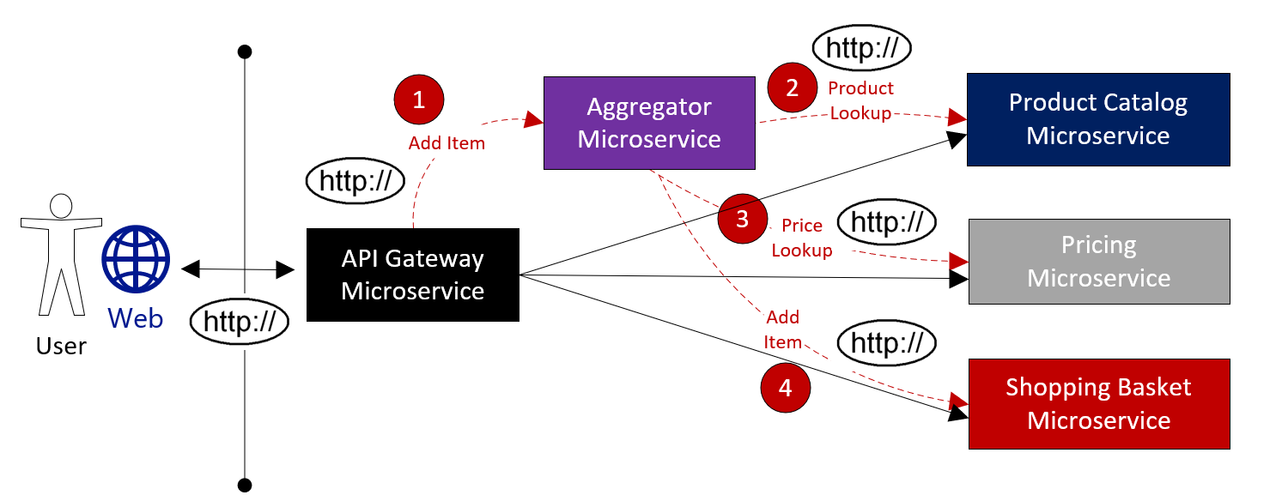

**Figure 5-6.** Aggregator microservice

While this approach encapsulates the business operation workflow inside of an individual microservice, it adds complexity and still results in direct HTTP calls.

A common approach for executing cross-service queries utilizes the [Materialized View Pattern](https://docs.microsoft.com/azure/architecture/patterns/materialized-view), shown in Figure 5-7.

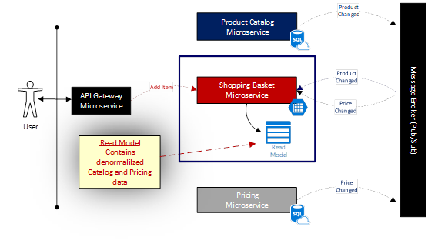

**Figure5-7**. Materialized View Pattern

With this pattern, you directly place a local table (known as a *read model*) in the shopping basket service that contains a denormalized copy of the data that is needed from the product and pricing microservices. Placing that data inside the shopping basket microservice eliminates the need for invoking expensive cross-service calls. With the data local to the service, you improve response time and reliability.

The catch with this approach is you now have duplicate data in your system. In cloud native systems, duplicate data is not considered an [anti-pattern](https://en.wikipedia.org/wiki/Anti-pattern) and is commonly implemented in cloud-native systems. However, one and only one system can be the owner of any dataset, and you will need to implement a synchronization mechanism for the system of record to update all of the associated read models, whenever a change to its underlying data occurs.

## Transactional support

While queries across microservices are challenging, implementing a transaction across microservices can be complex. The inherent challenge of maintaining data consistency across data sources that reside in different microservices cannot be understated. Figure 5-8 shows the problem.

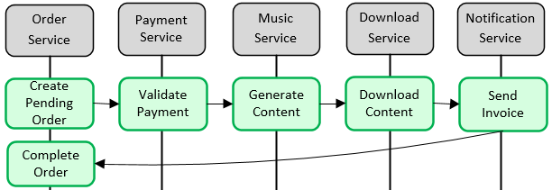

**Figure 5-8**. Implementing a transaction across microservices

Note how in the previous figure five independent microservices all participate in a distributed *Create Order* transaction. However, the transaction for each of the five individual microservices must succeed, or all must abort and roll-back the operation. While built-in transactional support is available inside each of the microservices, there is no support for a distributed transaction across all five services.

Since transactional support is essential for this operation to keep the data consistent in each of the microservices, you have to progammatically construct a distributed transaction.

A popular pattern for programmatically adding transactional support is the [Saga pattern](https://blog.couchbase.com/saga-pattern-implement-business-transactions-using-microservices-part/). It is implemented by grouping local transactions together and sequentially invoking each one. If a local transaction fails, the Saga aborts the operation and invokes a set of [compensating transactions](https://docs.microsoft.com/azure/architecture/patterns/compensating-transaction) to undo the changes made by the preceding local transactions. Figure 5-9 shows a failed transaction with the Saga pattern.

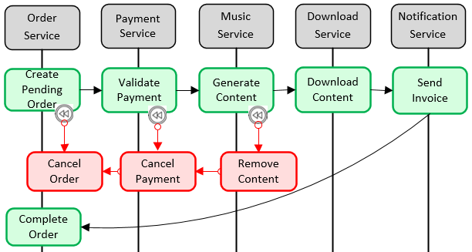

**Figure 5-9**. Rolling back a transaction

Note how in the previous figure the *GenerateContent* operation has failed in the music microservice. The Saga invokes compensating transactions (in red) to remove the content, cancel the payment, and cancel the order, returning the data for each microservice back to a consistent state.

Saga patterns are typically choreographed as a series of related events or orchestrated as a set of related commands.

## CQRS pattern

CQRS, or [Command and Query Responsibility Segregation](https://docs.microsoft.com/azure/architecture/patterns/cqrs), is an architectural pattern that separate operations that read data from those that write data. This pattern can help maximize performance, scalability, and security.

In normal data access scenarios, you implement a single model (entity and repository object) that perform *both* read and write data operations.

However, a more advanced data access scenario might benefit from separate models and data tables for reads and writes. To improve performance, the read operation, known as a *query*, might query against a highly denormalized representation of the data to avoid expensive repetitive table joins. Whereas the *write* operation, known as a *command*, might update against a fully normalized representation of the data. You would then need to implement a mechanism to keep both representations in sync. Typically, whenever the write table is modified, it raises an event that replicates the data modification to the read table.

Figure 5-10 shows an implementation of the CQRS pattern.

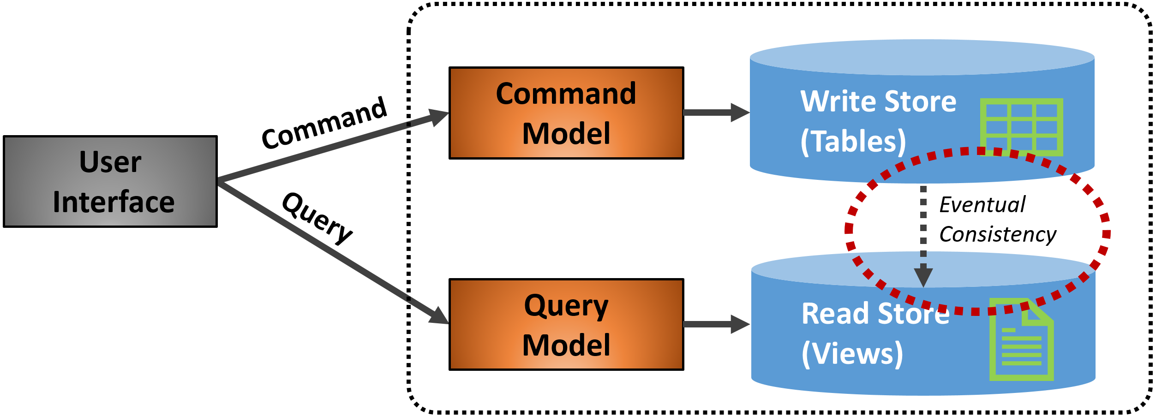

**Figure 5-10**. CQRS implementation

Note how in the previous figure separate command and query models are implemented. Moreover, each data write operation is saved to the write store and then propagated to the read store. Pay close attention to how the propagation process operates on the principle of [eventual consistency](http://www.cloudcomputingpatterns.org/eventual_consistency/), whereas the read model eventually synchronizes with the write model, but there may be some lag in the process.

By implementing separation, you have the ability to scale reads and writes separately. As well, you might impose tighter security on write operations than those concerning reads.

Typically, CQRS patterns are applied to limited sections of your system based upon specific needs.

## Relational vs NoSQL

The impact of [NoSQL](https://www.geeksforgeeks.org/introduction-to-nosql/) technologies cannot be overstated, especially for distributed cloud native systems. The proliferation of new data technologies in this space has disrupted solutions that once exclusively relied on relational databases.

On the one side, relational databases have been a prevalent technology for decades. They are mature, proven, and widely implemented. Competing database products, expertise and tooling abounds. Relational databases provide a store of related data tables. These tables have a fixed schema, use SQL (Structured Query Language) to manage data and have [ACID](https://www.geeksforgeeks.org/acid-properties-in-dbms/) (also known as Atomicity, Consistency, Isolation, and Durability) guarantees.

No-SQL databases, on the other side, refer to high-performance, non-relational data stores. They excel in their ease-of-use, scalability, resilience and availability characteristics. Instead of joining tables of normalized data, NoSQL stores self-describing (schemaless) data typically in JSON documents. They do not offer [ACID](https://www.geeksforgeeks.org/acid-properties-in-dbms/) guarantees.

A way to understand the differences between these types of databases can be found in the [CAP theorem](https://towardsdatascience.com/cap-theorem-and-distributed-database-management-systems-5c2be977950e), a set of principles that can be applied to distributed systems that store state. Figure 5-11 shows the three properties of the CAP theorem.

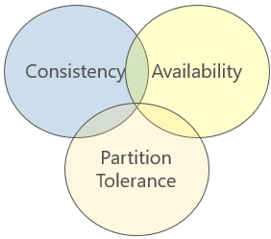

**Figure 5-11**. The CAP theorem

The theorem states that any distributed data system will offer a trade-off between consistency, availability, and partition tolerance, and that any database can only guarantee two of the three properties:

* *Consistency.* Every node in the cluster will respond with the most recent data, even if it requires blocking a request until all replicas are correctly updated.
* *Availability.* Every node will return a response in a reasonable amount of time, even if that response is not the most recent data.
* *Partition Tolerance.* Guarantees that the system will continue operating if a node fails or loses connectivity with another.

Relational databases exhibit consistency and availability, but not partition tolerance. Partitioning a relational database, such as sharding, is difficult and can impact performance.

On the other hand, NoSQL databases typically exhibit partition tolerance, known as horizontal scalability, and high availability. As the CAP theorem specifies, you can only have two of the three principles, and you lose the consistency property.

NoSQL databases are distributed and commonly scaled out across commodity servers. Doing so can provide great availability, both within and across geographical regions at a reduced cost. Data can be partitioned and replicated across these machines, or nodes, providing redundancy and fault tolerance. The downside is consistency. A change to data on one NoSQL node can take some time to propagate to other nodes. Typically, a NoSQL database node will provide an immediate response to a query, even if the data that it is presenting is stale and has not been updated yet.

This is known [eventual consistency](http://www.cloudcomputingpatterns.org/eventual_consistency/), a characteristic of distributed data systems where ACID transactions are not supported. It is a brief delay between the update of a data item and time that it takes to propagate that update to each of the replica nodes. If you update a product item in a NoSQL database in the United States, but at same time query that same data item from a replica node in Europe, you might retrieve the earlier product information - until the European node has been updated with product change. The trade-off is that by giving up [strong consistency](https://en.wikipedia.org/wiki/Strong_consistency), waiting for all replica nodes to update before returning a query result, you are able to support enormous scale and traffic volume, but with the possibility of presenting older data.

NoSQL databases can be categorized by the following four models:

* *Document Store.* (mongodb, couchdb, couchbase) Data (and corresponding metadata) is stored non-relationally in denormalized JSON-based documents inside the database.
* *Key/Value Store.* (redis, riak, memcached) Data is stored in simple key-value pairs with system operations performed against a unique access key that is mapped to a value of user data.
* *Wide-Column Store.* (hbase, Cassandra) Related Data is stored in a columnar format as a set of nested-key/value pairs within a single column with data typically retrieved as a single unit without having to join multiple tables together.
* *Graph stores.* (neo4j, titan) Data is stored as a graphical representation within a node along with edges that specify the relationship between the nodes.

NoSQL databases can be optimized to deal with large-scale data, especially when the data is relatively simple. Consider a NoSQL database when:

* Your workload requires large-scale and high-concurrency.
* You have large numbers of users.
* Your data can be expressed simply without relationships.
* You need to geographically distribute your data.
* You don’t need ACID guarantees.
* Will be deployed to commodity hardware.

Then, consider a relational database when:

* Your workloads require medium to large-scale.
* Concurrency isn’t a major concern.
* ACID guarantees are needed.
* Data is best expressed relationally.
* Your application will be deployed to large, high-end hardware.

Next, we look at data storage in the Azure cloud.

# Data storage in Azure

As we’ve seen throughout this book, the cloud is changing the way applications are designed, deployed and managed. When moving to the cloud, a critical question is how do you move your data? Fortunately, the Azure cloud offers many options.

You could simply provision an Azure virtual machine and install your database of choice. This is known as [Infrastructure as a Service (IaaS)](https://www.techopedia.com/definition/141/infrastructure-as-a-service-iaas). This approach simplifies moving an on-premises database to the cloud, as-is, but shifts the burden of managing the virtual machine and the database to you.

Instead, a fully-managed [Database as a Service (DBaaS)](https://www.stratoscale.com/blog/dbaas/what-is-database-as-a-service/) is a better option. You get many built-in features while the hosting, maintenance, and licensing is managed by Microsoft. Azure features a variety of fully-managed data storage options, each with specific benefits. They all support just-in-time capacity and a pay-as-you-go model.

We’ll next look at DBaaS options available in Azure. You will see how Microsoft continues is commitment to keeping Azure an “open platform,” offering managed support for numerous open-source relational and NoSQL databases and making key contributions to the various open-source foundations as an active member.

## Azure SQL Database

[Azure SQL Database](https://docs.microsoft.com/azure/sql-database/) is a feature-rich, general-purpose relational database-as-a-service (DBaaS) based on the Microsoft SQL Server Database Engine. It’s fully managed by Microsoft and is a high-performance, reliable, and secure cloud database. The service shares many of the features found in the on-premises version of SQL Server.

You can provision a SQL Database server and database in minutes. When demand for your application grows from a handful of customers to millions, Azure SQL Database scales on-the-fly with minimal downtime. You can dynamically add or remove resources, including CPU power, memory, IO throughput, and storage allocated to your databases.

Figure 5-12 shows the deployment options for Azure SQL Database.

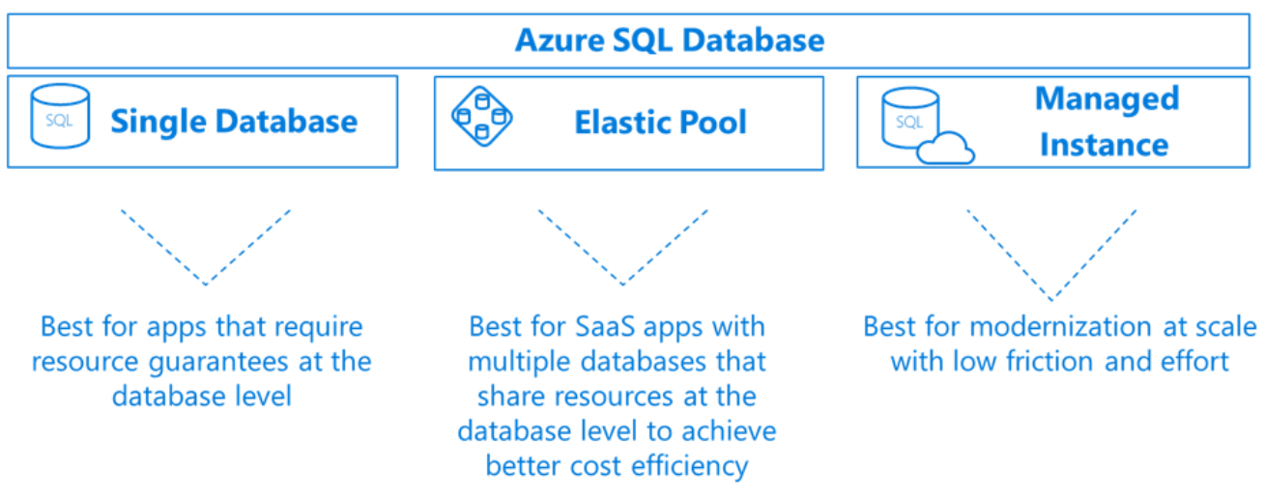

**Figure 5-12**. Azure SQL deployment options

Note the alternatives in the previous figure when deploying a SQL Database:

* A [Single database](https://docs.microsoft.com/azure/sql-database/sql-database-single-database) with its own set of resources managed by a [SQL Database server](https://docs.microsoft.com/azure/sql-database/sql-database-servers). A single database is similar to a [contained database](https://docs.microsoft.com/sql/relational-databases/databases/contained-databases) in an on-premises SQL Server deployment.
* An [Elastic pool](https://docs.microsoft.com/azure/sql-database/sql-database-elastic-pool) in which a collection of SQL Databases share a single SQL Database server at a set price. Single databases can be moved in and out of an elastic pool as needed to optimize the price performance for a group of databases.
* A [Managed Instance](https://docs.microsoft.com/azure/sql-database/sql-database-managed-instance) in which is a collection of system and user databases provide near-100% compatibility with an on-premises SQL Server. This option supports larger databases, up to 35 TB and is placed inside of an [Azure Virtual Network](https://docs.microsoft.com/azure/virtual-network/virtual-networks-overview) for better isolation.

Azure SQL Database is a fully managed [Platform as a Service (PaaS) Database Engine](https://docs.microsoft.com/azure/sql-database/sql-database-paas) which handles upgrading, patching, backups, and monitoring without user involvement. It always runs the latest stable version of the SQL Server Database Engine and patched OS and guarantees 99.99% availability. One feature, [active geo-replication](https://docs.microsoft.com/azure/sql-database/sql-database-active-geo-replication), lets you create readable secondary databases in the same or a different Azure data center. Upon failure, a failover to a secondary database can be initiated. At that point, the other secondaries automatically link to the new primary. Up to four secondary replicas are supported in either the same or in different regions, and these secondaries can also be used for read-only access queries.

Azure SQL Database includes [built-in monitoring and intelligent tuning](https://docs.microsoft.com/azure/sql-database/sql-database-monitoring-tuning-index) features that can help you maximize performance and reduce operational costs. For example, the [Automatic Tuning](https://docs.microsoft.com/azure/sql-database/sql-database-automatic-tuning) feature provides continuous performance tuning based on AI and machine learning. The service learns from your running workloads and can apply tuning recommendations. The longer an Azure SQL Database runs with automatic tuning enabled, the better it performs.

[Azure SQL Database serverless](https://docs.microsoft.com/azure/sql-database/sql-database-serverless) (available for preview at time of the writing of this book) is a compute tier for single databases that automatically scales based on workload demand, and bills for the amount of compute used per second. The serverless compute tier also automatically pauses databases during inactive periods so that only storage charges are billed. It automatically resumes when activity returns.

Finally, there is the new [Azure SQL Database Hyperscale](https://azure.microsoft.com/services/sql-database/) pricing tier. It is powered by a highly scalable storage architecture and enables your database to grow as needed, eliminating the need to pre-provision storage resources. You can scale compute and storage resources independently, providing the flexibility to optimize performance for each workload. Azure SQL Database Hyperscale is optimized for [OLTP](https://en.wikipedia.org/wiki/Online_transaction_processing) processing and high throughput analytic workloads with storage up to 100TB.  With read-intensive workloads, Hyperscale provides rapid scale-out by provisioning additional read replicas as needed for offloading read workloads.

In addition to the traditional Microsoft SQL Server stack, Azure also features managed versions of several popular open-source databases.

## Azure Database for MySQL

[MySQL](https://en.wikipedia.org/wiki/MySQL) is an [open-source](https://en.wikipedia.org/wiki/Open-source_software) [relational database](https://en.wikipedia.org/wiki/Relational_database_management_system). It is a component in the [LAMP software stack](https://en.wikipedia.org/wiki/LAMP_(software_bundle)) and used by many large organizations, including Facebook, Twitter and You Tube. The community edition is available for free and the enterprise edition requires a license purchase. Originally created in 1995, the product was purchased by Sun Microsystems in 2008, which was acquired by Oracle in 2010.

[Azure Database for MySQL](https://azure.microsoft.com/services/mysql/) is a fully-managed, enterprise-ready relational database service based on the open-source MySQL Server engine. Implementing the MySQL Community edition, it includes the following Platform as a Service (PaaS) capabilities at no additional cost:

* Built-in [high availability](https://docs.microsoft.com/azure/mysql/concepts-high-availability).
* Predictable performance, using inclusive [pay-as-you-go pricing](https://docs.microsoft.com/azure/mysql/concepts-pricing-tiers).
* [Scale](https://docs.microsoft.com/azure/mysql/concepts-high-availability) as needed within seconds.
* Secured to protect sensitive data at-rest and in-motion.
* [Automatic backups](https://docs.microsoft.com/azure/mysql/concepts-backup) and [point-in-time-restore](https://docs.microsoft.com/azure/mysql/concepts-backup) for up to 35 days.
* Enterprise-grade security and compliance.

These built-in PaaS features are important for organizaitons who have hundreds of “tactical” (non-strategic) databases in their data centers, but do not have the resources to perform patching, backup, security, and performance monitoring.

Additionally, the [Azure Data Migration Service](https://azure.microsoft.com/services/database-migration/) can migrate data from multiple database sources to Azure Data platforms with minimal downtime. The service generates assessment reports and provide recommendations to guide you through the changes required to performing a migration, both small or large.

The managed [Azure MySQL server](https://docs.microsoft.com/azure/mysql/concepts-servers) is the central administrative point for the service. It is the same MySQL server engine used for on-premises deployments. With it, you can create a single database per server to consume all resources or create multiple databases per server to share resources. Your team can continue to develop applications with the open-source tools and platform of your choice without having to learn new skills or manage virtual machines and infrastructure.

## Azure Database for MariaDB

[MariaDB](https://mariadb.com/) Server is another popular open-source database server. It was created as a fork of MySQL by the original developers of MySQL at the time that Oracle purchased Sun Microsystems who owned MySQL. The intent was to ensure that MariaDB remained open-source.

Since MariaDB is a [fork of MySQL](https://blog.panoply.io/a-comparative-vmariadb-vs-mysql), the data and table definitions are compatible, and the client protocols, structures, and APIs, are close-knit. MySQL data connectors will work MariaDB without modification.

MariaDB has a strong following and is used by many large enterprises. While Oracle continues to maintain, enhance and support MySQL, MariaDB is managed by the MariaDB Foundation allowing public contributions to the product and documentation.

[Azure Database for MariaDB](https://azure.microsoft.com/services/mariadb/) is a fully-managed database as a service in the Azure cloud. It is based on the [MariaDB community edition](https://mariadb.org/download/) server engine. It can handle mission-critical workloads with predictable performance and dynamic scalability. Similar to the other Azure Database platforms, it includes many Platform-as-a-Service capabilities at no additional cost:

* Built-in [high availability](https://docs.microsoft.com/azure/mariadb/concepts-high-availability).
* Predictable performance, using inclusive [pay-as-you-go pricing](https://docs.microsoft.com/azure/mariadb/concepts-pricing-tiers).
* [Scaling](https://docs.microsoft.com/azure/mariadb/concepts-high-availability) as needed within seconds.
* Secured protection of sensitive data at rest and in-motion.
* [Automatic backups](https://docs.microsoft.com/azure/mariadb/concepts-backup) and [point-in-time-restore](https://docs.microsoft.com/azure/mariadb/concepts-backup) for up to 35 days.
* Enterprise-grade security and compliance.

## Azure Database for PostgreSQL

[PostgreSQL](https://www.postgresql.org/) is another popular, open-source relational database with over 30 years of active development. It is a general purpose and object-relational database management system. Its licensing is considered to be “liberal” and the product is free to use, modify, and distribute in any form. Many large enterprises including Apple, Red Hat, and Fujitsu have built products using PostgreSQL.

[Azure Database for PostgreSQL](https://azure.microsoft.com/services/postgresql/) is a fully-managed relational database service, based on the open-source Postgres database engine. It can handle mission-critical workloads with predictable performance, security, high availability, and dynamic scalability. It supports several open source frameworks and languages—including C++, Java, Python, Node, C#, and PHP. It enables [migration](https://datamigration.microsoft.com/scenario/postgresql-to-azurepostgresql?step=1) of PostgreSQL databases through a command line interface or the [Azure Data Migration Service](https://azure.microsoft.com/services/database-migration/).

The service includes [built-in intelligence](https://docs.microsoft.com/azure/postgresql/concepts-monitoring) that studies your unique database patterns and provides customized recommendations and insights to help you maximize the performance of your PostgreSQL database. [Advanced Threat Protection](https://docs.microsoft.com/azure/postgresql/concepts-data-access-and-security-threat-protection) monitors your database around the clock and detects potential malicious activities, alerting you upon detection so you can intervene right away.

Azure Database for PostgreSQL is available as two deployment options: Single Server and Hyperscale (Citus), available for preview at time of the writing of this book

* The [Single Server](https://docs.microsoft.com/azure/postgresql/concepts-servers) deployment option is a central administrative point for multiple databases. It is the same PostgreSQL server engine available for on-premises deployments. With it, you can create a single database per server to consume all resources or create multiple databases to share the resources. The pricing is structured per-server based upon cores and storage.
* The [Hyperscale (Citus) option](https://azure.microsoft.com/blog/get-high-performance-scaling-for-your-azure-database-workloads-with-hyperscale/) is powered by [Citus Data](https://www.citusdata.com/) technology. It enables high-performance scaling by horizontally scaling a single database across hundreds of nodes to deliver blazingly fast performance and scale. This option allows the engine to fit more data in memory, parallelize queries across hundreds of nodes, and index data faster. The Hyperscale feature is compatible with the latest innovations, versions, and tools for PostgreSQL, so you can leverage your existing PostgreSQL expertise.

## Cosmos DB

Azure Cosmos DB is a fully-managed, globally distributed NoSQL database service that’s designed to provide low latency, elastic scalability, managed data consistency, and high availability. In short, if your application needs guaranteed fast response time anywhere in the world, if it’s required to be always online and needs unlimited and elastic scalability of throughput and storage, Cosmos DB is a great choice. Figure 5-13 shows a high-level overview of Cosmos DB.

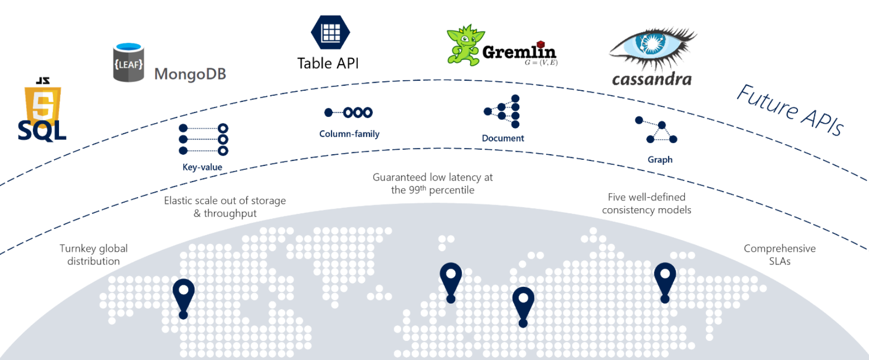

**Figure 5-13**: Overview of Cosmos DB

Note in the Figure 5-13 how Cosmos DB is a robust and highly-versatile database service with many built-in cloud-native capabilities. In this section, we’ll take a closer look at them.

### Global Support

You can globally distribute Cosmos databases across all Azure regions across the world, placing data close to your users, improving response time, and reducing latency. You can add or remove a database from a region without pausing or redeploying your application. In the background, Cosmos DB transparently replicates the data to all of the configured regions.

Cosmos DB supports [active/active](https://kemptechnologies.com/white-papers/unfog-confusion-active-passive-activeactive-load-balancing/) clustering at the global level, enabling you to configure any or all your database regions to support both writes and reads.

The [Multi-Master](https://docs.microsoft.com/azure/cosmos-db/how-to-multi-master) protocol feature in Cosmos DB enables the following functionality:

* Unlimited elastic write and read scalability.
* 99.999% read and write availability all around the world.
* Guaranteed reads and writes served in less than 10 milliseconds at the 99th percentile.

Internally, Cosmos DB handles data replication between regions with consistency level guarantees and financially backed service level agreements.

With the Cosmos DB [Multi-Homing APIs](https://docs.microsoft.com/azure/cosmos-db/distribute-data-globally), your application can automatically become aware of the nearest Azure region and send requests to it. The nearest region is identified by Cosmos DB without any configuration changes. Should a region become unavailable, Cosmos DB supports automatic failover, and the Multi-Homing feature will automatically route your request to the next nearest available region.

### Multi-Model Support

Cosmos DB is a *multi-model data platform* enabling you to interact with your data using a number of supported NoSQL models, including documents, key-value pairs, wide-column, and graph representations. Internally, data is stored in a simple [struct](https://docs.microsoft.com/dotnet/csharp/programming-guide/classes-and-structs/using-structs) format made up of primitive data types, including strings, bools, and numbers. For each request, the database engine translates data into the model representation you have selected. You can choose from a proprietary Cosmos DB SQL-based API or any of the [compatibility APIs](https://www.wikiwand.com/en/Cosmos_DB) shown in Figure 5-14.

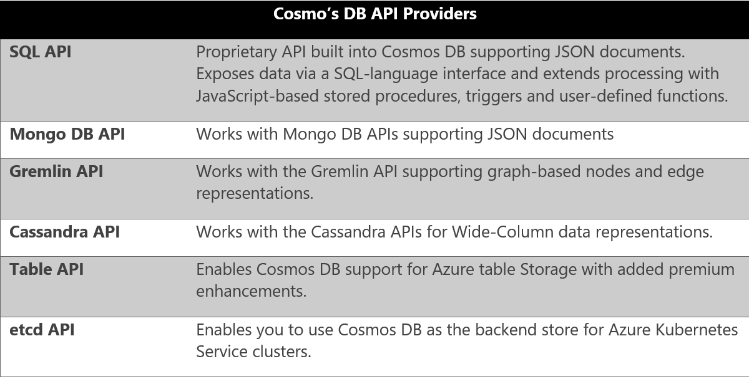

**Figure 5-14**: Cosmos DB providers

Note in Figure 5-14 how Cosmos DB supports [Table Storage](https://azure.microsoft.com/services/storage/tables/). Both Cosmos DB and [Azure Table Storage](https://docs.microsoft.com/azure/cosmos-db/table-storage-overview) share the same underlying table model and expose many of the same table operations. However, the [Cosmos DB Table API](https://docs.microsoft.com/azure/cosmos-db/table-introduction) provides many premium enhancements not available in the Azure Storage API. These features are contrasted in Figure 5-15.

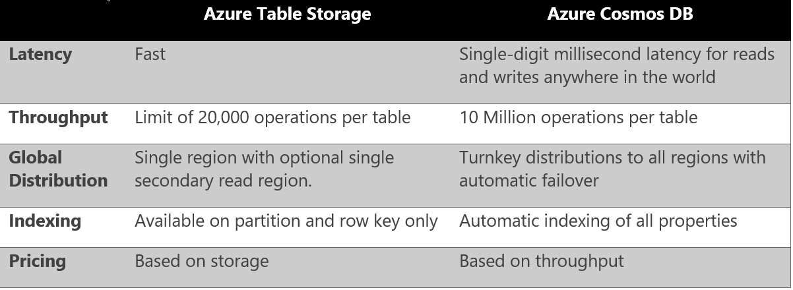

**Figure 5-15**: Azure Table API

Applications written for Azure Table storage can migrate to Azure Cosmos DB by using the Table API with no code changes.

In [Brownfield}(https://en.wikipedia.org/wiki/Brownfield_(software_development) application scenarios, development teams can migrate existing Mongo, Gremlin, or Cassandra databases into Cosmos DB with minimal changes to the existing data or application code. For [Greenfield](https://en.wikipedia.org/wiki/Greenfield_project) scenarios, development teams can choose the data model that best meets their requirements and preferences, including fully-supported open-source options for the MongoDB, Cassandra, and Gremlin platforms.

### Consistency Models

Earlier in the *Relational vs. NoSQL* section, we discussed the subject of *data consistency*, which is a term that refers to the integrity of your data. Distributed databases that rely on replication for high availability, low latency, or both, must make a fundamental tradeoff between read consistency, availability, and latency.

Most distributed databases allow developers to choose between two consistency models: [strong consistency](https://en.wikipedia.org/wiki/Strong_consistency) and [eventual consistency](https://en.wikipedia.org/wiki/Eventual_consistency). *Strong consistency* is the gold standard of data programmability. It guarantees that a query result will always return the most current data, even if it the system must incur latency waiting for an update to replicate across all database copies. On the other hand, a system configured for *eventual consistency* will return data immediately, even if that data is not the most current copy. This option enables higher availability, greater scale, and increased performance.

Azure Cosmos DB offers a spectrum of [five well-defined consistency models](https://docs.microsoft.com/azure/cosmos-db/consistency-levels) shown in Figure 5-16. These options enable you to make precise choices and granular tradeoffs with respect to availability and performance based on the needs of your application. These models are well-defined, intuitive, and backed by the service level agreements (SLAs).

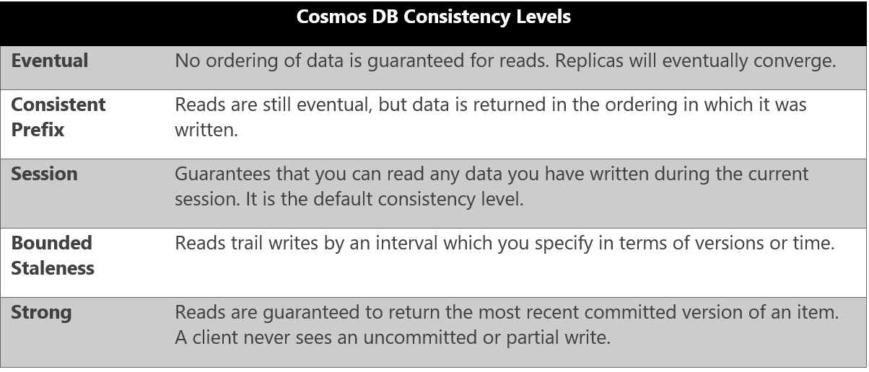

**Figure 5-16**: Cosmos DB Consistency Levels

### Partitioning

Azure Cosmos DB uses automatic [partitioning](https://docs.microsoft.com/azure/cosmos-db/partitioning-overview) to scale the database to meet the performance needs of your application.

You manage data in Cosmos DB data by creating [databases, containers and items](https://docs.microsoft.com/azure/cosmos-db/databases-containers-items), shown in Figure 5-17.

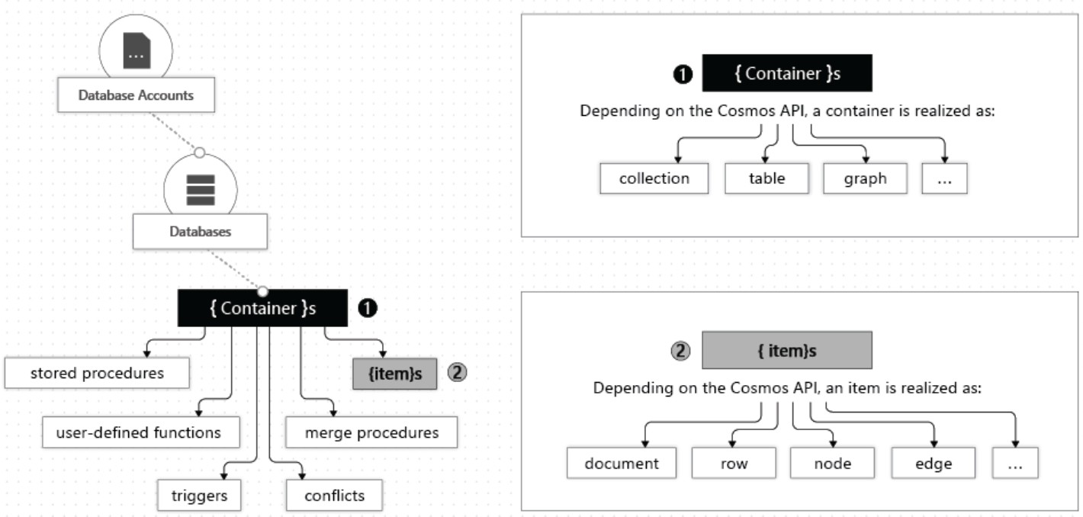

**Figure 5-17**: Hierarchy of Cosmos DB entities

Note in Figure 5-17 how you start by creating a Cosmos DB database inside of an Azure account. That database becomes the unit of management for a set of containers. A container is a schema-agnostic grouping of items that can be expressed as a collection, table or graph, based on your selected API provider (discussed in the prior section). Items are the data that you add to the container and are represented as documents, rows, nodes, or edges. By default, all items that you add to a container are automatically indexed without requiring explicit index or schema management.

To partition the container, items are divided into distinct subsets called [logical partitions](https://docs.microsoft.com/azure/cosmos-db/partition-data). Logical partitions are created based on the value of a partition key that is associated with each item in a container. Figure 5-18 shows how all items in a logical partition have the same partition key value.

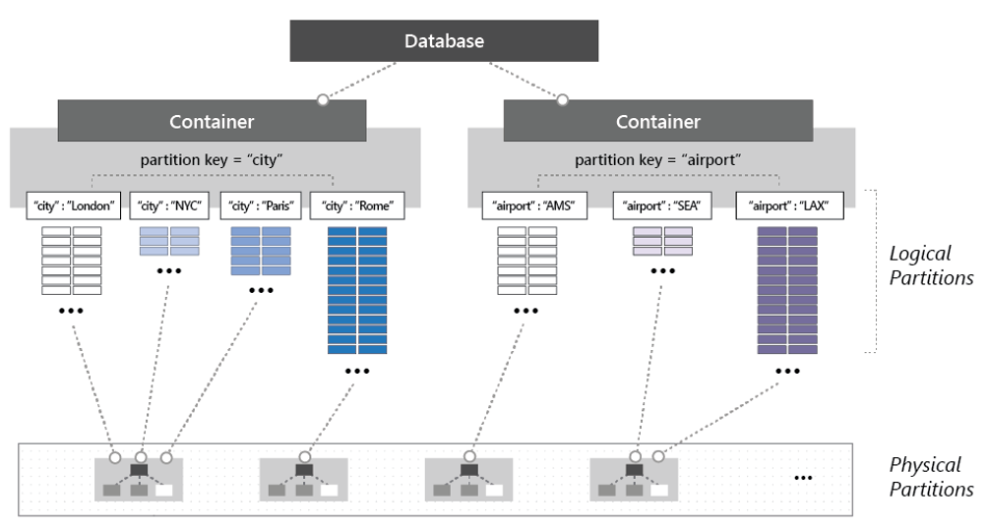

**Figure 5-18**: Cosmos DB partitioning mechanics

Note in Figure 5-18 how each item includes a partition key of either ‘city’ or ‘airport’. This partition key determines the item’s logical partition. Each city code is assigned to a logical partition in the container on the left-side and those with an airport code to the container on the right. Combining the partition key value with an item’s ID value creates the item’s index, which uniquely identifies the item.

Internally, Cosmos DB automatically manages the placement of [logical partitions](https://docs.microsoft.com/azure/cosmos-db/partition-data) on [physical partitions](https://docs.microsoft.com/azure/cosmos-db/partition-data) to efficiently satisfy the scalability and performance needs of the container. As the throughput and storage requirements of an application increase, Azure Cosmos DB moves logical partitions to redistribute the load across a greater number of servers. These redistribution operations are managed by Cosmos DB and are performed without any interruption or downtime.

## Azure Redis Cache

The benefits of caching to improve performance and scalability are well understood.

For a cloud native application, a common location to add caching is inside the API Gateway. The gateway serves as a front-end for all incoming requests. By adding caching, you can increase performance and responsiveness by returning cached data and avoiding round-trips to a local database or downstream service. Figure 5-19 shows a caching architecture for a cloud-native application.

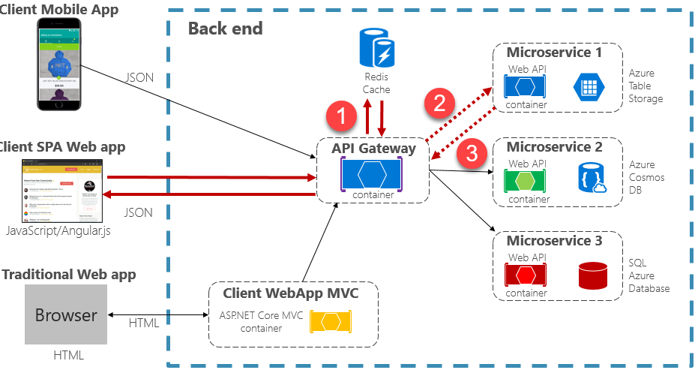

**Figure 5-19**: Caching in a cloud native app

A common caching pattern is the [cache-aside pattern](https://docs.microsoft.com/azure/architecture/patterns/cache-aside). For an incoming request, you first query the cache for the response, shown in step #1 in Figure 5-19. If found, the data is returned immediately. If the data does not exist in the cache (known as a [cache miss](https://www.techopedia.com/definition/6308/cache-miss)), it is retrieved from the local database or downstream service (step #2), written to the cache for future requests (step #3), and returned to the caller. Care must be taken to periodically evict cached data so that the system remains consistent and accurate.

Additionally, note in Figure 5-19 how the cache is not implemented locally within the boundaries of the service, but instead is consumed as a cloud-based backing service, as discussed in Chapter 1.

[Azure Redis Cache](https://azure.microsoft.com/services/cache/) is a data caching and messaging broker service. It provides high throughput and low-latency access to data for applications. It is fully-managed by Microsoft, hosted within Azure, and accessible to any application within or outside of Azure.

Internally, Azure Cache for Redis is backed by the open-source [Redis server](https://redis.io/) and natively supports data structures such as [strings](http://redis.io/topics/data-types#strings), [hashes](http://redis.io/topics/data-types#hashes), [lists](http://redis.io/topics/data-types#sets), [sets](http://redis.io/topics/data-types#sets), and [sorted sets](http://redis.io/topics/data-types#sorted-sets). If your application uses Redis, it’ll work as-is with Azure Cache for Redis.

Azure Cache for Redis can also be used as an in-memory data cache, a distributed non-relational database, and a message broker. It is available in 3 different pricing tiers. The Premium tier features many enterprise-level features such as clustering, data persistence, geo-replication, and Virtual-network security and isolation.

## Summary

## Additional resources

Cloud native resiliency

Resiliency is the ability of your system to react to failure and still remain functional. It isn’t about avoiding failure. But it’s about accepting that failure is inevitable in cloud-based systems and building your application to respond to it. The end-goal of resiliency is to return the application to a fully functioning state after a failure.

Unlike traditional monolithic applications, where everything runs together in a single process, cloud native systems embrace distributed architecture as shown in Figure 6-1:

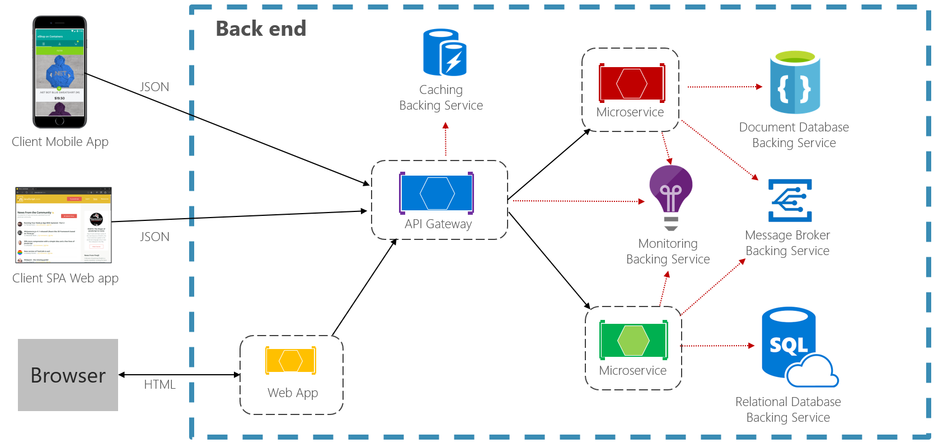

**Figure 6-1.** Distributed cloud native environment

In the previous figure, note how each client, microservice, and cloud-based [backing service](https://12factor.net/backing-services) executes as a separate process, running across different servers, all communicating via network-based calls.

So, what could go wrong?

* Unexpected [network latency](https://www.techopedia.com/definition/8553/network-latency).
* [Transient faults](https://docs.microsoft.com/azure/architecture/best-practices/transient-faults) (temporary network connectivity errors).
* Blocking by a long-running synchronous operation.
* A host process that has crashed and is being restarted or moved.
* An overloaded microservice that can’t respond for a short time.
* An in-flight DevOps operation such as an update or scaling operation.
* An Orchestrator operation such as moving a service from one node to another.
* Hardware failures from commodity hardware.

When deploying distributed services into cloud-based infrastructure, the factors from the previous list become very real and you must architect and develop defensively to deal with them.

In a small-scale distributed system, failure will be less frequent, but as a system scales up and out, you can expect to experience more of these issues to a point where partial failure becomes normal operation.

Therefore, your application and infrastructure must be resilient. In the following sections, we’ll explore defensive techniques that you can add to your application and built-in cloud features that you can leverage to help bullet-proof your user’s experience.

# Application resiliency patterns

The first line of defense is software-enabled application resiliency.

While you could invest considerable time writing your own resiliency framework, such products already exist. For example, [Polly](http://www.thepollyproject.org/) is a comprehensive .NET resilience and transient-fault-handling library that allows developers to express resiliency policies in a fluent and thread-safe manner. Polly targets applications built with either the full .NET Framework or .NET Core. Figure 6-2 shows the resiliency policies (that is, functionality) available from the Polly Library. These policies can be applied individually or combined together.

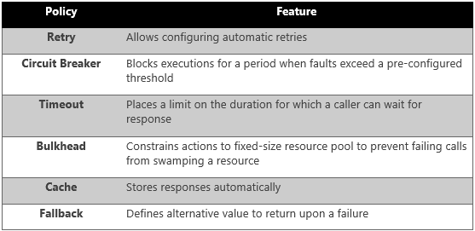

**Figure 6-2**. Polly resiliency framework features

Note how in the previous figure the resiliency policies apply to request messages, whether coming from an external client or another backend service. The goal is to compensate the request for a service that might be momentarily unavailable. These short interruptions typically manifest themselves with the HTTP status codes shown in Figure 6-3.

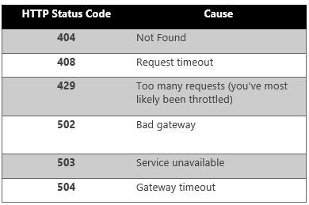

**Figure 6-3**. HTTP status codes to retry

Question: Would you retry an HTTP Status Code of 403 - Forbidden? No. Here, the system is functioning properly, but informing the caller that he or she isn’t authorized to perform the requested operation. Care must be taken to retry only those operations caused by failures.

As recommended in Chapter 1, Microsoft developers constructing cloud native applications should be targeting the .NET Core framework. Version 2.1 introduced the [HTTPClientFactory](https://www.stevejgordon.co.uk/introduction-to-httpclientfactory-aspnetcore) library for creating HTTP Client instances for interacting with URL-based resources. Superseding the original HTTPClient class, the factory class supports many enhanced features, one of which is [tight integration](https://docs.microsoft.com/dotnet/standard/microservices-architecture/implement-resilient-applications/implement-http-call-retries-exponential-backoff-polly) with the Polly resiliency library. With it, you can easily define resiliency policies in the application Startup class to to handle partial failures and connectivity issues.

Next, let’s expand on retry and circuit breaker patterns.

### Retry pattern

In a distributed cloud native environment, calls to services and cloud resources can fail because of transient (short-lived) failures, which typically correct themselves after a brief period of time. Implementing a retry strategy helps a cloud native service handle these scenarios.

The [Retry pattern](https://docs.microsoft.com/azure/architecture/patterns/retry) enables a service to retry a failed request operation a (configurable) number of times with an exponentially increasing wait time. Figure 6-4 shows a retry in action.

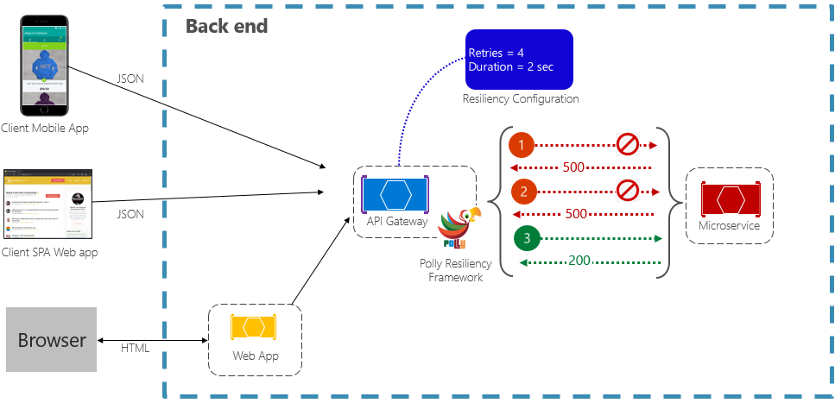

**Figure 6-4**. Retry pattern in action

In the prevous figure, a retry pattern has been implemented for a request operation. It’s configured to allow up to four retries before failing with a backoff interval (wait time) starting at two seconds, which exponentially doubles for each subsequent attempt.

* The first invocation fails and returns an HTTP status code of 500. The application waits for two seconds and reties the call.
* The second invocation also fails and returns an HTTP status code of 500. The application now doubles the backoff interval to four seconds and retries the call.
* Finally, the third call succeeds.
* In this scenario, the retry operation would have attempted up to four retries while doubling the backoff duration before failing the call.

It’s important to increase the backoff period before retrying the call to allow the service time to self-correct. It’s a best practice to implement an exponentially increasing backoff (doubling the period on each retry) to allow adequate correction time.

## Circuit breaker pattern

While the retry pattern can help salvage a request entangled in a partial failure, there are situations where failures can be caused by unanticipated events that will require longer periods of time to resolve. These faults can range in severity from a partial loss of connectivity to the complete failure of a service. In these situations, it’s pointless for an application to continually retry an operation that is unlikely to succeed.

To make things worse, executing continual retry operations on a non-responsive service can move you into a self-imposed denial of service scenario where you flood your service with continual calls exhausting resources such as memory, threads and database connections, causing failure in unrelated parts of the system that use the same resources.

In these situations, it would be preferable for the operation to fail immediately and only attempt to invoke the service if it’s likely to succeed.

The [Circuit Breaker pattern](https://docs.microsoft.com/azure/architecture/patterns/circuit-breaker) can prevent an application from repeatedly trying to execute an operation that’s likely to fail. It also monitors the application with a periodic trial call to determine whether the fault has resolved. Figure 6-5 shows the Circuit Breaker pattern in action.

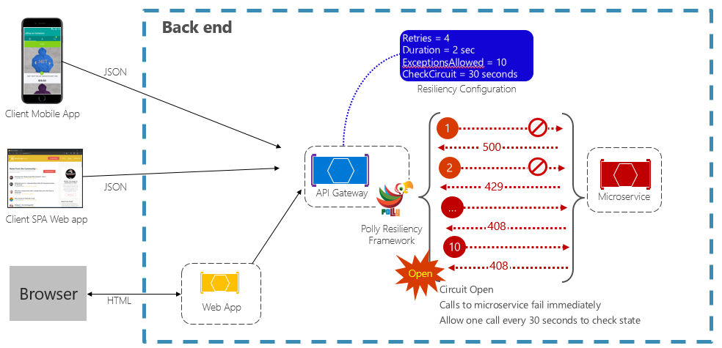

Figure 6-5. Circuit breaker pattern in action

In the previous figure, a Circuit Breaker pattern has been added to the original retry pattern. Note how after 10 failed requests, the circuit breakers opens and no longer allows calls to the service. The CheckCircuit value, set at 30 seconds, specifies how often the library allows one request to proceed to the service. If that call succeeds, the circuit closes and the service is once again available to traffic.

Keep in mind that the intent of the Circuit Breaker pattern is *different* than that of the Retry pattern. The Retry pattern enables an application to retry an operation in the expectation that it will succeed. The Circuit Breaker pattern prevents an application from doing an operation that is likely to fail. Often, an application will *combine* these two patterns by using the Retry pattern to invoke an operation through a circuit breaker. However, the retry logic should be sensitive to any exceptions returned by the circuit breaker and abandon retry attempts if the circuit breaker indicates that a fault isn’t transient.

Application resiliency is a must for handling problematic requested operations. But, it’s only half of the story. Next, we cover resiliency features available in the Azure cloud.

# Azure platform resiliency

Building a reliable application in the cloud is different from traditional on-premises application development. While historically you purchased higher-end hardware to scale up, in a cloud environment you scale out. Instead of trying to prevent failures, the goal is to minimize their effects and keep the system stable.

That said, reliable cloud applications display distinct characteristics:

* They’re resilient, recover gracefully from problems and continue to function.
* They’re highly available (HA) and run as designed in a healthy state with no significant downtime.

Understanding how these characteristics work together - and how they affect cost - is essential to building a reliable cloud native application. We’ll next look at ways that you can build resiliency and availability into your cloud native applications leveraging features from the Azure cloud.

## Design with redundancy

Failures vary in scope of impact. A hardware failure, such as a failed disk, can affect a single node in a cluster. A failed network switch could affect an entire server rack. Less common failures, such as loss of power, could disrupt a whole datacenter. Rarely, an entire region becomes unavailable.

[Redundancy](https://docs.microsoft.com/azure/architecture/guide/design-principles/redundancy) is one way to provide application resilience. The exact level of redundancy needed depends on your business requirements and will affect both cost and complexity of your system. For example, a multi-region deployment is more expensive and more complex to manage than a single-region deployment. You’ll need operational procedures to manage failover and failback. The additional cost and complexity might be justified for some business scenarios and not others.

To architect redundancy, you need to identify the critical paths in your application, and then determine if there’s redundancy at each point in the path? If a subsystem should fail, will the application fail over to something else? Finally, you need a clear understanding of those features built into the Azure cloud platform that you can leverage to meet your redundancy requirements. Here are recommendations for architecting redundancy:

* *Deploy multiple instances of services.* If your application depends on a single instance of a service, it creates a single point of failure. Provisioning multiple instances improves both resiliency and scalability. When hosting in Azure Kubernetes Service, you can declaratively configure redundant instances (replica sets) in the Kubernetes manifest file. The replica count value can be managed programmatically, in the portal or through autoscaling features, which will be discussed later on.
* *Leveraging a load balancer.* Load-balancing distributes your application’s requests to healthy service instances and automatically removes unhealthy instances from rotation. When deploying to Kubernetes, load balancing can be specified in the Kubernetes manifest file in the Services section.
* *Plan for multiregion deployment.* If your application is deployed to a single region, and the region becomes unavailable, your application will also become unavailable. This may be unacceptable under the terms of your application’s service level agreements. Instead, consider deploying your application and its services across multiple regions. For example, an Azure Kubernetes Service (AKS) cluster is deployed to a single region. To protect your system from a regional failure, you might deploy your application to multiple AKS clusters across different regions and use the [Paired Regions](https://buildazure.com/2017/01/06/azure-region-pairs-explained/) feature to coordinate platform updates and prioritize recovery efforts.
* *Enable* [geo-replication](https://docs.microsoft.com/azure/sql-database/sql-database-active-geo-replication)*.* Geo-replication for services such as Azure SQL Database and Cosmos DB will create secondary replicas of your data across multiple regions. While both services will automatically replicate data within the same region, geo-replication protects you against a regional outage by enabling you to fail over to a secondary region. Another best practice for geo-replication centers around storing container images. To deploy a service in AKS, you need to store and pull the image from a repository. Azure Container Registry integrates with AKS and can securely store container images. To improve performance and availability, consider geo-replicating your images to a registry in each region where you have an AKS cluster. Each AKS cluster then pulls container images from the local container registry in its region as shown in Figure 6-6:

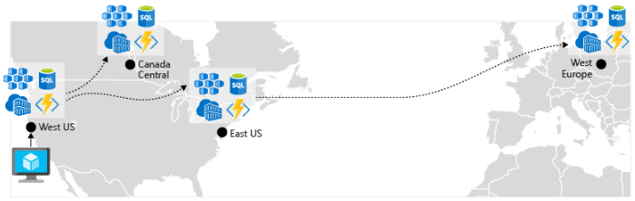

**Figure 6-6**. Replicated resources across regions

* *Implement a DNS traffic load balancer.* [Azure Traffic Manager](https://docs.microsoft.com/azure/traffic-manager/traffic-manager-overview) provides high-availability for critical applications by load-balancing at the DNS level. It can route traffic to different regions based on geography, cluster response time and even application endpoint health. For example, Azure Traffic Manager can direct customers to the closest AKS cluster and application instance. If you have multiple AKS clusters in different regions, use Traffic Manager to control how traffic flows to the applications that run in each cluster. Figure 6-7 shows this scenario.

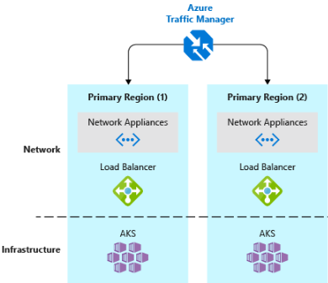

**Figure 6-7**. AKS and Azure Traffic Manager

## Design for scalability

The cloud thrives on scaling. The ability to increase/decrease system resources to address increasing/decreasing system load is a key tenet of the Azure cloud. But, to effectively scale an application, you need an understanding of the scaling features of each Azure service that you include in your application. Here are recommendations for effectively implementing scaling in your system.

* *Design for scaling.* An application must be designed for scaling. To start, services should be stateless so that requests can be routed to any instance. Having stateless services also means that adding or removing an instance doesn’t adversely impact current users.
* *Partition workloads*. Decomposing domains into independent, self-contained microservices enable each service to scale independently of others. Typically, services will have different scalability needs and requirements. Partitioning enables you to scale only what needs to be scaled without the unnecessary cost of scaling an entire application.
* *Favor scale-out.* Cloud-based applications favor scaling out resources as opposed to scaling up. Scaling out (also known as horizontal scaling) involves adding more service resources to an existing system to meet and share a desired level of performance. Scaling up (also known as vertical scaling) involves replacing existing resources with more powerful hardware (more disk, memory, and processing cores). Scaling out can be invoked automatically with the autoscaling features available in some Azure cloud resources. Scaling out across multiple resources also adds redundancy to the overall system. Finally scaling up a single resource is typically more expensive than scaling out across many smaller resources. Figure 6-8 shows the two approaches:

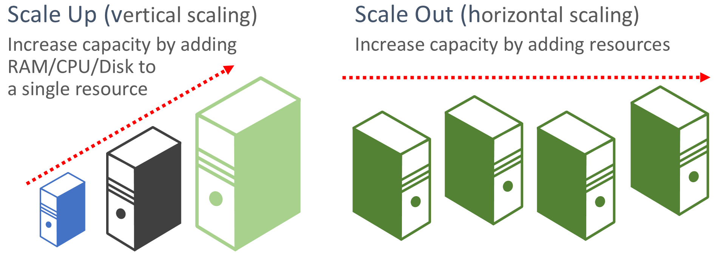

**Figure 6-8.** Scale up vs. scale out

* *Scale proportionally.* When scaling a service, think in terms of *resource sets*. If you were to dramatically scale out a specific service, what impact would that have on back-end data stores, caches and dependent services? Some resources such as Cosmos DB can scale out proportionally, while many others can’t. You want to ensure that you don’t scale out a resource to a point where it will exhaust other associated resources.
* *Avoid affinity.* A best practice is to ensure a node doesn’t require local affinity, often referred to as a *sticky session*. A request should be able to route to any instance. If you need to persist state, it should be saved to a distributed cache, such as [Azure Redis cache](https://azure.microsoft.com/services/cache/).
* *Take advantage of platform autoscaling features.* Use built-in autoscaling features whenever possible, rather than custom or third-party mechanisms. Where possible, use scheduled scaling rules to ensure that resources are available without a startup delay, but add reactive autoscaling to the rules as appropriate, to cope with unexpected changes in demand. For more information, see [Autoscaling guidance](https://docs.microsoft.com/azure/architecture/best-practices/auto-scaling).
* *Scale-up aggressively.* A final practice would be to scale up aggressively so that you can quickly meet immediate spikes in traffic without losing business. And, then scale down (that is, remove unneeded resources) conservatively to keep the system stable. A simple way to implement this is to set the cool down period, which is the time to wait between scaling operations, to five minutes for adding resources and up to fifteen minutes for removing instances.

## Built-in retry in services

We encouraged the best practice of implementing programmatic retry operations in an earlier section. Keep in mind that many Azure services and their corresponding client SDKs also include retry mechanisms. The following list summarizes retry features in the many of the Azure services that are discussed in this book:

* *Azure Cosmos DB.* The <xref:Microsoft.Azure.Documents.Client.DocumentClient> class from the client API automatically retires failed attempts. The number of retries and maximum wait time are configurable. Exceptions thrown by the client API are either requests that exceed the retry policy or non-transient errors.
* *Azure Redis Cache.* The Redis StackExchange client uses a connection manager class that includes retries on failed attempts. The number of retries, specific retry policy and wait time are all configurable.
* *Azure Service Bus.* The Service Bus client exposes a [RetryPolicy class](xref:Microsoft.ServiceBus.RetryPolicy) that can be configured with a back-off interval, retry count, and <xref:Microsoft.ServiceBus.RetryExponential.TerminationTimeBuffer>, which specifies the maximum time an operation can take. The default policy is nine maximum retry attempts with a 30-second backoff period between attempts.
* *Azure SQL Database.* Retry support is provided when using the [Entity Framework Core](https://docs.microsoft.com/ef/core/miscellaneous/connection-resiliency) library.
* *Azure Storage.* The storage client library support retry operations. The strategies vary across Azure storage tables, blobs, and queues. As well, alternate retries switch between primary and secondary storage services locations when the geo-redundancy feature is enabled.
* *Azure Event Hubs.* The Event Hub client library features a RetryPolicy property, which includes a configurable exponential backoff feature.

# Resilient communications

Throughout this book, we’ve evangelized the merits of moving beyond traditional monolithic application design and embracing a microservice-based architecture where a set of distributed, self-contained services run independently and communicate with each other using standard communication protocols such as HTTP and HTTPS. While such an architecture buys you many important benefits, it also presents many challenges. Consider for example the following concerns:

* *Out-of-process network communication.* Each service communicates over a network protocol which introduces network congestion, latency and transient faults.
* *Service discovery.* With each service running across a cluster of machines with its own IP address and port, how do services discover and communicate with each other?
* *Resiliency.* How do you manage short-lived failures and keep the system stable?
* *Load balancing.* How does inbound traffic get distributed across multiple instances of a service?
* *Security.* How are security concerns such as transport-level encryption and certificate management enforced?
* *Distributed Monitoring. - How do you correlate and capture traceability and monitoring for a single request across multiple consuming services?

While these concerns can be addressed with various libraries and frameworks, implementing them inside your codebase can be expensive, complex and time-consuming. Moreover, you end up with a solution where infrastructure concerns are coupled to business logic.

## Service mesh

A better approach is to consider a new and rapidly evolving technology entitled *Service Mesh*. A [service mesh](https://www.nginx.com/blog/what-is-a-service-mesh/) is a configurable infrastructure layer with built-in capabilities to handle service communication and many of the challenges mentioned above. It decouples these concerns from your business code and moves them into a service proxy, an instance of which accompanies each of your services. Often referred to as the [Sidecar pattern](https://docs.microsoft.com/azure/architecture/patterns/sidecar), the service mesh proxy is deployed into a separate process to provide isolation and encapsulation from your business code. However, the proxy is closely linked to the service being created along with it and sharing its lifecycle. Figure 6-9 depicts this scenario.

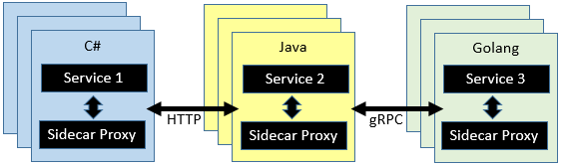

**Figure 6-9**. Service mesh with a side car

In the previous figure, note how the proxy intercepts and manages communication among the microservices and the cluster.

A service mesh is logically split into two disparate components: A [data plane](https://blog.envoyproxy.io/service-mesh-data-plane-vs-control-plane-2774e720f7fc) and [control plane](https://blog.envoyproxy.io/service-mesh-data-plane-vs-control-plane-2774e720f7fc). Figure 6-10 shows these components and their responsibilities.

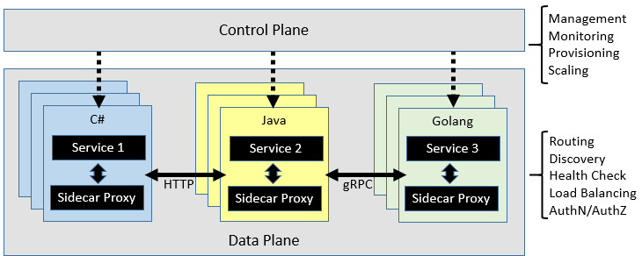

**Figure 6-10.** Service mesh control and data plane

Once configured, a service mesh is highly functional. It can retrieve a corresponding pool of instances from a service discovery endpoint. It can then send a request to a specific instance, recording the latency and response type of the result. A mesh can choose the instance most likely to return a fast response based on a variety of factors, including its observed latency for recent requests.

If an instance is unresponsive or fails, the mesh can retry the request on another instance. If a pool consistently returns errors, a mesh can evict it from the load balancing pool to be retried periodically later after it heals. If a request times out, a mesh can fail and then retry the request. A mesh captures behavior in the form of metrics and distributed tracing which then can be emitted to a centralized metrics system.

## Istio and Envoy

While a few service mesh options currently exist, [Istio](https://istio.io/docs/concepts/what-is-istio/) is the most popular as of the time of this writing. A joint venture from IBM, Google and Lyft, it is an open source offering that can be integrated into a new or existing distributed applications. It provides a consistent and complete solution to secure, connect and monitor microservices. Its features include:

* Secure service-to-service communication in a cluster with strong identity-based authentication and authorization.
* Automatic load balancing for HTTP, [gRPC](https://grpc.io/), WebSocket, and TCP traffic.
* Fine-grained control of traffic behavior with rich routing rules, retries, failovers, and fault injection.
* A pluggable policy layer and configuration API supporting access controls, rate limits and quotas.
* Automatic metrics, logs, and traces for all traffic within a cluster, including cluster ingress and egress.

A key component for an Istio implementation is a proxy service entitled the [Envoy proxy](https://www.envoyproxy.io/docs/envoy/latest/intro/what_is_envoy). Originating from Lyft and subsequently contributed to the [Cloud Native Computing Foundation](https://www.cncf.io/) (discussed in chapter 1), the Envoy proxy runs alongside each service and provides a platform-agnostic foundation for the following features:

* Dynamic service discovery.
* Load balancing.
* TLS termination.
* HTTP and gRPC proxies.
* Circuit breaker resiliency.
* Health checks.
* Rolling updates with [canary](https://martinfowler.com/bliki/CanaryRelease.html) deployments.

As previously discussed, Envoy is deployed as a sidecar to each microservice in the cluster.

## Integration with Azure Kubernetes Services

The Azure cloud embraces Istio and provides direct support for it within Azure Kubernetes Services. The following links can help you get started:

* [Installing Istio in AKS](https://docs.microsoft.com/azure/aks/istio-install)
* [Using AKS and Istio](https://docs.microsoft.com/azure/aks/istio-scenario-routing)

## Summary

(add summary here)

## Additional resources

(add references here)

Monitoring and health

Microservices and cloud native applications go hand in hand with good DevOps practices. DevOps is many things to many people but perhaps one of the better definitions comes from cloud advocate and DevOps evangelist Donovan Brown:

“DevOps is the union of people, process, and products to enable continuous delivery of value to our end users.”

Unfortunately, with terse definitions, there’s always room to say more things. One of the key components of DevOps is ensuring that the applications running in production are functioning properly and efficiently. To gauge the health of the application in production, it’s necessary to monitor the various logs and metrics being produced from the servers, hosts, and the application proper.

# Observability patterns

Just as patterns have been developed to aid in the layout of code in applications, there are patterns for operating applications in a reliable way. Three useful patterns in maintaining applications have emerged: logging, monitoring, and alerts.

## Logging

The first pattern is logging. This pattern is simply having applications write down what they’re doing. Anytime failures or problems occur in production, the goal should be to reproduce the conditions under which the failures occurred, in a non-production environment. Having good logging in place provides a roadmap for developers to follow in order to duplicate problems in an environment that can be tested and experimented with.

Every programming language has tooling that permits writing logs, and typically the overhead for writing these logs is low. Many of the logging libraries provide logging different kinds of criticalities, which can be tuned at run time. For instance, the Serilog library is a popular structured logging library for .NET that provides the following logging levels

* Verbose
* Debug
* Information
* Warning
* Error
* Fatal

These many log levels provide granularity in logging. When the application is functioning properly in production, it may be configured to only log important messages. When the application is misbehaving, then the log level can be increased so more verbose logs are gathered. This balances performance and debuggability.

The high performance of logging tools and the tunability of verbosity should encourage developers to log as frequently as possible. Many favor a pattern of logging the entry and exit of each method. This approach may sound like overkill, but it’s infrequent that developers will wish for less logging. In fact, it’s not uncommon to perform deployments for the sole purpose of adding logging around a problematic method. Err on the side of too much logging and not on too little.

In traditional applications, the log files were typically stored on the local machine. In fact, on Unix-like operating systems, there’s a folder structure defined to hold any logs, typically under /var/log. The usefulness of logging to a flat file on a single machine is vastly reduced in a cloud environment. Applications producing logs may not have access to the local disk or the local disk may be highly transient as containers are shuffled around physical machines.

Cloud applications developed with an eye to microservices also pose some challenges for the file system-based loggers of yesteryear. User interaction may now span multiple services that are run on different machines. It would be very challenging to correlate the logs from a user or a session across these many services and machines.

Finally, the number of users in some cloud applications is high. Imagine that each user generates a hundred lines of log messages when they log into an application. In isolation, that is manageable, but multiply that over 100,000 users and the volume of logs becomes large.

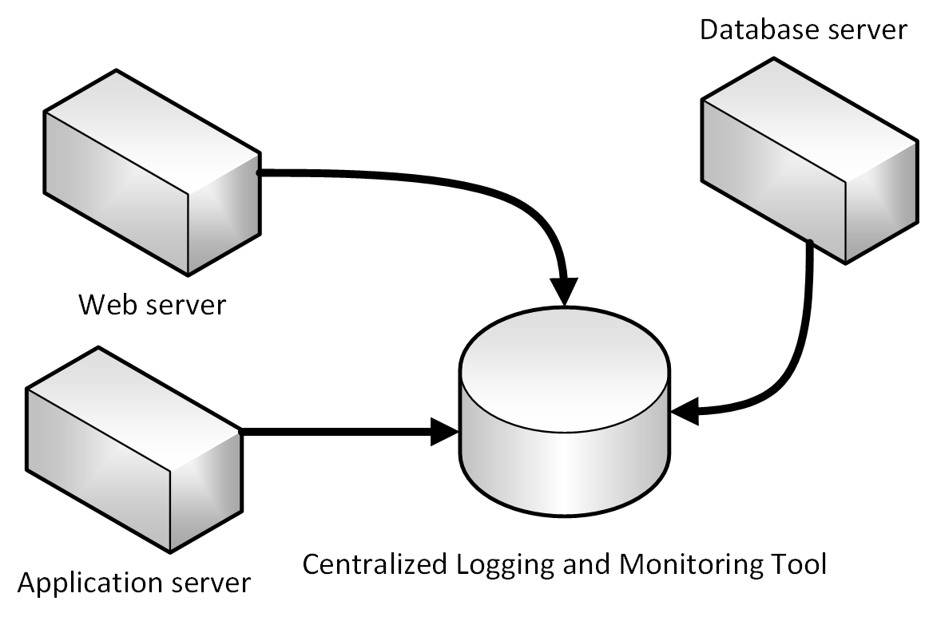

Fortunately, there are some fantastic alternatives to using file system-based logging. A centralized log server to which all logs are sent, fixes all these problems. Logs are collected by the applications and shipped to a central logging application which indexes and stores the logs. This class of system can ingest tens of gigabytes of logs every day.

It’s also helpful to follow some standard practices when building logging that spans many services. For instance, generating a [correlation ID](https://blog.rapid7.com/2016/12/23/the-value-of-correlation-ids/) at the start of a lengthy interaction, and then logging it in each message that is related to that interaction, makes it easier to search for all related messages. One need only find a single message and extract the correlation ID to find all the related messages. Another example is ensuring that the log format is the same for every service, whatever the language or logging library it uses. This standardization makes reading logs much easier.

## Monitoring

Having centralized logging is helpful in the event that a problem is discovered in the application. In an ideal world, however, end users shouldn’t be the ones reporting errors. By taking a proactive approach to failure detection, problems can be detected and corrected before the end users are even aware that there has been an issue.

Some centralized logging systems take on an additional role of collecting telemetry outside of pure logs. They can collect metrics, such as time to run an SQL query, average response time from a web server, and even CPU load averages and memory pressure as reported by the operating system. In conjunction with the logs, these systems can provide a holistic view of the health of nodes in the system and the application as a whole.

The metric gathering capabilities of the monitoring tools can also be fed manually from within the application. Business flows that are of particular interest such as new users signing up or orders being placed, may be instrumented such that they increment a counter in the central monitoring system. This unlocks the monitoring tools to not only monitor the health of the application but the health of the business.

Queries can be constructed in the log aggregation tools to look for certain statistics or patterns, which can then be displayed in graphical form, on custom dashboards. Frequently, teams will invest in large, wall-mounted displays that rotate through the statistics related to an application. This way, it’s very simple to see the problems as they occur.

## Alerts

The next logical step to improve reactions to live site incidents is to craft queries against the monitoring tools to look for known failure conditions. For instance, queries could search through the incoming logs for indications of status code 500, which indicates a problem on a web server. As soon as one of these is detected, then an e-mail or an SMS could be sent to the owner of the originating service who can begin to investigate.

Typically though, a single 500 error is not sufficient to determine that a problem has occurred. It could simply mean that a user mistyped their password or entered some malformed data. The alert queries can be crafted to only fire when a larger than average number of 500 errors are detected.

One of the most damaging patterns in alerting is to fire too many alerts for humans to investigate. Service owners will rapidly become desensitized to errors which they’ve previously investigated and found to be benign. When true errors occur then they will be lost in the noise of hundreds of false positives. The parable of the [Boy Who Cried Wolf](https://en.wikipedia.org/wiki/The_Boy_Who_Cried_Wolf) is frequently told to children to warn them of this very danger. It’s important to ensure that the alerts that do fire are indicative of a real problem.

# Elastic Stack

There are many good centralized logging tools and they vary in cost from being free, open-source tools, to some expensive options. In many cases, the free tools are as good as or better than the paid offerings. One such tool is a combination of three open-source components: Elastic search, Logstash, and Kibana. Collectively these tools are known as the Elastic Stack.

The first component is Logstash. This tool is used to gather log information from a large variety of different sources. For instance, Logstash can read logs from disk and also receive messages from logging libraries like [Serilog](https://serilog.net/). Logstash can do some basic filtering and expansion on the logs as they arrive. For instance, if your logs contain IP addresses then Logstash may be configured to do a geographical lookup and obtain a country or even city of origin for that message.

Serilog is a logging library for .NET languages, which allows for parameterized logging. Instead of generating a textual log message that embeds fields, parameters are kept separate. This allows for more intelligent filtering and searching. A sample Serilog configuration for writing to Logstash appears in Figure 8-1.

var log = new LoggerConfiguration()   
 .WriteTo.Http("http://localhost:8080")  
 .CreateLogger();

**Figure 8-1** Serilog config for writing log information directly to logstash over HTTP

Logstash would then be configured using something like the configuration shown in Figure 8-2.

input {  
 http {  
 #default host 0.0.0.0:8080  
 codec => json  
 }  
}  
  
output {  
 elasticsearch {  
 hosts => "elasticsearch:9200"  
 index=>"sales-%{+xxxx.ww}"  
 }  
}

**Figure 8-2** - A Logstash configuration for consuming logs from Serilog

For scenarios where extensive log manipulation isn’t needed there’s an alternative to Logstash known as Beats. Beats is a family of tools that can gather a wide variety of data from logs to network data and uptime information.

Once the logs have been gathered by Logstash, it needs somewhere to put them. While Logstash supports many different outputs, one of the more exciting ones is Elastic search. Elastic search is a powerful search engine that can index logs as they arrive. It makes running queries against the logs quick. Elastic search can handle huge quantities of logs and, in extreme cases, can be scaled out across many nodes.

Log messages that have been crafted to contain parameters or that have had parameters split from them through Logstash processing, can be queried directly as Elasticsearch preserves this information.

A query that searches for the top 10 pages visited by jill@example.com, appears in Figure 8-1.

"query": {  
 "match": {  
 "user": "jill@example.com"  
 }  
 },  
 "aggregations": {  
 "top_10_pages": {  
 "terms": {  
 "field": "page",  
 "size": 10  
 }  
 }  
 }

**Figure 8-3** - An Elasticsearch query for finding top 10 pages visited by a user

The final component of the stack is Kibana. This tool is used for providing interactive visualizations in a web dashboard. Dashboards may be crafted even by users who are non-technical. Most data that is resident in the Elasticsearch index, can be included in the Kibana dashboards. Of course, individual users may have different dashboard desires and Kibana enables this through allowing user-specific dashboards.

The Elastic stack can be installed on Azure in a number of ways. As always, it is possible to provision virtual machines and install Elastic Stack on them directly. This option is preferred by some experienced users as it offers the highest degree of customizability. Deploying on infrastructure as a service introduces a significant management overhead forcing those who take that path to take ownership of all the tasks associated with infrastructure as a service such as securing the machines and keeping up-to-date with patches.

An option with less overhead is to make use of one of the many Docker containers on which the Elastic Stack has already been configured. These containers can be dropped into an existing Kubernetes cluster and run alongside application code. The [sebp/elk](https://elk-docker.readthedocs.io/) container is a well-documented and tested Elastic Stack container.

# Monitoring in Azure Kubernetes Services

Kubernetes is an orchestration engine for running Docker images on both Linux and [Windows](https://kubernetes.io/docs/setup/windows/). It is immensely popular and is likely to remain an excellent candidate for hosting a wide variety of applications. The learning curve can be steep but the advantages are too.

The logging in Kubernetes is somewhat primitive. However there are some great options for getting the logs out of Kubernetes and into a place where they can be properly analyzed.

## Elastic Stack

The Elastic Stack is a powerful option for gathering information from a Kubernetes cluster. Kubernetes supports sending logs to an Elasticsearch endpoint, and for the [most part](https://kubernetes.io/docs/tasks/debug-application-cluster/logging-elasticsearch-kibana/), all that is needed to get started is to set the environmental variables as shown in Figure 8-4.

KUBE_LOGGING_DESTINATION=elasticsearch  
KUBE_ENABLE_NODE_LOGGING=true

**Figure 8-4** - Configuration variables for Kubernetes

This will install Elasticsearch on the cluster and target sending all the cluster logs to it.

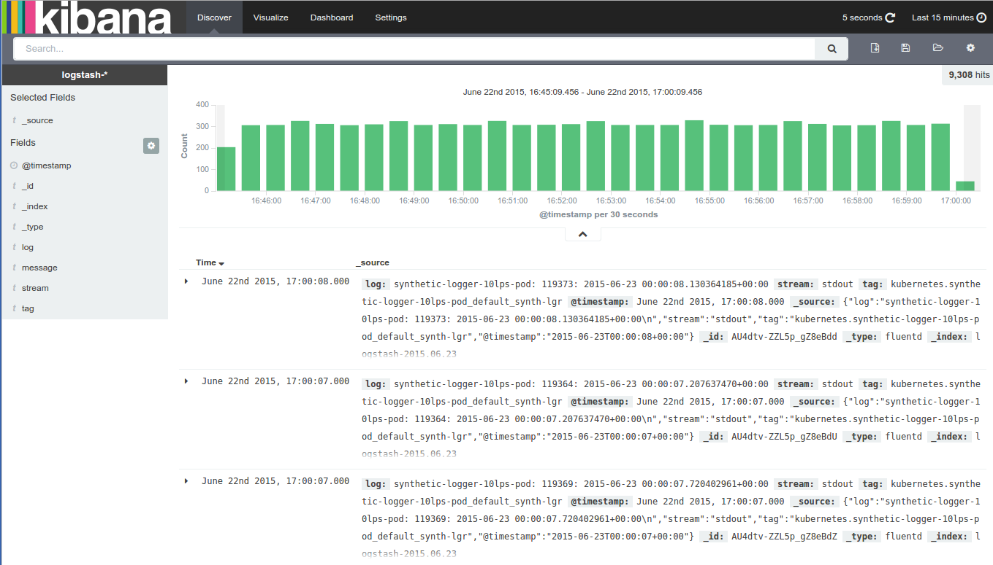

## Azure Container Monitoring

Azure Container Monitoring supports consuming logs from not just Kubernetes but also from other orchestration engines such as DC/OS, Docker Swarm, and Red Hat OpenShift.

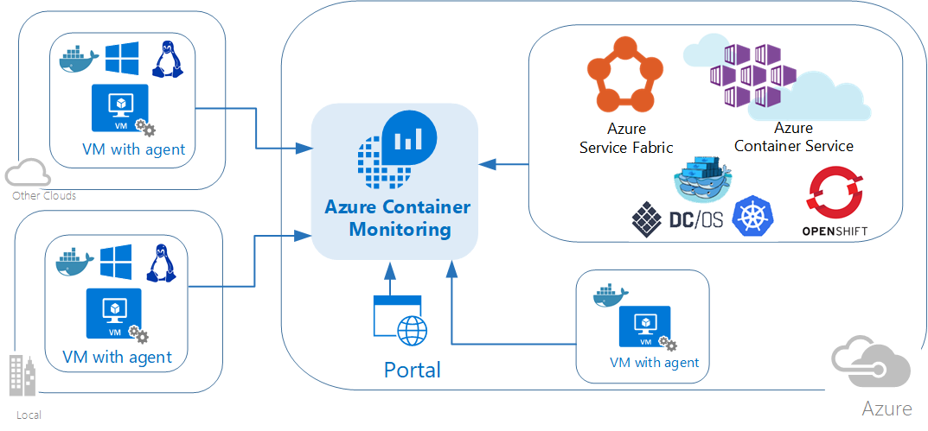

Log and metric information is gathered not just from the containers running in the cluster but also from the cluster hosts themselves. This allows correlating log information from the two making it much easier to track down an error.

Installing the log collectors differs on [Windows](https://docs.microsoft.com/azure/azure-monitor/insights/containers#configure-a-log-analytics-windows-agent-for-kubernetes) and [Linux](https://docs.microsoft.com/azure/azure-monitor/insights/containers#configure-a-log-analytics-linux-agent-for-kubernetes) clusters. But in both cases the log collection is implemented as a Kubernetes [DaemonSet](https://kubernetes.io/docs/concepts/workloads/controllers/daemonset/), meaning that the log collector is run as a container on each of the nodes.

No matter which orchestrator or operating system running the Azure Monitor daemon the log information is forwarded to the same Azure Monitor tools with which users are familiar. This ensures a parallel experience in environments that mix different log sources such as a hybrid Kubernetes/Azure Functions environment.

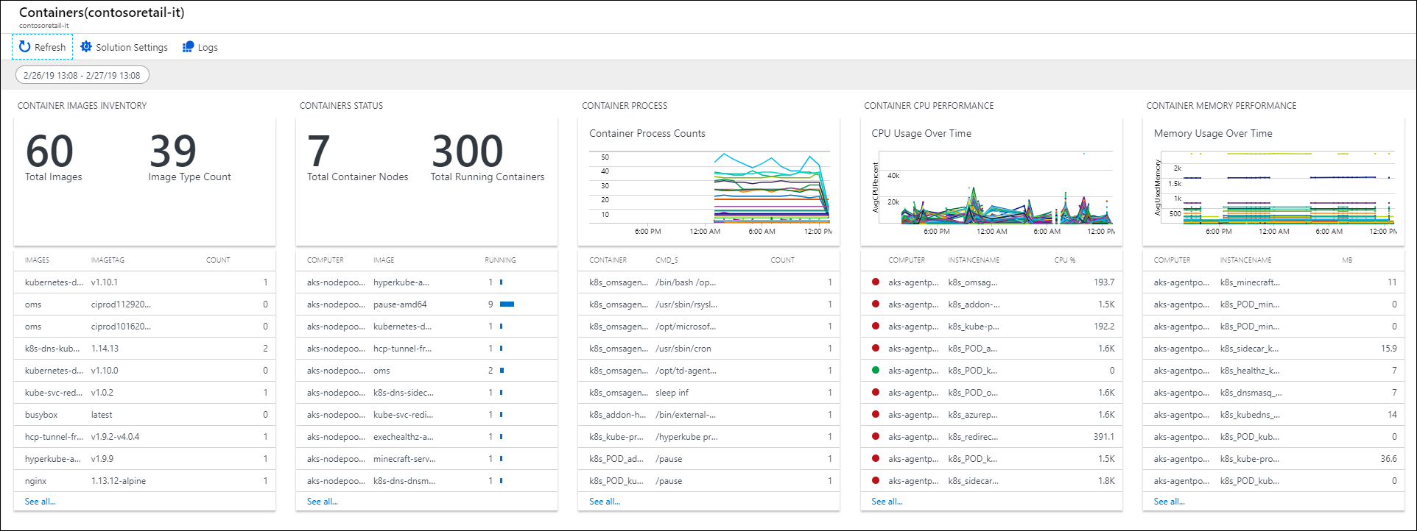

## Log.Finalize()

Logging is one of the most overlooked and yet most important parts of deploying any application at scale. As the size and complexity of applications increase, then so does the difficulty of debugging them. Having top quality logs available makes debugging much easier and moves it from the realm of “nearly impossible” to “a pleasant experience”.

Identity

Most software applications need to have some knowledge of the user or process that is calling them. The user or process interacting with an application is known as a security principal, and the process of authenticating and authorizing these principals is known as identity management, or simply *identity*. Simple applications may include all of their identity management within the application, but this approach doesn’t scale well with many applications and many kinds of security principals. Windows supports the use of Active Directory to provide centralized authentication and authorization.

(insert figure showing Windows AD auth model)

While this solution is effective within corporate networks, it isn’t designed for use by users or applications that are outside of the AD domain. With the growth of Internet-based applications and the rise of cloud native apps, security models have evolved.

In today’s cloud native identity model, architecture is assumed to be distributed. Apps can be deployed anywhere and may communicate with other apps anywhere. Clients may communicate with these apps from anywhere, and in fact, clients may consist of any combination of platforms and devices. Cloud native identity solutions leverage open standards to achieve secure application access from clients. These clients range from human users on PCs or phones, to other apps hosted anywhere online, to set-top boxes and IOT devices running any software platform anywhere in the world.

Modern cloud native identity solutions typically leverage access tokens that are issued by a secure token service/server (STS) to a security principal once their identity is determined. The access token, typically a JSON Web Token (JWT), includes *claims* about the security principal. These claims will minimally include the user’s identity but may also include additional claims that can be used by applications to determine the level of access to grant the principal.

(insert figure showing basic handshake involving a principal, an STS, and an app)

Typically, the STS is only responsible for authenticating the principal. Determining their level of access to resources is left to other parts of the application.

## References

* [Microsoft identity platform](https://docs.microsoft.com/azure/active-directory/develop/)

# Authentication and authorization in cloud native apps

*Authentication* is the process of determining the identity of a security principal. *Authorization* is the act of granting an authenticated principal permission to perform an action or access a resource. Sometimes authentication is shortened to AuthN and authorization is shortened to AuthZ. Cloud native applications need to rely on open HTTP-based protocols to authenticate security principals since both clients and applications could be running anywhere in the world on any platform or device. The only common factor is HTTP.

Many organizations still rely on local authentication services like Active Directory Federation Services (ADFS). While this has traditionally served organizations well for on premises authentication needs, cloud native applications benefit from systems designed specifically for the cloud. A recent 2019 United Kingdom NCSC advisory states that “organizations using Azure AD as their primary authentication source will actually lower their risk compared to ADFS.” Some reasons outlined in [this analysis](https://oxfordcomputergroup.com/resources/o365-security-native-cloud-authentication/) include:

* Access to full set of Microsoft credential protection technologies.
* Most organizations are already relying on Azure AD to some extent.
* Double hashing of NTLM hashes ensures compromise won’t allow credentials that work in local Active Directory.

## References

* [Authentication basics](https://docs.microsoft.com/azure/active-directory/develop/authentication-scenarios)
* [Access tokens and claims](https://docs.microsoft.com/azure/active-directory/develop/access-tokens)
* [It may be time to ditch your on premises authentication services](https://oxfordcomputergroup.com/resources/o365-security-native-cloud-authentication/)

# Azure Active Directory

Microsoft Azure Active Directory (Azure AD) offers identity and access management as a service. Customers use it to configure and maintain who users are, what information to store about them, who can access that information, who can manage it, and what apps can access it. AAD can authenticate users for applications configured to use it, providing a single sign-on (SSO) experience. It can be used on its own or be integrated with Windows AD running on premises.

Azure AD is built for the cloud. It’s truly a cloud native identity solution that uses a REST-based Graph API and OData syntax for queries, unlike Windows AD, which uses LDAP. On premises Active Directory can sync user attributes to the cloud using Identity Sync Services, allowing all authentication to take place in the cloud using Azure AD. Alternately, authentication can be configured via Connect to pass back to local Active Directory via ADFS to be completed by Windows AD on premises.

Azure AD supports company branded sign in screens, multi-factory authentication, and cloud-based application proxies that are used to provide SSO for applications hosted on premises. It offers different kinds of security reporting and alert capabilities.

## References

* [Microsoft identity platform](https://docs.microsoft.com/azure/active-directory/develop/)

# IdentityServer for cloud native applications

IdentityServer is an open-source authentication server that implements OpenID Connect (OIDC) and OAuth 2.0 standards for ASP.NET Core. It’s designed to provide a common way to authenticate requests to all of your applications, whether they’re web, native, mobile, or API endpoints. IdentityServer can be used to implement Single Sign-On (SSO) for multiple applications and application types. It can be used to authenticate actual users via sign in forms and similar user interfaces as well as service-based authentication that typically involves token issuance, verification, and renewal without any user interface. IdentityServer is designed to be a customizable solution. Each instance is typically customized to suit an individual organization and/or set of applications’ needs.

## Common web app scenarios

Typically, applications need to support some or all of the following scenarios:

* Human users accessing web applications with a browser.
* Human users accessing back-end Web APIs from browser-based apps.
* Human users on mobile/native clients accessing back-end Web APIs.
* Other applications accessing back-end Web APIs (without an active user or user interface).
* Any application may need to interact with other Web APIs, using its own identity or delegating to the user’s identity.

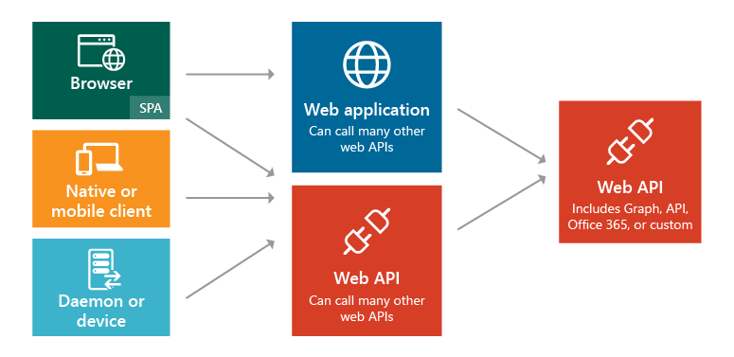

**Figure 8-1**. Application types and scenarios.

In each of these scenarios, the exposed functionality needs to be secured against unauthorized use. At a minimum, this typically requires authenticating the user or principal making a request for a resource. This authentication may use one of several common protocols such as SAML2p, WS-Fed, or OpenID Connect. Communicating with APIs typically uses the OAuth2 protocol and its support for security tokens. Separating these critical cross-cutting security concerns and their implementation details from the applications themselves ensures consistency and improves security and maintainability. Outsourcing these concerns to a dedicated product like IdentityServer helps the requirement for every application to solve these problems itself.

IdentityServer provides middleware that runs within an ASP.NET Core application and adds support for OpenID Connect and OAuth2 (see [supported specifications](http://docs.identityserver.io/en/latest/intro/specs.html)). Organizations would create their own ASP.NET Core app using IdentityServer middleware to act as the STS for all of their token-based security protocols. The IdentityServer middleware exposes endpoints to support standard functionality, including:

* Authorize (authenticate the end user)
* Token (request a token programmatically)
* Discovery (metadata about the server)
* User Info (get user information with a valid access token)
* Device Authorization (used to start device flow authorization)
* Introspection (token validation)
* Revocation (token revocation)
* End Session (trigger single sign-out across all apps)

## Getting started

IdentityServer4 is open-source and free to use. You can add it to your applications using its NuGet packages. The main package is [IdentityServer4](https://www.nuget.org/packages/IdentityServer4/) that has been downloaded over four million times. The base package doesn’t include any user interface code and only supports in memory configuration. To use it with a database, you’ll also want a data provider like [IdentityServer4.EntityFramework](https://www.nuget.org/packages/IdentityServer4.EntityFramework) that uses Entity Framework Core to store configuration and operational data for IdentityServer. For user interface, you can copy files from the [Quickstart UI repository](https://github.com/IdentityServer/IdentityServer4.Quickstart.UI) into your ASP.NET Core MVC application to add support for sign in and sign out using IdentityServer middleware.

## Configuration

IdentityServer supports different kinds of protocols and social authentication providers that can be configured as part of each custom installation. This is typically done in the ASP.NET Core application’s Startup class in the ConfigureServices method. The configuration involves specifying the supported protocols and the paths to the servers and endpoints that will be used. Figure 8-X shows an example configuration taken from the IdentityServer4 Quickstart UI project:

public class Startup  
{  
 public void ConfigureServices(IServiceCollection services)  
 {  
 services.AddMvc();  
   
 // some details omitted  
 services.AddIdentityServer();  
   
 services.AddAuthentication()  
 .AddGoogle("Google", options =>  
 {  
 options.SignInScheme = IdentityServerConstants.ExternalCookieAuthenticationScheme;  
  
 options.ClientId = "<insert here>";  
 options.ClientSecret = "<inser here>";  
 })  
 .AddOpenIdConnect("demoidsrv", "IdentityServer", options =>  
 {  
 options.SignInScheme = IdentityServerConstants.ExternalCookieAuthenticationScheme;  
 options.SignOutScheme = IdentityServerConstants.SignoutScheme;  
  
 options.Authority = "https://demo.identityserver.io/";  
 options.ClientId = "implicit";  
 options.ResponseType = "id_token";  
 options.SaveTokens = true;  
 options.CallbackPath = new PathString("/signin-idsrv");  
 options.SignedOutCallbackPath = new PathString("/signout-callback-idsrv");  
 options.RemoteSignOutPath = new PathString("/signout-idsrv");  
  
 options.TokenValidationParameters = new TokenValidationParameters  
 {  
 NameClaimType = "name",  
 RoleClaimType = "role"  
 };  
 });  
 }  
}

**Figure 8-X**. Configuring IdentityServer.

IdentityServer also hosts a public demo site that can be used to test various protocols and configurations. It’s located at <https://demo.identityserver.io/> and includes information on how to configure its behavior based on the client_id provided to it.

## JavaScript clients

Many cloud native applications leverage server-side APIs and rich client single page applications (SPAs) on the front end. IdentityServer ships a [JavaScript client](http://docs.identityserver.io/en/latest/quickstarts/6_javascript_client.html) (oidc-client.js) via NPM that can be added to SPAs to enable them to use IdentityServer for sign in, sign out, and token-based authentication of web APIs.

## References

* [IdentityServer documentation](http://docs.identityserver.io/)
* [Application types](https://docs.microsoft.com/azure/active-directory/develop/app-types)
* [JavaScript OIDC client](http://docs.identityserver.io/en/latest/quickstarts/6_javascript_client.html)

Security

Not a day goes by where the news doesn’t contain some story about a company being hacked or somehow losing their customers’ data. Even countries aren’t immune to the problems created by treating security as an afterthought. For years, companies have treated the security of customer data and, in fact, their entire networks as something of a “nice to have”. Windows servers were left unpatched, ancient versions of PHP kept running and MongoDB databases left wide open to the world.

However, there are starting to be real-world consequences for not maintaining a security mindset when building and deploying applications. Many companies learned the hard way what can happen when servers and desktops aren’t patched during the 2017 outbreak of [NotPetya](https://www.wired.com/story/notpetya-cyberattack-ukraine-russia-code-crashed-the-world/). The cost of these attacks has easily reached into the billions, with some estimates putting the losses from this single attack at 10 billion US dollars.

Even governments aren’t immune to hacking incidents. The city of Baltimore was held ransom by [criminals](https://www.vox.com/recode/2019/5/21/18634505/baltimore-ransom-robbinhood-mayor-jack-young-hackers) making it impossible for citizens to pay their bills or use city services.

There has also been an increase in legislation that mandates certain data protections for personal data. In Europe, GDPR has been in effect for more than a year and, more recently, California passed their own version called CCDA, which comes into effect January 1, 2020. The fines under GDPR can be so punishing as to put companies out of business. Google has already been fined 50 million Euros for violations, but that’s just a drop in the bucket compared with the potential fines.

In short, security is serious business.

# Azure security for cloud native apps

Cloud native applications can be both easier and more difficult to secure than traditional applications. On the downside, you need to secure more smaller applications and dedicate more energy to build out the security infrastructure. The heterogeneous nature of programming languages and styles in most service deployments also means you need to pay more attention to security bulletins from many different providers.

On the flip side, smaller services, each with their own data store, limit the scope of an attack. If an attacker compromises one system, it’s probably more difficult for the attacker to make the jump to another system than it is in a monolithic application. Process boundaries are strong boundaries. Also, if a database backup leaks, then the damage is more limited, as that database contains only a subset of data and is unlikely to contain personal data.

## Threat modeling

No matter if the advantages outweigh the disadvantages of cloud native applications, the same holistic security mindset must be followed. Security and secure thinking must be part of every step of the development and operations story. When planning an application ask questions like:

* What would be the impact of this data being lost?
* How can we limit the damage from bad data being injected into this service?
* Who should have access to this data?
* Are there auditing policies in place around the development and release process?

All these questions are part of a process called [threat modeling](https://docs.microsoft.com/azure/security/azure-security-threat-modeling-tool). This process tries to answer the question of what threats there are to the system, how likely the threats are, and the potential damage from them.

Once the list of threats has been established, you need to decide whether they’re worth mitigating. Sometimes a threat is so unlikely and expensive to plan for that it isn’t worth spending energy on it. For instance, some state level actor could inject changes into the design of a process that is used by millions of devices. Now, instead of running a certain piece of code in [Ring 3](https://en.wikipedia.org/wiki/Protection_ring), that code is run in Ring 0. This allows an exploit that can bypass the hypervisor and run the attack code on the bare metal machines, allowing attacks on all the virtual machines that are running on that hardware.

The altered processors are difficult to detect without a microscope and advanced knowledge of the on silicon design of that processor. This scenario is unlikely to happen and expensive to mitigate, so probably no threat model would recommend building exploit protection for it.

More likely threats, such as broken access controls permitting Id incrementing attacks (replacing Id=2 with Id=3 in the URL) or SQL injection, are more attractive to build protections against. The mitigations for these threats are quite reasonable to build and prevent embarrassing security holes that smear the company’s reputation.

## Principle of least privilege

One of the founding ideas in computer security is the Principle of Least Privilege (POLP). It’s actually a foundational idea in most any form of security be it digital or physical. In short, the principle is that any user or process should have the smallest number of rights possible to execute its task.

As an example, think of the tellers at a bank: accessing the safe is an uncommon activity. So, the average teller can’t open the safe themselves. To gain access, they need to escalate their request through a bank manager, who performs additional security checks.

In a computer system, a fantastic example is the rights of a user connecting to a database. In many cases, there’s a single user account used to both build the database structure and run the application. Except in extreme cases, the account running the application doesn’t need the ability to update schema information. There should be several accounts that provide different levels of privilege. The application should only use the permission level that grants read and write access to the data in the tables. This kind of protection would eliminate attacks that aimed to drop database tables or introduce malicious triggers.

Almost every part of building a cloud native application can benefit from remembering the principle of least privilege. You can find it at play when setting up firewalls, network security groups, roles, and scopes in Role-based access control (RBAC).

## Penetration testing

As applications become more complicated the number of attack vectors increases at an alarming rate. Threat modeling is flawed in that it tends to be executed by the same people building the system. In the same way that many developers have trouble envisioning user interactions and then build unusable user interfaces, most developers have difficulty seeing every attack vector. It’s also possible that the developers building the system aren’t well versed in attack methodologies and miss something crucial.

Penetration testing or “pen testing” involves bringing in external actors to attempt to attack the system. These attackers may be an external consulting company or other developers with good security knowledge from another part of the business. They’re given carte blanche to attempt to subvert the system. Frequently, they’ll find extensive security holes that need to be patched. Sometimes the attack vector will be something totally unexpected like exploiting a phishing attack against the CEO.

Azure itself is constantly undergoing attacks from a [team of hackers inside Microsoft](https://azure.microsoft.com/resources/videos/red-vs-blue-internal-security-penetration-testing-of-microsoft-azure/). Over the years, they’ve been the first to find dozens of potentially catastrophic attack vectors, closing them before they can be exploited externally. The more tempting a target, the more likely that eternal actors will attempt to exploit it and there are a few targets in the world more tempting than Azure.

## Monitoring

Should an attacker attempt to penetrate an application, there should be some warning of it. Frequently, attacks can be spotted by examining the logs from services. Attacks leave telltale signs that can be spotted before they succeed. For instance, an attacker attempting to guess a password will make many requests to a login system. Monitoring around the login system can detect weird patterns that are out of line with the typical access pattern. This monitoring can be turned into an alert that can, in turn, alert an operations person to activate some sort of countermeasure. A highly mature monitoring system might even take action based on these deviations proactively adding rules to block requests or throttle responses.

## Securing the build

One place where security is often overlooked is around the build process. Not only should the build run security checks, such as scanning for insecure code or checked-in credentials, but the build itself should be secure. If the build server is compromised, then it provides a fantastic vector for introducing arbitrary code into the product.

Imagine that an attacker is looking to steal the passwords of people signing into a web application. They could introduce a build step that modifies the checked-out code to mirror any login request to another server. The next time code goes through the build, it’s silently updated. The source code vulnerability scanning won’t catch this as it runs before the build. Equally, nobody will catch it in a code review because the build steps live on the build server. The exploited code will go to production where it can harvest passwords. Probably there’s no audit log of the build process changes, or at least nobody monitoring the audit.

This is a perfect example of a seemingly low value target that can be used to break into the system. Once an attacker breaches the perimeter of the system, they can start working on finding ways to elevate their permissions to the point that they can cause real harm anywhere they like.

## Building secure code

The .NET Framework is already a quite secure framework. It avoids some of the pitfalls of unmanaged code, such as walking off the ends of arrays. Work is actively done to fix security holes as they’re discovered. There’s even a [bug bounty program](https://www.microsoft.com/msrc/bounty) that pays researchers to find issues in the framework and report them instead of exploiting them.

There are many ways to make .NET code more secure. Following guidelines such as the [Secure coding guidelines for .NET](https://docs.microsoft.com/dotnet/standard/security/secure-coding-guidelines) article is a reasonable step to take to ensure that the code is secure from the ground up. The [OWASP top 10](https://www.owasp.org/index.php/Category:OWASP_Top_Ten_2017_Project) is another invaluable guide to build secure code.

The build process is a good place to put scanning tools to detect problems in source code before they make it into production. Most every project has dependencies on some other packages. A tool that can scan for outdated packages will catch problems in a nightly build. Even when building Docker images, it’s useful to check and make sure that the base image doesn’t have known vulnerabilities. Another thing to check is that nobody has accidentally checked in credentials.

## Built-in security

Azure is designed to balance usability and security for the majority of users. Different users are going to have different security requirements, so they need to fine-tune their approach to cloud security. Microsoft publishes a great deal of security information in the [Trust Center](https://azure.microsoft.com/support/trust-center/). This resource should be the first stop for those professionals interested in understanding how the built-in attack mitigation technologies work.

Within the Azure portal, the [Azure Advisor](https://azure.microsoft.com/services/advisor/) is a system that is constantly scanning an environment and making recommendations. Some of these recommendations are designed to save users money, but others are designed to identify potentially insecure configurations, such as having a storage container open to the world and not protected by a Virtual Network.

## Azure network infrastructure

In an on-premises deployment environment, a great deal of energy is dedicated to setting up networking. Setting up routers, switches, and the such is complicated work. Networks allow certain resources to talk to other resources and prevent access in some cases. A frequent network rule is to restrict access to the production environment from the development environment on the off chance that a half-developed piece of code runs awry and deletes a swath of data.

Out of the box, most PaaS Azure resources have only the most basic and permissive networking setup. For instance, anybody on the Internet can access an app service. New SQL Server instances typically come restricted, so that external parties can’t access them, but the IP address ranges used by Azure itself are permitted through. So, while the SQL server is protected from external threats, an attacker only needs to set up an Azure bridgehead from where they can launch attacks against all SQL instances on Azure.

Fortunately, most Azure resources can be placed into an Azure Virtual Network that allows finer grained access control. Similar to the way that on-premises networks establish private networks that are protected from the wider world, virtual networks are islands of private IP addresses that are located within the Azure network.

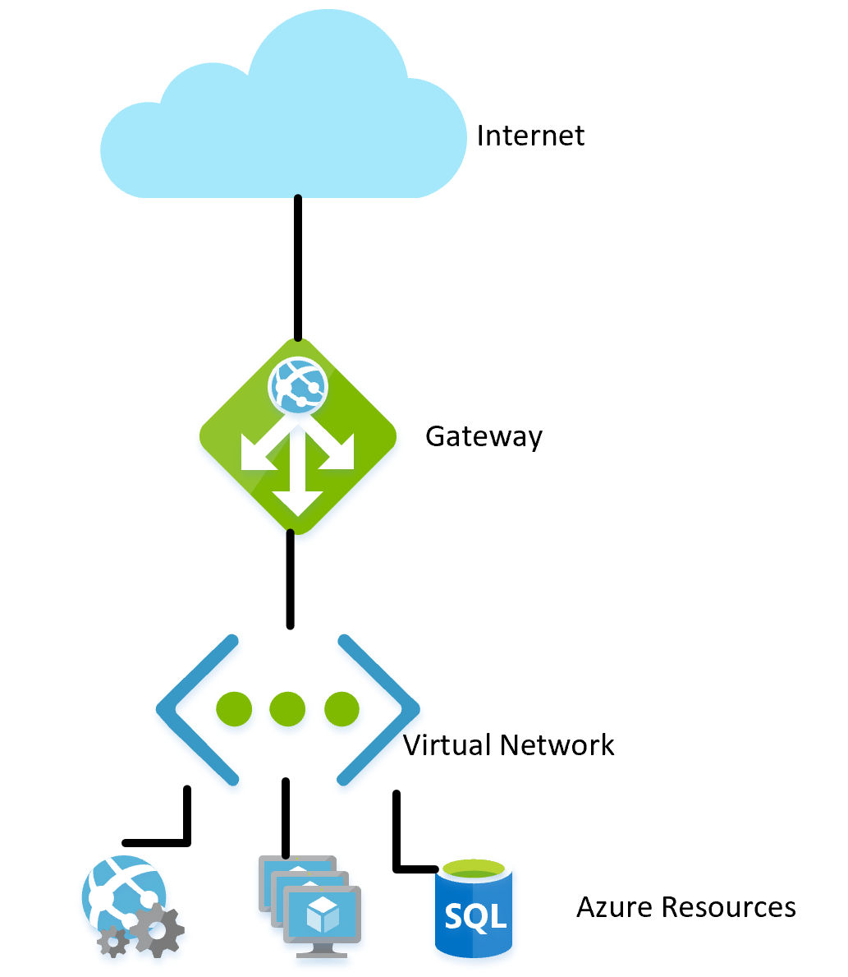

**Figure 10-1**. A virtual network in Azure.

In the same way that on-premises networks have a firewall governing access to the network, you can establish a similar firewall at the boundary of the virtual network. By default, all the resources on a virtual network can still talk to the Internet. It’s only incoming connections that require some form of explicit firewall exception.

With the network established, internal resources like storage accounts can be set up to only allow for access by resources that are also on the Virtual Network. This firewall provides an extra level of security, should the keys for that storage account be leaked, attackers wouldn’t be able to connect to it to exploit the leaked keys. This is another example of the principle of least privilege.

The nodes in an Azure Kubernetes cluster can participate in a virtual network just like other resources that are more native to Azure. This functionality is called [Azure Container Networking Interface](https://github.com/Azure/azure-container-networking/blob/master/docs/cni.md). In effect, it allocates a subnet within the virtual network on which virtual machines and container images are allocated.

Continuing down the path of illustrating the principle of least privilege, not every resource within a Virtual Network needs to talk to every other resource. For instance, in an application that provides a web API over a storage account and a SQL database, it’s unlikely that the database and the storage account need to talk to one another. Any data sharing between them would go through the web application. So, a [network security group (NSG)](https://docs.microsoft.com/azure/virtual-network/security-overview) could be used to deny traffic between the two services.

A policy of denying communication between resources can be annoying to implement, especially coming from a background of using Azure without traffic restrictions. On some other clouds, the concept of network security groups is much more prevalent. For instance, the default policy on AWS is that resources can’t communicate among themselves until enabled by rules in an NSG. While slower to develop this, more restrictive environment provides a more secure default. Making use of proper DevOps practices, especially using [Azure Resource Manager or Terraform]**INTERNAL-LINK:(infrastructure-as-code.md)** to manage permissions can make controlling the rules easier.

Virtual Networks can also be useful when setting up communication between on-premises and cloud resources. A virtual private network can be used to seamlessly attach the two networks together. This allows running a virtual network without any sort of gateway for scenarios where all the users are on-site. There are a number of technologies that can be used to establish this network. The simplest is to use a [site-to-site VPN](https://docs.microsoft.com/azure/vpn-gateway/vpn-gateway-about-vpngateways?toc=%2fazure%2fvirtual-network%2ftoc.json#s2smulti) that can be established between many routers and Azure. Traffic is encrypted and tunneled over the Internet at the same cost per byte as any other traffic. For scenarios where more bandwidth or more security is desirable, Azure offers a service called [Express Route](https://docs.microsoft.com/azure/vpn-gateway/vpn-gateway-about-vpngateways?toc=%2fazure%2fvirtual-network%2ftoc.json#ExpressRoute) that uses a private circuit between an on-premises network and Azure. It’s more costly and difficult to establish but also more secure.

## Role-based access control for restricting access to Azure resources

RBAC is a system that provides an identity to applications running in Azure. Applications can access resources using this identity instead of or in addition to using keys or passwords.

## Security Principals

The first component in RBAC is a security principal. A security principal can be a user, group, service principal, or managed identity.

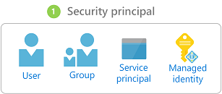

**Figure 10-2**. Different types of security principals.

* User - Any user who has an account in Azure Active Directory is a user.
* Group - A collection of users from Azure Active Directory. As a member of a group, a user takes on the roles of that group in addition to their own.
* Service principal - A security identity under which services or applications run.
* Managed identity - An Azure Active Directory identity managed by Azure. Managed identities are typically used when developing cloud applications that manage the credentials for authenticating to Azure services.

The security principal can be applied to most any resource. This means that it’s possible to assign a security principal to a container running within Azure Kubernetes, allowing it to access secrets stored in Key Vault. An Azure Function could take on a permission allowing it to talk to an Active Directory instance to validate a JWT for a calling user. Once services are enabled with a service principal, their permissions can be managed granularly using roles and scopes.

## Roles

A security principal can take on many roles or, using a more sartorial analogy, wear many hats. Each role defines a series of permissions such as “Read messages from Azure Service Bus endpoint”. The effective permission set of a security principal is the combination of all the permissions assigned to all the roles that security principal has. Azure has a large number of built-in roles and users can define their own roles.

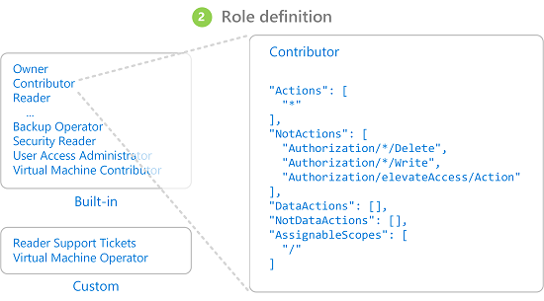

**Figure 10-3**. RBAC role definitions.

Built into Azure are also a number of high-level roles such as Owner, Contributor, Reader, and User Account Administrator. With the Owner role, a security principal can access all resources and assign permissions to others. A contributor has the same level of access to all resources but they can’t assign permissions. A Reader can only view existing Azure resources and a User Account Administrator can manage access to Azure resources.

More granular built-in roles such as [DNS Zone Contributor](https://docs.microsoft.com/azure/role-based-access-control/built-in-roles#dns-zone-contributor) have rights limited to a single service. Security principals can take on any number of roles.

## Scopes

Roles can be applied to a restricted set of resources within Azure. For instance, applying scope to the previous example of reading from a Service Bus queue, you can narrow the permission to a single queue: “Read messages from Azure Service Bus endpoint blah.servicebus.windows.net/queue1”

The scope can be as narrow as a single resource or it can be applied to an entire resource group, subscription, or even management group.

When testing if a security principal has a certain permission, the combination of role and scope are taken into account. This combination provides a powerful authorization mechanism.

## Deny

Previously, only “allow” rules were permitted for RBAC. This behavior made some scopes complicated to build. For instance, allowing a security principal access to all storage accounts except one required granting explicit permission to a potentially endless list of storage accounts. Every time a new storage account was created, it would have to be added to this list of accounts. This added management overhead that certainly wasn’t desirable.

Deny rules take precedence over allow rules. Now representing the same “allow all but one” scope could be represented as two rules “allow all” and “deny this one specific one”. Deny rules not only ease management but allow for resources that are extra secure by denying access to everybody.

## Checking access

As you can imagine, having a large number of roles and scopes can make figuring out the effective permission of a service principal quite difficult. Piling deny rules on top of that, only serves to increase the complexity. Fortunately, there’s a permissions calculator that can show the effective permissions for any service principal. It’s typically found under the IAM tab in the portal, as shown in Figure 10-3.

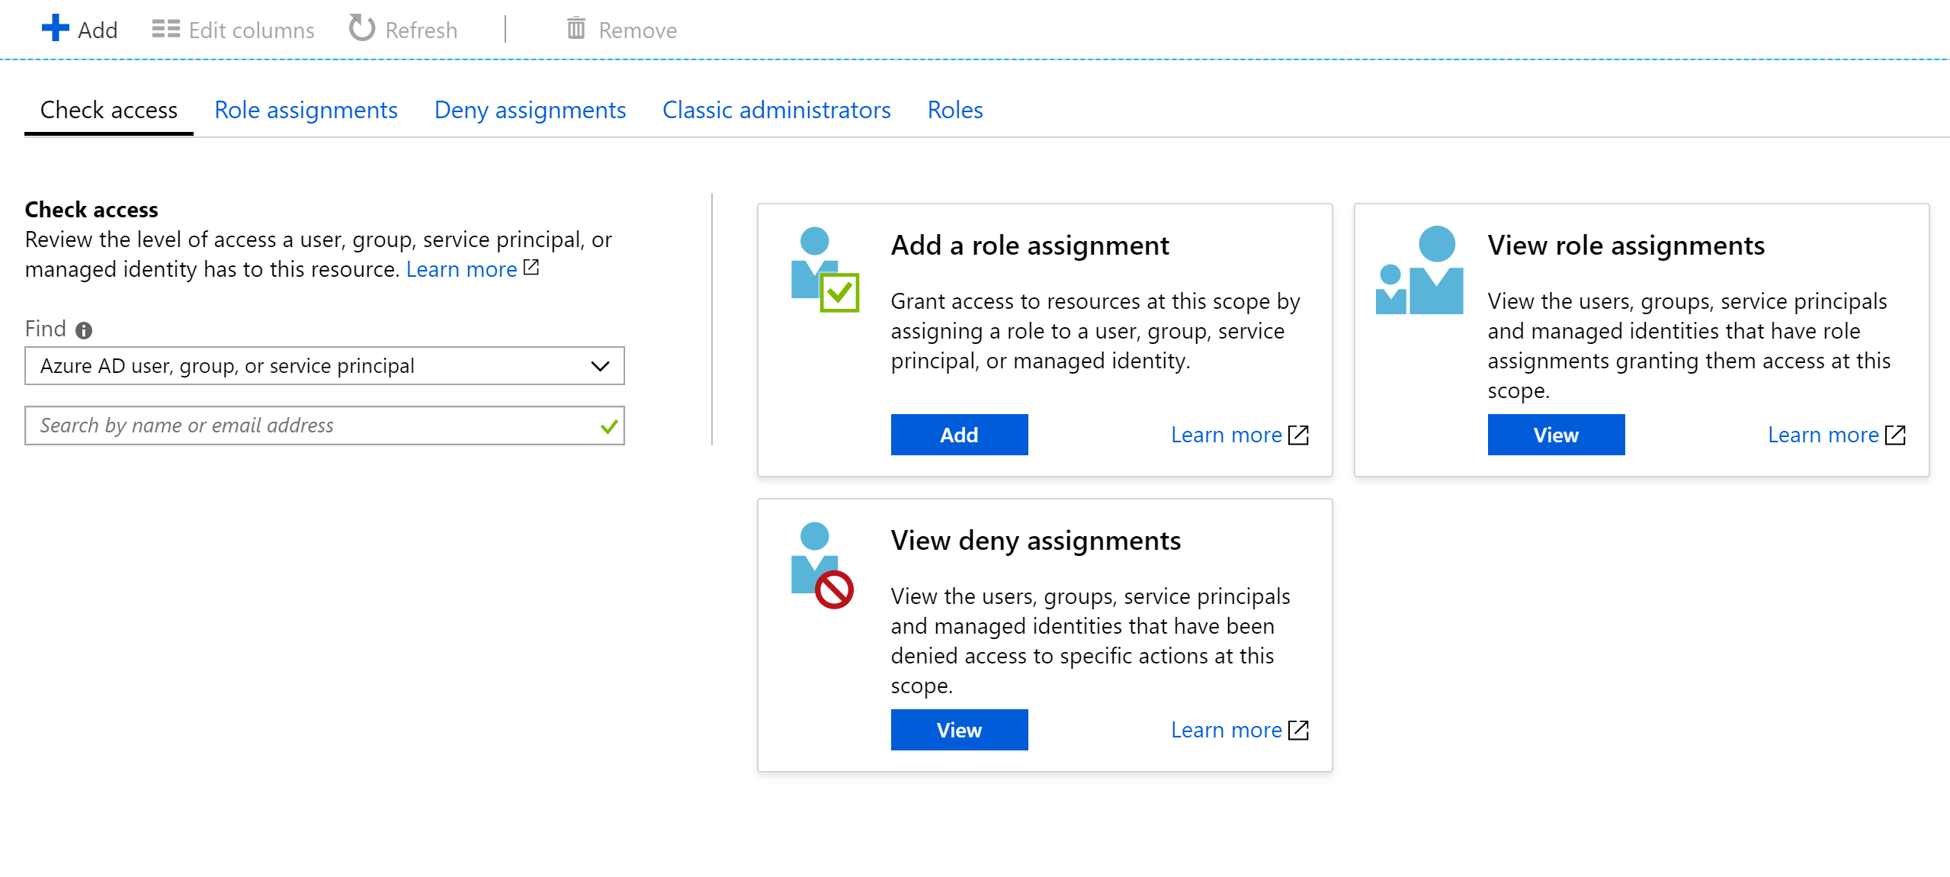

**Figure 10-4**. Permission calculator for an app service.

## Securing secrets

Passwords and certificates are a common attack vector for attackers. Password-cracking hardware can do a brute-force attack and try to guess billions of passwords per second. So it’s important that the passwords that are used to access resources are strong, with a large variety of characters. These passwords are exactly the kind of passwords that are near impossible to remember. Fortunately, the passwords in Azure don’t actually need to be known by any human.

Many security [experts suggest](https://www.troyhunt.com/password-managers-dont-have-to-be-perfect-they-just-have-to-be-better-than-not-having-one/) that using a password manager to keep your own passwords is the best approach. While it centralizes your passwords in one location, it also allows using highly complex passwords and ensuring they’re unique for each account. The same system exists within Azure: a central store for secrets.

## Azure Key Vault

Azure Key Vault provides a centralized location to store passwords for things such as databases, API keys, and certificates. Once a secret is entered into the Vault, it’s never shown again and the commands to extract and view it are purposefully complicated. The information in the safe is protected using either software encryption or FIPS 140-2 Level 2 validated Hardware Security Modules.

Access to the key vault is provided through RBACs, meaning that not just any user can access the information in the vault. Say a web application wishes to access the database connection string stored in Azure Key Vault. To gain access, applications need to run using a service principal. Under this assumed role, they can read the secrets from the safe. There are a number of different security settings that can further limit the access that an application has to the vault, so that it can’t update secrets but only read them.

Access to the key vault can be monitored to ensure that only the expected applications are accessing the vault. The logs can be integrated back into Azure Monitor, unlocking the ability to set up alerts when unexpected conditions are encountered.

## Kubernetes

Within Kubernetes, there’s a similar service for maintaining small pieces of secret information. Kubernetes Secrets can be set via the typical kubectl executable.

Creating a secret is as simple as finding the base64 version of the values to be stored:

echo -n 'admin' | base64  
YWRtaW4=  
echo -n '1f2d1e2e67df' | base64  
MWYyZDFlMmU2N2Rm

Then adding it to a secrets file named secret.yml for example that looks similar to the following example:

apiVersion: v1  
kind: Secret  
metadata:  
 name: mysecret  
type: Opaque  
data:  
 username: YWRtaW4=  
 password: MWYyZDFlMmU2N2Rm

Finally, this file can be loaded into Kubernetes by running the following command:

kubectl apply -f ./secret.yaml

These secrets can then be mounted into volumes or exposed to container processes through environment variables. The [Twelve-factor app](https://12factor.net/) approach to building applications suggests using the lowest common denominator to transmit settings to an application. Environment variables are the lowest common denominator, because they’re supported no matter the operating system or application.

An alternative to use the built-in Kubernetes secrets is to access the secrets in Azure Key Vault from within Kubernetes. The simplest way to do this is to assign an RBAC role to the container looking to load secrets. The application can then use the Azure Key Vault APIs to access the secrets. However, this approach requires modifications to the code and doesn’t follow the pattern of using environment variables. Instead, it’s possible to inject values into a container through the use of the [Azure Key Vault Injector](https://mrdevops.io/introducing-azure-key-vault-to-kubernetes-931f82364354). This approach is actually more secure than using the Kubernetes secrets directly, as they can be accessed by users on the cluster.

## Encryption in transit and at rest

Keeping data safe is important whether it’s on disk or transiting between various different services. The most effective way to keep data from leaking is to encrypt it into a format that can’t be easily read by others. Azure supports a wide range of encryption options.

### In transit

There are several ways to encrypt traffic on the network in Azure. The access to Azure services is typically done over connections that use Transport Layer Security (TLS). For instance, all the connections to the Azure APIs require TLS connections. Equally, connections to endpoints in Azure storage can be restricted to work only over TLS encrypted connections.

TLS is a complicated protocol and simply knowing that the connection is using TLS isn’t sufficient to ensure security. For instance, TLS 1.0 is chronically insecure, and TLS 1.1 isn’t much better. Even within the versions of TLS, there are various settings that can make the connections easier to decrypt. The best course of action is to check and see if the server connection is using up-to-date and well configured protocols.

This check can be done by an external service such as SSL labs’ SSL Server Test. A test run against a typical Azure endpoint, in this case a service bus endpoint, yields a near perfect score of A.

Even services like Azure SQL databases use TLS encryption to keep data hidden. The interesting part about encrypting the data in transit using TLS is that it isn’t possible, even for Microsoft, to listen in on the connection between computers running TLS. This should provide comfort for companies concerned that their data may be at risk from Microsoft proper or even a state actor with more resources than the standard attacker.

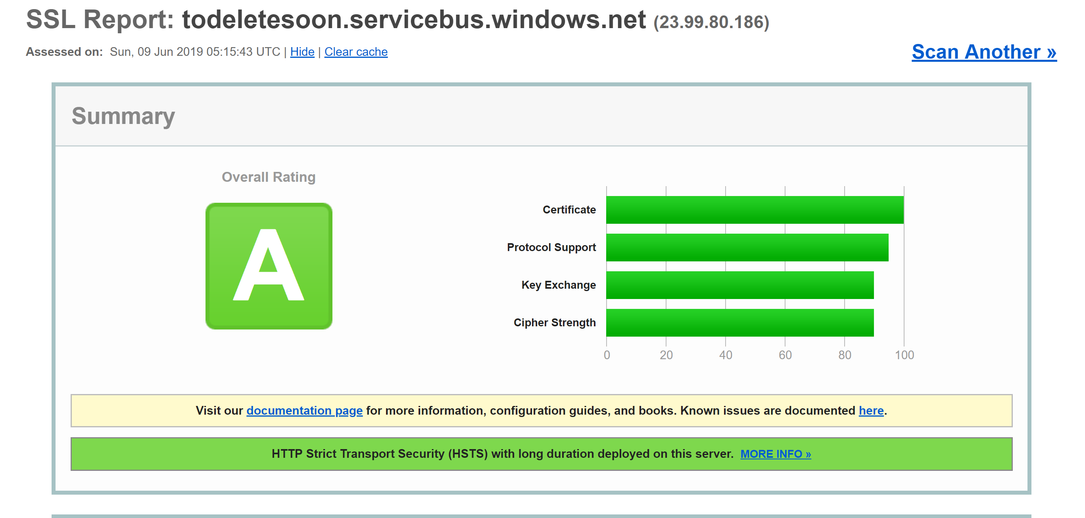

**Figure 10-5**. SSL labs report showing a score of A for a Service Bus endpoint.

While this level of encryption isn’t going to be sufficient for all time, it should inspire confidence that Azure TLS connections are quite secure. Azure will continue to evolve its security standards as encryption improves. It’s nice to know that there’s somebody watching the security standards and updating Azure as they improve.

### At rest

In any application, there are a number of places where data rests on disk. The application code itself is loaded from some storage mechanism. Most applications also use some kind of database such as SQL Server, Cosmos DB, or even the amazingly price-efficient Table Storage. These databases all use heavily encrypted storage to ensure that nobody other than the applications with proper permissions can read your data. Even the system operators can’t read data that has been encrypted. So customers can remain confident their secret information remains secret.

### Storage

The underpinning of much of Azure is the Azure Storage engine. Virtual machine disks are mounted on top of Azure Storage. Azure Kubernetes Services run on virtual machines that, themselves, are hosted on Azure Storage. Even serverless technologies, such as Azure Functions Apps and Azure Container Instances, run out of disk that is part of Azure Storage.

If Azure Storage is well encrypted, then it provides for a foundation for most everything else to also be encrypted. Azure Storage [is encrypted](https://docs.microsoft.com/azure/storage/common/storage-service-encryption) with [FIPS 140-2](https://en.wikipedia.org/wiki/FIPS_140) compliant [256-bit AES](https://en.wikipedia.org/wiki/Advanced_Encryption_Standard). This is a well-regarded encryption technology having been the subject of extensive academic scrutiny over the last 20 or so years. At present, there’s no known practical attack that would allow someone without knowledge of the key to read data encrypted by AES.

By default, the keys used for encrypting Azure Storage are managed by Microsoft. There are extensive protections in place to ensure to prevent malicious access to these keys. However, users with particular encryption requirements can also [provide their own storage keys](https://docs.microsoft.com/azure/storage/common/storage-encryption-keys-powershell), that are managed in Azure Key Vault. These keys can be revoked at any time, which would effectively render the contents of the Storage account using them inaccessible.

Virtual machines use encrypted storage, but it’s possible to provide another layer of encryption by using technologies like BitLocker on Windows or DM-Crypt on Linux. These technologies mean that even if the disk image was leaked off of storage, it would remain near impossible to read it.

### Azure SQL

Databases hosted on Azure SQL use a technology called [Transparent Data Encryption (TDE)](https://docs.microsoft.com/sql/relational-databases/security/encryption/transparent-data-encryption) to ensure data remains encrypted. It’s enabled by default on all newly created SQL databases, but must be enabled manually for legacy databases. TDE executes real-time encryption and decryption of not just the database, but also the backups and transaction logs.

The encryption parameters are stored in the master database and, on startup, are read into memory for the remaining operations. This means that the master database must remain unencrypted. The actual key is managed by Microsoft. However, users with exacting security requirements may provide their own key in Key Vault in much the same way as is done for Azure Storage. The Key Vault provides for such services as key rotation and revocation.

The “Transparent” part of TDS comes from the fact that there aren’t client changes needed to use an encrypted database. While this approach provides for good security, leaking the database password is enough for users to be able to decrypt the data. There’s another approach that encrypts individual columns or tables in a database. [Always Encrypted](https://docs.microsoft.com/azure/sql-database/sql-database-always-encrypted-azure-key-vault) ensures that at no point the encrypted data appears in plain text inside the database.

Setting up this tier of encryption requires running through a wizard in SQL Server Management Studio to select the sort of encryption and where in Key Vault to store the associated keys.

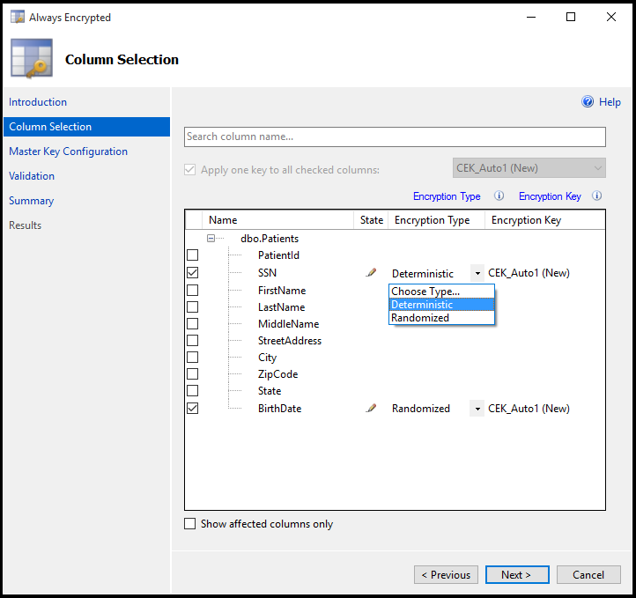

**Figure 10-6**. Selecting columns in a table to be encrypted using Always Encrypted.

Client applications that read information from these encrypted columns need to make special allowances to read encrypted data. Connection strings need to be updated with Column Encryption Setting=Enabled and client credentials must be retrieved from the Key Vault. The SQL Server client must then be primed with the column encryption keys. Once that is done, the remaining actions use the standard interfaces to SQL Client. That is, tools like Dapper and Entity Framework, which are built on top of SQL Client, will continue to work without changes. Always Encrypted may not yet be available for every SQL Server driver on every language.

The combination of TDE and Always Encrypted, both of which can be used with client-specific keys, ensures that even the most exacting encryption requirements are supported.

### Cosmos DB

Cosmos DB is the newest database provided by Microsoft in Azure. It has been built from the ground up with security and cryptography in mind. AES-256bit encryption is standard for all Cosmos DB databases and can’t be disabled. Coupled with the TLS 1.2 requirement for communication, the entire storage solution is encrypted.

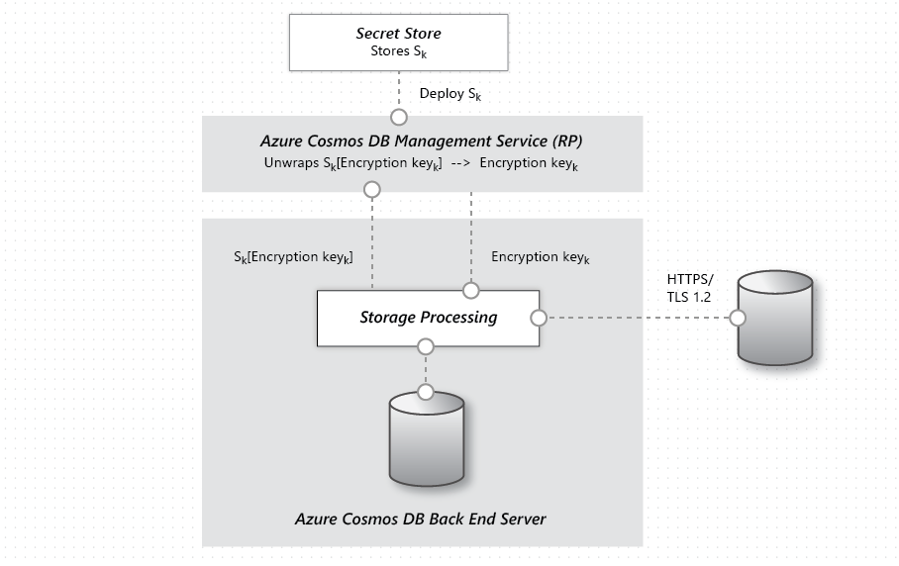

**Figure 10-7**. The flow of data encryption within Cosmos DB.

While Cosmos DB doesn’t provide for supplying customer encryption keys, there has been significant work done by the team to ensure it remains PCI-DSS compliant without that. Cosmos DB also doesn’t support any sort of single column encryption similar to Azure SQL’s Always Encrypted yet.

## Keeping secure

Azure has all the tools necessary to release a highly secure product. However, a chain is only as strong as its weakest link. If the applications deployed on top of Azure aren’t developed with a proper security mindset and good security audits, then they become the weak link in the chain. There are many great static analysis tools, encryption libraries, and security practices that can be used to ensure that the software installed on Azure is as secure as Azure itself. [WhiteSource]**INTERNAL-LINK:(**[**static analysis tools**](https://www.whitesourcesoftware.com/), [encryption libraries](https://www.libressl.org/), and [security practices](https://azure.microsoft.com/resources/videos/red-vs-blue-internal-security-penetration-testing-of-microsoft-azure/), LibreSSL(https://www.libressl.org/) and [Red vs. Blue - Internal security penetration testing of Microsoft Azure](https://azure.microsoft.com/resources/videos/red-vs-blue-internal-security-penetration-testing-of-microsoft-azure/) are examples of that, respectively.

Cloud Native DevOps

The favorite mantra of software consultants is to answer “It depends” to any question posed. It isn’t because software consultants are fond of not taking a position. It’s because there’s no one true answer to any questions in software. There’s no absolute right and wrong, but rather a balance between opposites.

Take, for instance, the two major schools of developing web applications: Single Page Applications (SPAs) vs. server-side applications. On the one hand, the user experience tends to be better with SPAs and the amount of traffic to the web server can be minimized making it possible to host them on something as simple as static hosting. On the other hand, SPAs tend to be slower to develop and more difficult to test. Which one is the right choice? Well, it depends on your situation.

Cloud-native applications aren’t immune to that same dichotomy. They have clear advantages in terms of speed of development, stability, and scalability, but managing them can be quite a bit more difficult.

Years ago, it wasn’t uncommon for the process of moving an application from development to production to take a month, or even more. Companies released software on a 6-month or even every year cadence. One needs to look no further than Microsoft Windows to get an idea for the cadence of releases that were acceptable before the ever-green days of Windows 10. Five years passed between Windows XP and Vista, a further 3 between Vista and Windows 7.

It’s now fairly well established that being able to release software rapidly gives fast-moving companies a huge market advantage over their more sloth-like competitors. It’s for that reason that major updates to Windows 10 are now approximately every six months.

The patterns and practices that enable faster, more reliable releases to deliver value to the business are collectively known as DevOps. They consist of a wide range of ideas spanning the entire software development life cycle from specifying an application all the way up to delivering and operating that application.

DevOps emerged before microservices and it’s likely that the movement towards smaller, more fit to purpose services wouldn’t have been possible without DevOps to make releasing and operating not just one but many applications in production easier.

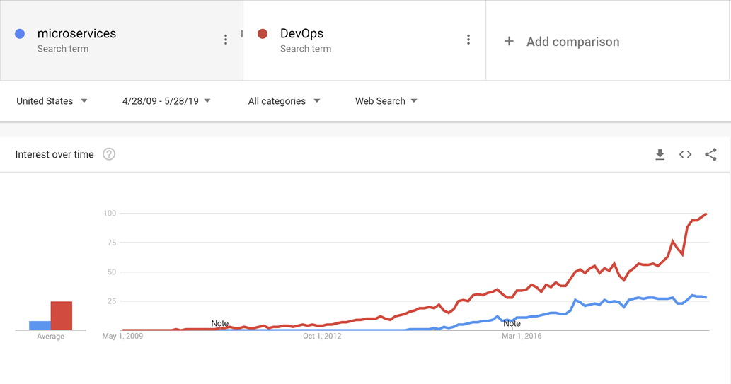

Through good DevOps practices, it’s possible to realize the advantages of cloud-native applications without suffocating under a mountain of work actually operating the applications.

There’s no golden hammer when it comes to DevOps. Nobody can sell a complete and all-encompassing solution for releasing and operating high-quality applications. This is because each application is wildly different from all others. However, there are tools that can make DevOps a far less daunting proposition. One of these tools is known as Azure DevOps.

## Azure DevOps

Azure DevOps has a long pedigree. It can trace its roots back to when Team Foundation Server first moved online and through the various name changes: Visual Studio Online and Visual Studio Team Services. Through the years, however, it has become far more than its predecessors.

Azure DevOps is divided into five major components:

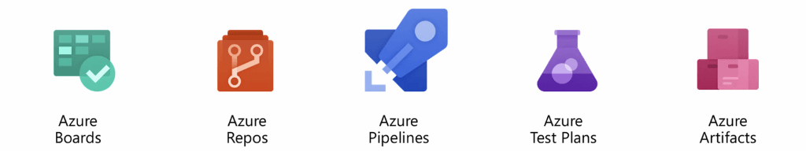

**Azure Boards** - Provides an issue and work item tracking tool that strives to allow users to pick the workflows that work best for them. It comes with a number of pre-configured templates including ones to support SCRUM and Kanban styles of development.

**Azure Repos** - Source code management that supports the venerable Team Foundation Version Control (TFVC) and the industry favorite git. Pull requests provide a way to enable social coding by fostering discussion of changes as they’re made.

**Azure Pipelines** - A build and release management system that supports tight integration with Azure. Builds can be run on a variety of platforms from Windows to Linux to MacOS. Build agents may be provisioned in the cloud or on premise.

**Azure Test Plans** - No QA person will be left behind with the test management and exploratory testing support offered by the Test Plans feature.

**Azure Artifacts** - An artifact feed that allows companies to create their own, internal, versions of NuGet, npm, and others. It serves a double purpose of acting as a cache of upstream packages if there is a failure of a centralized repository.

The top-level organizational unit in Azure DevOps is known as a Project. Within each project the various components, such as Azure Artifacts, can be turned on and off. If users want to manage their source code in GitHub but still take advantage of Azure Pipelines, then that’s perfectly possible. In fact, many open-source projects leverage the [free builds](https://azure.microsoft.com/blog/announcing-azure-pipelines-with-unlimited-ci-cd-minutes-for-open-source/) offered by Azure DevOps while keeping their source code on GitHub. Some significant open-source projects such as [Visual Studio Code](https://code.visualstudio.com/), [yarn](https://yarnpkg.com/en/), [gulp](https://gulpjs.com/), and [NumPy](https://www.numpy.org/) have made the transition.

Each of these components provides some advantages for cloud-native applications, but the three most useful are the source control, boards and pipelines.

## Source control

Organizing the code for a cloud-native application can be challenging. Instead of a single giant application, the cloud-native applications tend to be made up of a web of smaller applications that talk with one another. As with all things in computing, the best arrangement of code remains an open question. There are examples of successful applications using different kinds of layouts, but two variants seem to have the most popularity.

Before getting down into the actual source control itself, it’s probably worth deciding on how many projects are appropriate. Within a single project, there’s support for multiple repositories, and build pipelines. Boards are a little more complicated but there too the tasks can easily be assigned to multiple teams within a single project. It’s certainly possible to support hundreds, even thousands of developers, out of a single Azure DevOps project. Doing so is likely the best approach as it provides a single place for all developer to work out of and reduces the confusion of finding that one application when developers are unsure in which project in which it resides.

Splitting up code for microservices within the Azure DevOps project can be slightly more challenging.

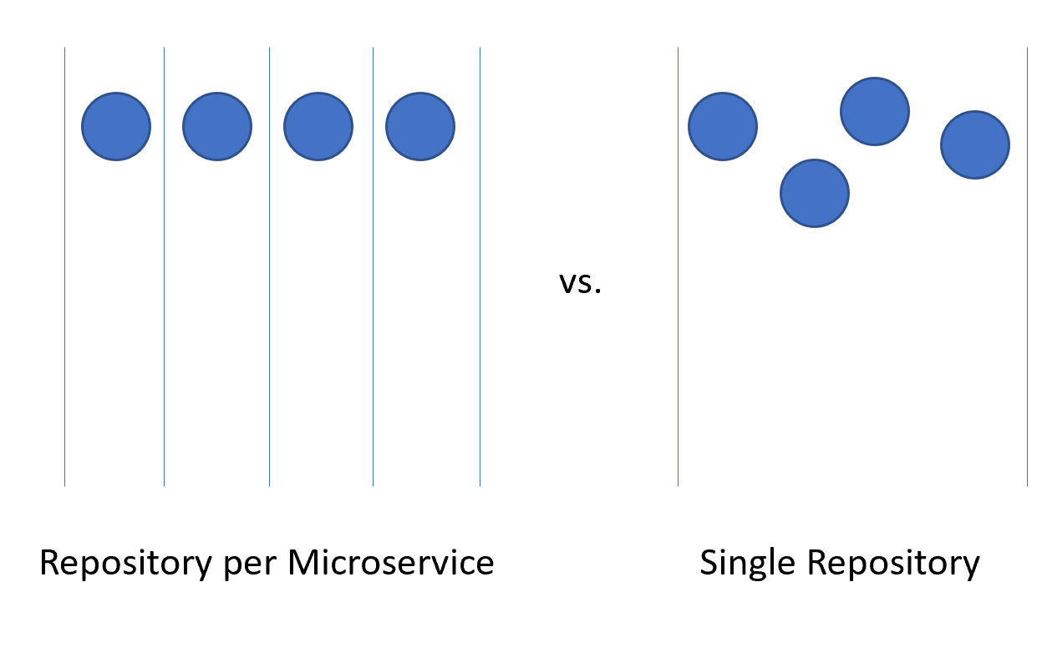

### Repository per microservice

At first glance, this seems like the most logical approach to splitting up the source code for microservices. Each repository can contain the code needed to build the one microservice. The advantages to this approach are readily visible:

* Instructions for building and maintaining the application can be added to a README file at the root of each repository. When flipping through the repositories, it’s easy to find these instructions, reducing spin-up time for developers.
* Every service is located in a logical place, easily found by knowing the name of the service.
* Builds can easily be set up such that they’re only triggered when a change is made to the owning repository.
* The number of changes coming into a repository is limited to the small number of developers working on the project.
* Security is easy to set up by restricting the repositories to which developers have read and write permissions.
* Repository level settings can be changed by the owning team with a minimum of discussion with others.

One of the key ideas behind microservices is that services should be siloed and separated from each other. When using Domain Driven Design to decide on the boundaries for services the services act as transactional boundaries. Database updates shouldn’t span multiple services. This collection of related data is referred to as a bounded context. This idea is reflected by the isolation of microservice data to a database separate and autonomous from the rest of the services. It makes a great deal of sense to carry this idea all the way through to the source code.

However, this approach isn’t without its issues. One of the more gnarly development problems of our time is managing dependencies. Consider the number of files that make up the average node_modules directory. A fresh install of something like create-react-app is likely to bring with it thousands of packages. The question of how to manage these dependencies is a difficult one.

If a dependency is updated, then downstream packages must also update this dependency. Unfortunately, that takes development work so, invariably, the node_modules directory ends up with multiple versions of a single package, each one a dependency of some other package that is versioned at a slightly different cadence. When deploying an application, which version of a dependency should be used? The version that is currently in production? The version that is currently in Beta but is likely to be in production by the time the consumer makes it to production? Difficult problems that aren’t resolved by simply using microservices.

There are libraries that are depended upon by a wide variety of projects. By dividing the microservices up with one in each repository the internal dependencies can best be resolved by using the internal repository, Azure Artifacts. Builds for libraries will push their latest versions into Azure Artifacts for internal consumption. The downstream project must still be manually updated to take a dependency on the newly updated packages.

Another disadvantage presents itself when moving code between services. Although it would be nice to believe that the first division of an application into microservices is 100% correct, the reality is that rarely we’re so prescient as to make no service division mistakes. Thus, functionality and the code that drives it will need to move from service to service: repository to repository. When leaping from one repository to another the code loses its history. There are many cases, especially in the event of an audit, where having full history on a piece of code is invaluable.

The final and perhaps most important disadvantage is coordinating changes. In a true microservices application, there should be no deployment dependencies between services. It should be possible to deploy services A, B, and C in any order as they have loose coupling. In reality, however, there are times when it’s desirable to make a change that crosses multiple repositories at the same time. Some examples include updating a library to close a security hole or changing a communication protocol used by all services.

To perform a cross-repository change requires a commit to each repository be made in succession. Each change in each repository will need to be pull-requested and reviewed separately. This can be difficult to coordinate and generally annoying to perform.

An alternative to using many repositories is to put all the source code together in a giant, all knowing, single repository.

### Single repository

In this approach, sometimes referred to as a [monorepository](http://danluu.com/monorepo/), all the source code for every service is put into the same repository. At first, this seems like a terrible idea likely to make dealing with source code unwieldy. There are, however, some marked advantages to working this way.

The first advantage is that it’s easier to manage dependencies between projects. Instead of relying on some external artifact feed, projects can directly import one another. This means that updates are instant, and conflicting versions are likely to be found at compile time on the developer’s workstation. In effect shifting some of the integration testing left.

When moving code between projects, it’s now easier to preserve the history as the files will be detected as having been moved rather than being rewritten.

Another advantage is that wide ranging changes that cross service boundaries can be made in a single commit. This reduces the overhead of having potentially dozens of changes to review individually.

There are many tools that can perform static analysis of code to detect insecure programming practices or problematic use of APIs. In a multi-repository world, each repository will need to be iterated over to find the problems in them. The single repository allows running the analysis all in one place.

There are also many disadvantages to the single repository approach. One of the most worrying ones is that having a single repository raises security concerns. If the contents of a repository are leaked in a repository per service model, the amount of code lost is minimal. With a single repository, everything the company owns could be lost. There have been many examples in the past of this happening and derailing entire game development efforts. Having multiple repositories exposes less surface area, which is a very desirable trait in most security practices.

The size of the single repository is likely to become unmanageable rapidly. This presents some interesting performance implications. It may become necessary to use specialized tools such as [Virtual File System for Git](https://vfsforgit.org/), which was originally designed to improve the experience for developers on the Windows team.

Frequently the argument for using a single repository boils down to an argument that Facebook or Google use this method for source code arrangement. If the approach is good enough for these companies, then, surely, it’s the correct approach for all companies. The truth of the matter is that very few companies operate on anything like the scale of Facebook or Google. The problems that occur at those scales are different from those most developers will face. What is good for the goose may not be good for the gander.

In the end, either solution can be used to host the source code for microservices. However, in most cases, the management and engineering overhead of operating in a single repository isn’t worth the meager advantages. Splitting code up over multiple repositories encourages better separation of concerns and encourages autonomy among development teams.

### Standard directory structure

Regardless of the single vs. multiple repositories debate each service will have its own directory. One of the best optimizations to allow developers to cross between projects quickly is to maintain a standard directory structure.

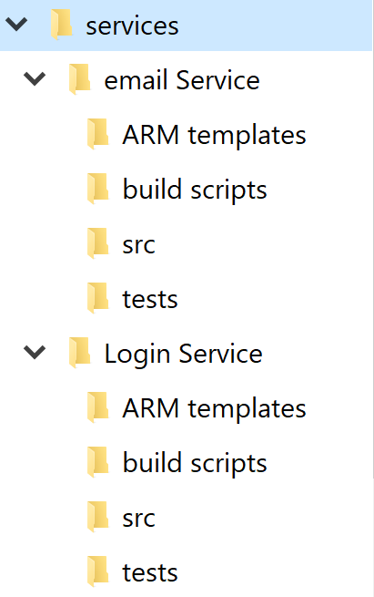

Whenever a new project is created, a template that puts in place the correct structure should be used. This template can also include such useful items as a skeleton README file and an azure-pipelines.yml. In any microservice architecture, a high degree of variance between projects makes bulk operations against the services more difficult.

There are many tools that can provide templating for an entire directory, containing several source code directories. [Yeoman](https://yeoman.io/) is popular in the JavaScript world and GitHub have recently released [Repository Templates](https://github.blog/2019-06-06-generate-new-repositories-with-repository-templates/), which provide much of the same functionality.

## Task management

Managing tasks in any project can be difficult. Up front there are countless questions to be answered about the sort of workflows to set up to ensure optimal developer productivity.

Cloud-native applications tend to be smaller than traditional software products or at least they’re divided into smaller services. Tracking of issues or tasks related to these services remains as important as with any other software project. Nobody wants to lose track of some work item or explain to a customer that their issue wasn’t properly logged. Boards are configured at the project level but within each project, areas can be defined. These allow breaking down issues across several components. The advantage to keeping all the work for the entire application in one place is that it’s easy to move work items from one team to another as they’re understood better.

Azure DevOps comes with a number of popular templates pre-configured. In the most basic configuration, all that is needed to know is what’s in the backlog, what people are working on, and what’s done. It’s important to have this visibility into the process of building software, so that work can be prioritized and completed tasks reported to the customer. Of course, very few software projects stick to a process as simple as to do, doing, and done. It doesn’t take long for people to start adding steps like QA or Detailed Specification to the process.

One of the more important parts of Agile methodologies is self-introspection at regular intervals. These reviews are meant to provide insight into what problems the team is facing and how they can be improved. Frequently, this means changing the flow of issues and features through the development process. So, it’s perfectly healthy to expand the layouts of the boards with additional stages.

The stages in the boards aren’t the only organizational tool. Depending on the configuration of the board, there’s a hierarchy of work items. The most granular item that can appear on a board is a task. Out of the box a task contains fields for a title, description, a priority, an estimate of the amount of work remaining and the ability to link to other work items or development items (branches, commits, pull requests, builds, and so forth). Work items can be classified into different areas of the application and different iterations (sprints) to make finding them easier.

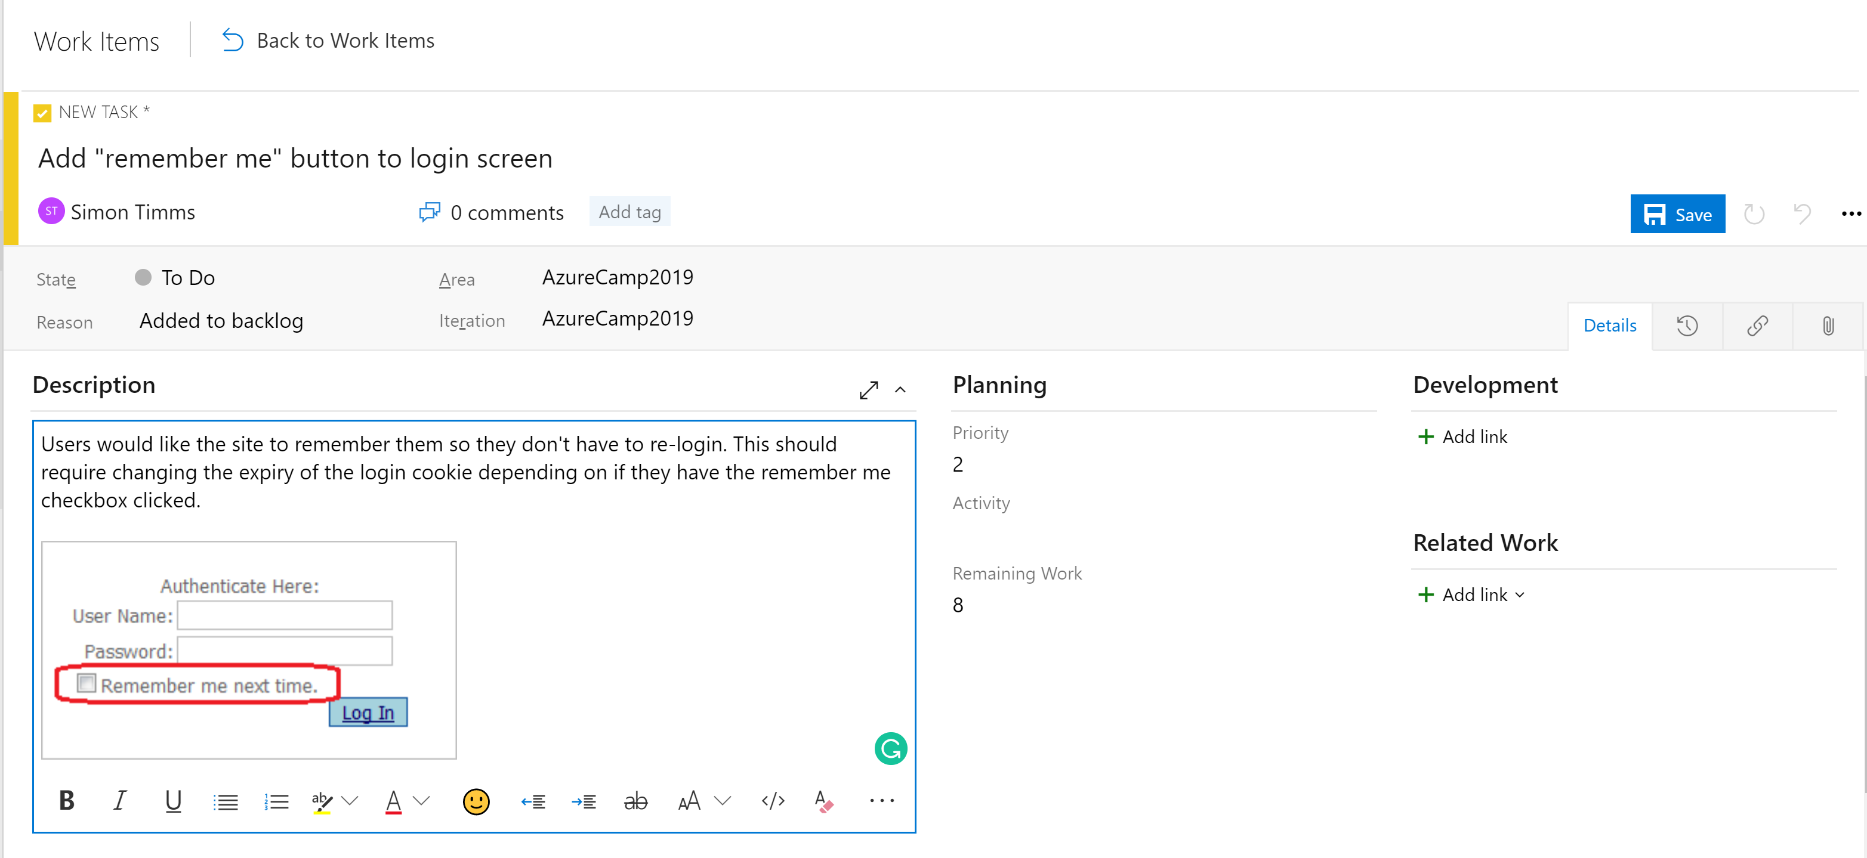

The description field supports the normal styles you’d expect (bold, italic underscore and strike through) and the ability to insert images. This makes it a very powerful tool for use when specifying work or bugs.

Tasks can be rolled up into features, which define a larger unit of work. Features, in turn, can be [rolled up into epics](https://docs.microsoft.com/azure/devops/boards/backlogs/define-features-epics?view=azure-devops). Classifying tasks in this hierarchy makes it much easier to understand how close a large feature is to rolling out.

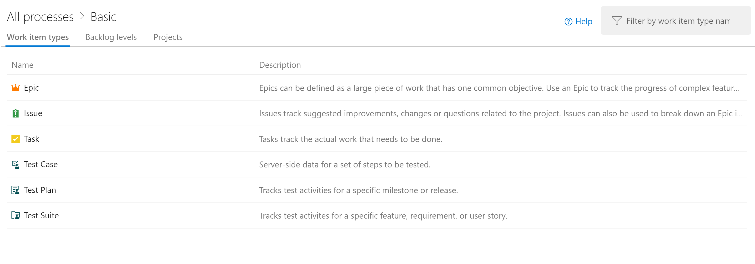

There are different kinds of views into the issues in Azure Boards. Items that aren’t yet scheduled appear in the backlog. From there, they can be assigned to a sprint. A sprint is a time box during which it’s expected some quantity of work will be completed. This work can include tasks but also the resolution of tickets. Once there, the entire sprint can be managed from the Sprint board section. This view shows how work is progressing and includes a burn down chart to give an ever-updating estimate of if the sprint will be successful.

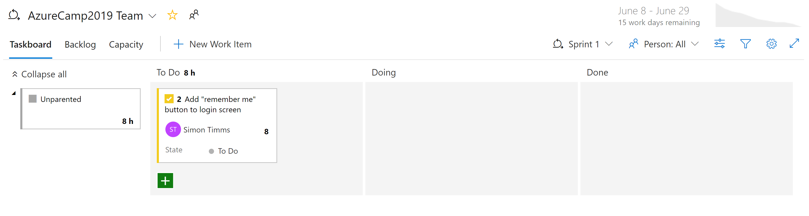

By now, it should be apparent that there’s a great deal of power in the Boards in Azure DevOps. For developers, there are easy views of what is being worked on. For project managers views into upcoming work as well as an overview of existing work. For managers, there are plenty of reports about resourcing and capacity. Unfortunately, there’s nothing magical about cloud-native applications that eliminate the need to track work. But if you must track work, there are a few places where the experience is better than in Azure DevOps.

## CI/CD pipelines

Almost no change in the software development life cycle has been so revolutionary as the advent of continuous integration (CI) and continuous delivery (CD). Building and running automated tests against the source code of a project as soon as a change is checked in catches mistakes early. Prior to the advent of continuous integration builds, it wouldn’t be uncommon to pull code from the repository and find that it didn’t pass tests or couldn’t even be built. This resulted in a lot of tracking down the source of the breakage.

Traditionally shipping software to the production environment required extensive documentation and a list of steps. Each one of these steps needed to be manually completed in a very error prone process.



The sister of continuous integration is continuous delivery in which the freshly built packages are deployed to an environment. The manual process can’t scale to match the speed of development so automation becomes more important. Checklists are replaced by scripts that can execute the same tasks faster and more accurately than any human.

The environment to which continuous delivery delivers might be a test environment or, as is being done by many major technology companies, it could be the production environment. The latter requires an investment in high-quality tests that can give confidence that a change isn’t going to break production for users. In the same way that continuous integration caught issues in the code early continuous delivery catches issues in the deployment process early.

The importance of automating the build and delivery process is accentuated by cloud-native applications. Deployments happen more frequently and to more environments so manually deploying borders on impossible.

### Azure Builds

Azure DevOps provides a set of tools to make continuous integration and deployment easier than ever. These tools are located under Azure Pipelines. The first of them is Azure Builds, which is a tool for running YAML-based build definitions at scale. Users can either bring their own build machines (great for if the build requires a meticulously set up environment) or use a machine from a constantly refreshed pool of Azure hosted virtual machines. These hosted build agents come pre-installed with a wide range of development tools for not just .NET development but for everything from Java to Python to iPhone development.

DevOps includes a wide range of out of the box build definitions that can be customized for any build. The build definitions are defined in a file called azure-pipelines.yml and checked into the repository so they can be versioned along with the source code. This makes it much easier to make changes to the build pipeline in a branch as the changes can be checked into just that branch. An example azure-pipelines.yml for building an ASP.NET web application on full framework is show in Figure 11-8.

name: $(rev:r)  
  
variables:  
 version: 9.2.0.$(Build.BuildNumber)  
 solution: Portals.sln  
 artifactName: drop  
 buildPlatform: any cpu  
 buildConfiguration: release  
   
pool:  
 name: Hosted VS2017  
 demands:  
 - msbuild  
 - visualstudio  
 - vstest  
  
steps:  
- task: NuGetToolInstaller@0  
 displayName: 'Use NuGet 4.4.1'  
 inputs:  
 versionSpec: 4.4.1  
  
- task: NuGetCommand@2  
 displayName: 'NuGet restore'  
 inputs:  
 restoreSolution: '$(solution)'  
   
- task: VSBuild@1  
 displayName: 'Build solution'  
 inputs:  
 solution: '$(solution)'  
 msbuildArgs: '/p:DeployOnBuild=true /p:WebPublishMethod=Package /p:PackageAsSingleFile=true /p:SkipInvalidConfigurations=true /p:PackageLocation="$(build.artifactstagingdirectory)\\"'  
 platform: '$(buildPlatform)'  
 configuration: '$(buildConfiguration)'  
  
- task: VSTest@2  
 displayName: 'Test Assemblies'  
 inputs:  
 testAssemblyVer2: |  
 **\$(buildConfiguration)\**\*test*.dll  
 !**\obj\**  
 !**\*testadapter.dll  
 platform: '$(buildPlatform)'  
 configuration: '$(buildConfiguration)'  
  
- task: CopyFiles@2  
 displayName: 'Copy UI Test Files to: $(build.artifactstagingdirectory)'  
 inputs:  
 SourceFolder: UITests  
 TargetFolder: '$(build.artifactstagingdirectory)/uitests'  
  
- task: PublishBuildArtifacts@1  
 displayName: 'Publish Artifact'  
 inputs:  
 PathtoPublish: '$(build.artifactstagingdirectory)'  
 ArtifactName: '$(artifactName)'  
 condition: succeededOrFailed()

**Figure 11-8** - A sample azure-pipelines.yml

This build definition uses a number of built-in tasks that make creating builds as simple as building a Lego set (simpler than the giant Millennium Falcon). For instance, the NuGet task restores NuGet packages, while the VSBuild task calls the Visual Studio build tools to perform the actual compilation. There are hundreds of different tasks available in Azure DevOps, with thousands more that are maintained by the community. It’s likely that no matter what build tasks you’re looking to run, somebody has built one already.

Builds can be triggered manually, by a check-in, on a schedule, or by the completion of another build. In most cases, building on every check-in is desirable. Builds can be filtered so that different builds run against different parts of the repository or against different branches. This allows for scenarios like running fast builds with reduced testing on pull requests and running a full regression suite against the trunk on a nightly basis.

The end result of a build is a collection of files known as build artifacts. These artifacts can be passed along to the next step in the build process or added to an Azure Artifact feed, so they can be consumed by other builds.

### Azure DevOps releases

Builds take care of compiling the software into a shippable package, but the artifacts still need to be pushed out to a testing environment to complete continuous delivery. For this, Azure DevOps uses a separate tool called Releases. Releases make use of the same tasks’ library that were available to the Build but introduce a concept of “stages”. A stage is an isolated environment into which the package is installed. For instance, a product might make use of a development, a QA, and a production environment. Code is continuously delivered into the development environment where automated tests can be run against it. Once those tests pass the release moves onto the QA environment for manual testing. Finally, the code is pushed to production where it’s visible to everybody.

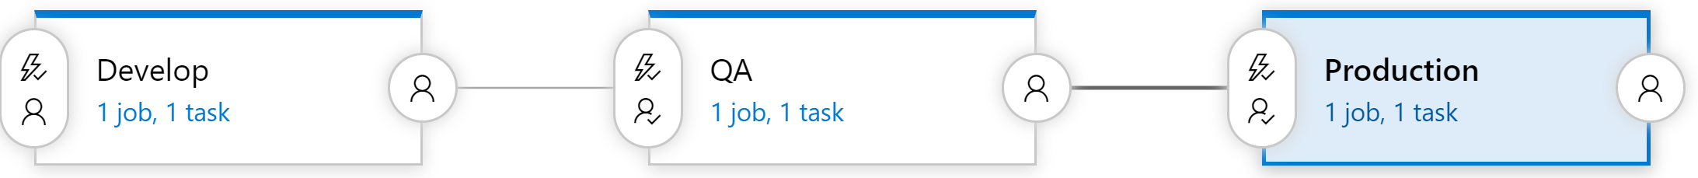

Each stage in the build can be automatically triggered by the completion of the previous phase. In many cases, however, this isn’t desirable. Moving code into production might require approval from somebody. Releases supports this by allowing approvers at each step of the release pipeline. Rules can be set up such that a specific person or group of people must sign off on a release before it makes into production. These gates allow for manual quality checks and also for compliance with any regulatory requirements related to control what goes into production.

### Everybody gets a build pipeline

There’s no cost to configuring many build pipelines, so it’s advantageous to have at least one build pipeline per microservice. Ideally, microservices are independently deployable to any environment so having each one able to be released via its own pipeline without releasing a mass of unrelated code is perfect. Each pipeline can have its own set of approvals allowing for variations in build process for each service.

### Versioning releases

One drawback to using the Releases functionality is that it can’t be defined in a checked-in azure-pipelines.yml file. There are many reasons you might want to do that from having per-branch release definitions to including a release skeleton in your project template. Fortunately, work is ongoing to shift some of the stages support into the Build component. This will be known as multi-stage build and the [first version is available now](https://devblogs.microsoft.com/devops/whats-new-with-azure-pipelines/)!

# Infrastructure as code

Cloud-native applications tend to make use of all sorts of fantastic platform as a service (PaaS) components. On a cloud platform like Azure, these components might include things like storage, Service Bus, and the SignalR service. As applications become more complicated, the number of these services in use is likely to grow. Just as how continuous delivery broke the traditional model of deploying to an environment manually, the rapid pace of change also broke the model of having a centralized IT group manage environments.

Building environments can, and should, also be automated. There’s a wide range of well thought out tools that can make the process easy.

## Azure Resource Manager templates

Azure Resource Manager templates are a JSON-based language for defining various resources in Azure. The basic schema looks something like Figure 11-10.

{  
 "$schema": "https://schema.management.azure.com/schemas/2015-01-01/deploymentTemplate.json#",  
 "contentVersion": "",  
 "apiProfile": "",  
 "parameters": { },  
 "variables": { },  
 "functions": [ ],  
 "resources": [ ],  
 "outputs": { }  
}

**Figure 11-10** - The schema for a Resource Manager template

Within this template, one might define a storage container inside the resources section like so:

"resources": [  
 {  
 "type": "Microsoft.Storage/storageAccounts",  
 "name": "[variables('storageAccountName')]",  
 "location": "[parameters('location')]",  
 "apiVersion": "2018-07-01",  
 "sku": {  
 "name": "[parameters('storageAccountType')]"  
 },  
 "kind": "StorageV2",  
 "properties": {}  
 }  
 ],

**Figure 11-11** - An example of a storage account defined in a Resource Manager template

The templates can be parameterized so that one template can be reused with different settings to define development, QA, and production environments. This helps eliminate surprises when migrating to a higher environment that is set up differently from the lower environments. The resources defined in a template are typically all created within a single resource group on Azure (it’s possible to define multiple resource groups in a single Resource Manager template but unusual). This makes it very easy to delete an environment by simply deleting the resource group as a whole. Cost analysis can also be run at the resource group level, allowing for quick accounting of how much each environment is costing.

There are many example templates defined in the [Azure Quickstart Templates](https://github.com/Azure/azure-quickstart-templates) project on GitHub that will give a leg up when starting on a new template or adding to an existing one.

Resource Manager templates can be run in a variety of ways. Perhaps the simplest way is to simply paste them into the Azure portal. For experimental deployments, this method can be very quick. They can also be run as part of a build or release process in Azure DevOps. There are tasks that will leverage connections into Azure to run the templates. Changes to Resource Manager templates are applied incrementally, meaning that to add a new resource requires just adding it to the template. The tooling will handle diffing the current resource group with the desired resource group defined in the template. Resources will then be created or altered so they match what is defined in the template.

## Terraform

A perceived disadvantage of Resource Manager templates is that they are specific to the Azure cloud. It’s unusual to create applications that include resources from more than one cloud, but in cases where the business relies on spectacular uptime, the cost of supporting multiple clouds might be worthwhile. If there were one templating language that could be used across every cloud, then it would also allow for developer skills to be much more portable.

Several technologies exist which do just that! The most mature offering in that space is known as [Terraform](https://www.terraform.io/). Terraform supports every major cloud player such as Azure, Google Cloud Platform, AWS, and AliCloud, and it also supports dozens of minor players such as Heroku and DigitalOcean. Instead of using JSON as the template definition language, it uses the slightly more terse YAML.

An example Terraform file that does the same as the previous Resource Manager template (Figure 11-11) is shown in Figure 11-12:

provider "azurerm" {  
 version = "=1.28.0"  
}  
  
resource "azurerm_resource_group" "test" {  
 name = "production"  
 location = "West US"  
}  
  
resource "azurerm_storage_account" "testsa" {  
 name = "${var.storageAccountName}"  
 resource_group_name = "${azurerm_resource_group.testrg.name}"  
 location = "${var.region}"  
 account_tier = "${var.tier}"  
 account_replication_type = "${var.replicationType}"  
  
}

**Figure 11-12** - An example of a Resource Manager template

Terraform does a better job of providing sensible error messages when a resource can’t be deployed because of an error in the template. This is an area where Resource Manager templates have some ongoing challenges. There’s also a very handy validate task that can be used in the build phase to catch template errors early.

As with Resource Manager templates, there are command-line tools that can be used to deploy Terraform templates. There are also community-created tasks in Azure Pipelines that can validate and apply Terraform templates.

In the event that the Terraform or Resource Manager template outputs interesting values such as the connection string to a newly created database they can be captured in the build pipeline and used in subsequent tasks.

# Cloud Native Application Bundles

A key property of cloud native applications is that they leverage the properties of the cloud to speed up development. This often means that a full application uses different kinds of technologies. Applications may be shipped in Docker containers, some services may use Azure Functions while other parts may run directly on virtual machines allocated on large metal servers with hardware GPU acceleration. No two cloud native applications are the same, so it’s been difficult to provide a single mechanism for shipping them.

The Docker containers may run on Kubernetes using a Helm Chart for deployment. The Azure Functions may be allocated using Terraform templates. Finally, the virtual machines may be allocated using Terraform but built out using Ansible. This is a whole mess of technologies and there has been no way to package them all together into a reasonable package. Until now.

Cloud Native Application Bundles (CNABs) are a joint effort of a number of community-minded companies such as Microsoft, Docker, and HashiCorp to develop a specification to package distributed applications.

The effort was announced in December of 2018, so there’s still a fair bit of work to do to expose the effort to the greater community. However, there’s already an [open specification](https://github.com/deislabs/cnab-spec) and a reference implementation known as [Duffle](https://duffle.sh/). This tool, which was written in Go, is a joint effort between Docker and Microsoft.

The CNABs can contain different kinds of installation technologies. This allows things like Helm Charts, Terraform templates, and Ansible Playbooks to coexist in the same package. Once built, the packages are self-contained and portable; they can be installed from a USB stick. The packages are cryptographically signed to ensure they originate from the party they claim.

The core of a CNAB is a file called bundle.json. This file defines the contents of the bundle, be they Terraform or images or anything else. Figure 11-9 defines a CNAB that invokes some Terraform. Notice, however, that it actually defines an invocation image that is used to invoke the Terraform. When packaged up, the Docker file that is located in the cnab directory is built into a Docker image, which will be included in the bundle. Having Terraform installed inside a Docker container in the bundle means that users don’t need to have Terraform installed on their machine to run the bundling.

{  
 "name": "terraform",  
 "version": "0.1.0",  
 "schemaVersion": "v1.0.0-WD",  
 "parameters": {  
 "backend": {  
 "type": "boolean",  
 "defaultValue": false,  
 "destination": {  
 "env": "TF_VAR_backend"  
 }  
 }  
 },  
 "invocationImages": [  
 {  
 "imageType": "docker",  
 "image": "cnab/terraform:latest"  
 }  
 ],  
 "credentials": {  
 "tenant_id": {  
 "env": "TF_VAR_tenant_id"  
 },  
 "client_id": {  
 "env": "TF_VAR_client_id"  
 },  
 "client_secret": {  
 "env": "TF_VAR_client_secret"  
 },  
 "subscription_id": {  
 "env": "TF_VAR_subscription_id"  
 },  
 "ssh_authorized_key": {  
 "env": "TF_VAR_ssh_authorized_key"  
 }  
 },  
 "actions": {  
 "status": {  
 "modifies": true  
 }  
 }  
}

**Figure 11-13** - An example Terraform file

The bundle.json also defines a set of parameters that are passed down into the Terraform. Parameterization of the bundle allows for installation in a variety of different environments.

The CNAB format is also flexible, allowing it to be used against any cloud. It can even be used against on-premise solutions such as [OpenStack](https://www.openstack.org/).

## DevOps Decisions

There are so many great tools in the DevOps space these days and even more fantastic books and papers on how to succeed. A favorite book to get started on the DevOps journey is [The Phoenix Project](https://www.oreilly.com/library/view/the-phoenix-project/9781457191350/), which follows the transformation of a fictional company from NoOps to DevOps. One thing is for certain: DevOps is no longer a “nice to have” when deploying complex, Cloud Native Applications. It’s a requirement and should be planned for and resourced at the start of any project.